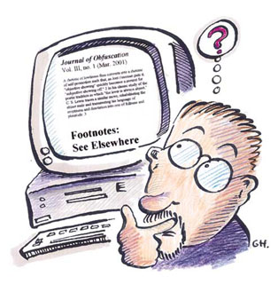

E-manual for Executive Directors

By Matt Guidry
Sections and directions have been taken from the UWSP IT Help Desk Site, as well as other UWSP IT pages

E-manual for Executive Directors
This manual is for the education of the Executive Directors of the Student Government Association to help create a better transition from administration to administration. We live in a world of ever-developing technology. This manual addresses some of the basic necessities that must be used to better transitions.

What to make sure to do this year: Save early and often all electronic documents, and save them preferably to the SGA Network Drive. All of what you save, especially final drafts should have a copy in you’re the SGA Network drive, also referred to as: \\fs1\SGA , folder so that the next year’s director can access it

Table of Contents

How to Connect to:
Myfiles - ------------------------------------------------------------------------------------ 3

Remote Lab - ------------------------------------------------------------------------------ 5

The SGA network Drive- ---------------------------------------------------------------- 10

Basics of SharePoint and SGA Resources-------------------------------------------- 16

A note about Work orders ------------------------------------------------------------- 18

MyFiles Read/Write Access - Internet Explorer 7

This method provides read/write Internet access to your network storage space (myfiles.uwsp.edu). Using this method you can open, edit, save, create new and delete files just as if the files were stored on your local computer. You can drag and drop files from your computer to your myfiles.uwsp.edu network space.
Important: Before opening and making changes to a file, you should ALWAYS save the file to your desktop or other folder on your local computer first. Then open the file, make your changes and save the file again. Once you have saved all your changes you can copy (or drag and drop) the file back to your network storage space.
- Open Internet Explorer 7
- Click File then Open
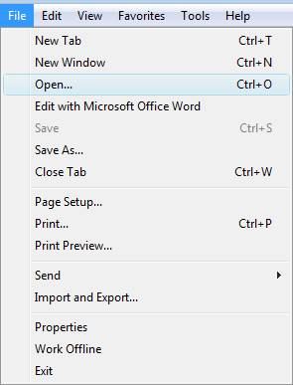
- Enter https://myfiles.uwsp.edu/ followed by your username
- Check the box for Open as Web Folder

- Click OK
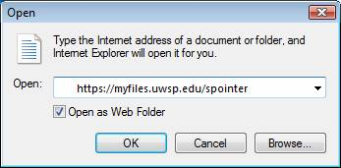
- Enter your User Name and Password
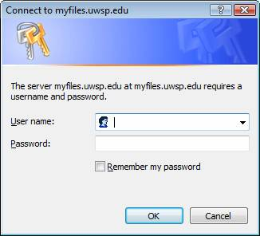
- Then click Allow 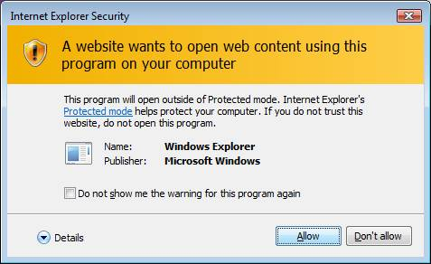
- You are now in your myfiles web folder!

Subsequent Access for Windows XP and Vista
Once you have connected to your myfiles.uwsp.edu by opening it as a web folder, the location of the web folder is stored in My Network Places and can be easily accessed in the future.
- Click Start
- Click My Network Places (Click Network (Vista))
- Double-click your myfiles.uwsp.edu network storage space.
Also viewed at: http://www.uwsp.edu/it/Content/GetInformation.aspx?View=wmsStuView&Content=MyFiles_FAQ&SubTopic=FAQ_List
This can be found on the Information Technology homepage: http://www.uwsp.edu/it

Brought to you by UWSP IT Helpdesk at: http://www.uwsp.edu/it/computerLabs/remoteLab/connectingtoremotelabinstructionsFS.aspx

Connecting to the Remote Lab (PC Only)
- Open Internet Explorer Internet browser. Other web browsers will not work with remote lab.
- Change your Internet Security options.
  - Add the remote lab web site to your trusted Internet sites. In Internet Explorer, click on Tools, Options to open the Internet Options dialog box:
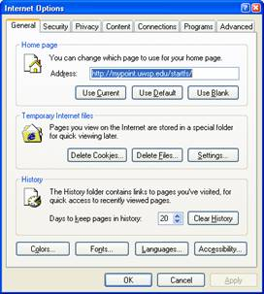
  - Click on the Security tab to see your Internet zones: 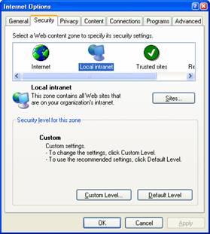
  - Click on the Trusted Sites icon and the Sites button to open your Trusted Sites list:
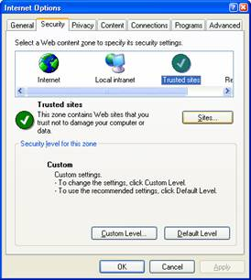

  - Type the remote computer labs web address in the Add this Web site to the zone field and click on the Add but ton
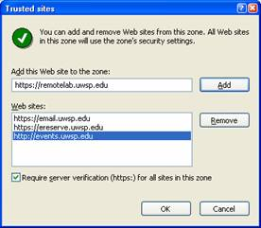
  - Click OK, once you see the https://remotelab.uwsp.edu site in your Web sites list.
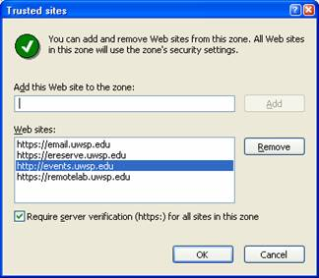
  - Click OK to close your Internet Options dialog box.

- Enter the address of the remote lab web site: https://remotelab.uwsp.edu and press Enter. You should see this Remote Computer Lab homepage.
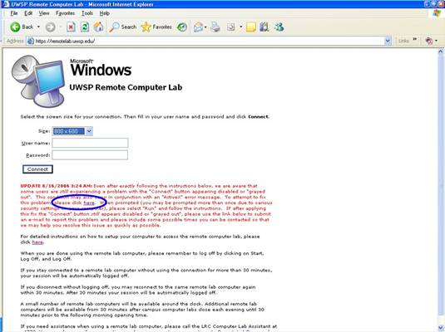
- Select the screen size you prefer to use. The best choice for 15” & 17” monitors/screens is 800 x 600. If you have a larger monitor, you might want to select one of the other screen sizes from the dropdown choices by pointing to the down arrow to the right of the Size: box and clicking on your choice.
- Fill in the User name and Password boxes and click on the Connect button.
- Try logging onto a remote computer lab computer again at: https://remotelab.uwsp.edu.
- If the Connect button is grayed out and does nothing when you click on it, read through the Update: information located below the Connect button. Follow the instructions to install the fix that is provided.
- If you continue to have problems accessing the Remote Lab, contact the Help Desk for further assistance. Call 346-HELP (4357) or send an email to the Help Desk.
- If you need assistance using the software on the remote lab computer, please call the LRC 110 Computer Lab Assistant at 715-346-4773.

The SGA network drive, also called \\fs1\SGA, is a place that directors should save all SGA relevant documents. This folder will be automatically transition to the next year’s directors. This is very important because having electronic documents and templates to start and continue work started and completed the previous year saves vast amount time. Please save all electronic Word, Excel, Adobe, and other documents on the SGA Network Drive.

If you simply want to connect one time you can do the following: (Note this only works on Campus)

- Click the “Start” button, usually located in the bottom left hand corner

- Or

- Click “Run”

- Type \\fs1\SGA in the Run box:
- Then you will have to login using your email address and password

And you have arrived at the SGA Network Drive.

Here is how to connect to the network drive from ON OR OFF –CAMPUS for windows XP followed by Windows Vista, this would be used to repeatedly connect to the SGA Network Drive, \\fs1\SGA on the following page.

Windows XP

These instructions can be used on all office computers.

- Go to the “Start” button, usually located in the bottom left hand corner

Or

- Click on “Control Panel” to open the control panel, which will bring up the following Screen:

This is classic view:
If your view does not look like this,
you can switch it by clicking “Switch
to Classic View”, which is located at
the arrow.

- Next Click on “Network Connections”.

This should bring up a window that looks like this:

- Now Click on “My Network Places”

And this window should appear:

- Next Click on “Add a Network Place”

- A new screen will appear, click Next

- Click Next again.

- Type \\fs1\SGA in the box labeled internet or network address and click Next:
- Click next one last time.
- And finally click Finish.

Now if you want to make the SGA Network Drive easier to find do the following:

- Go to Network Places in the Control Panel (See above directions)
- Right Click on the network folder “SGA on fs1”

- Click on “Send To” and highlight Desktop (create shortcut)

- You should now have a shortcut to the SGA Network Drive on your desktop.

SGA Website and Resources / SharePoint
- To find the SharePoint area goes to the sga website, you can search the UWSP homepage or go to http://www.uwsp.edu/stuorg/sga, and click on the “SGA Resources” button.

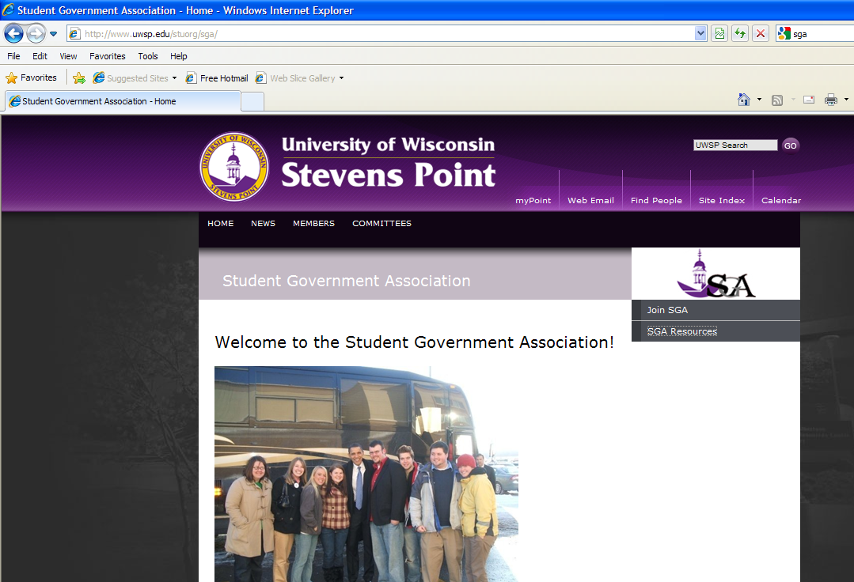
- This will take you to the this screen where you can “Sign in” using your UWSP email and password:

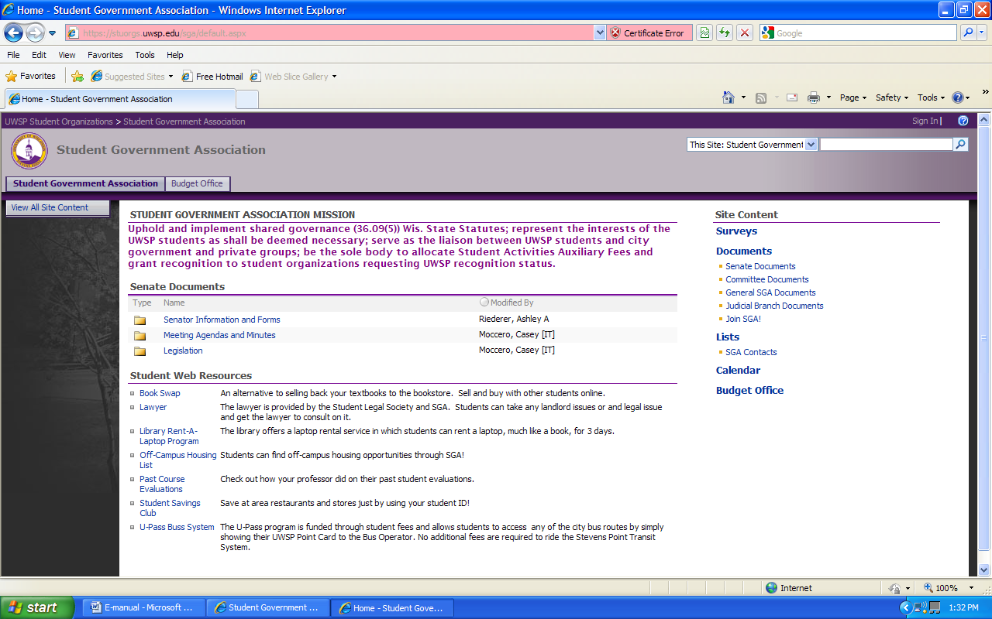

- Signing in allows those on the Student Government Executive Officer list to upload documents for the student body to see or edit content of the site. You are not able to add web parts to the site but you can edit the content of the web parts already on the site.

- Use the Committee Documents and General SGA Documents areas to your advantage. Here, you can share items for you specific committee in their designated folder. This is a great way to share documents with students on your committees.
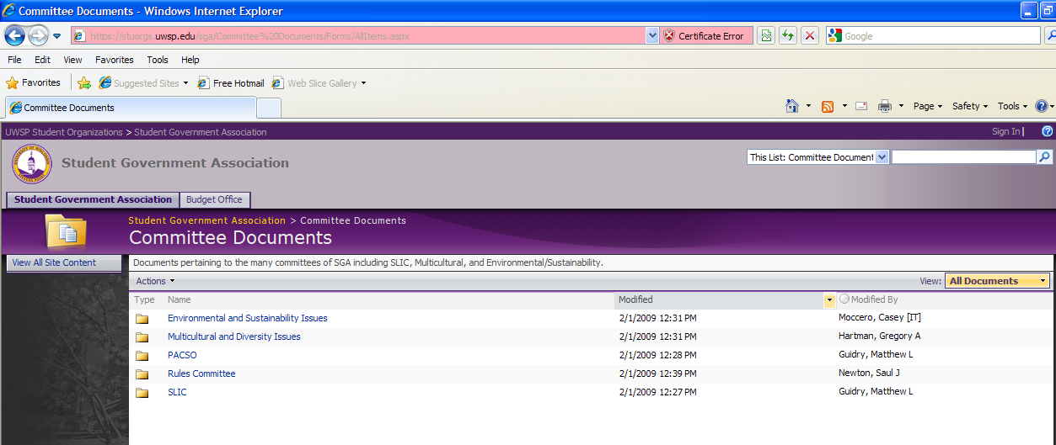

You can upload files to these folders.

A note about the Work order system
- If the computer is broken to the point where it is no longer functional consult President or VP and they will have Susan enter a Work order. Only Susan should enter work orders. Susan will need all the information such as Computer Name, the exact problem, what the problem is doing (all information about the problem), and your login name.

