

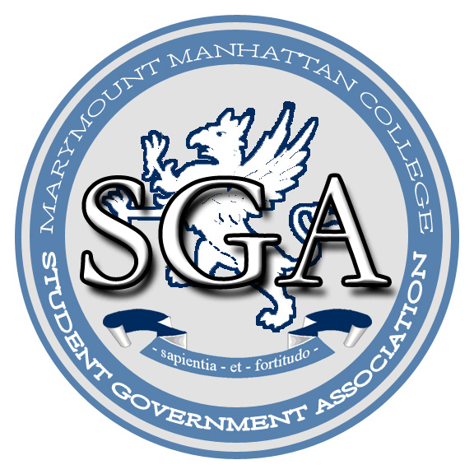

Student Government Association
Official Position:
Marymount Manhattan College Student Communication and Technology

November 20, 2006
Authored by Sarah E. Doolin, President

In an effort to promote effective and efficient use of technological resources, to enhance the college community environment, and to raise the level of awareness of activities and services available for students, encouraging greater campus involvement, the Student Government Association (SGA) of Marymount Manhattan College (MMC) hereby takes this official position regarding student communication and technology.

WHEREAS the website of MMC currently allows for its alumni and parents to have separate branches, or portals, its current students do not;

WHEREAS peer undergraduate institutions provide savvy marketing methods for their constituents, MMC is still advertising with outdated methods such as posters and flyers;

WHEREAS the student body of MMC has a general frustration regarding internal spam in MMC email accounts;

THEREFORE BE IT RESOLVED THAT the SGA as representatives of the student body requests a revision of the MMC website, to include a student branch or portal. SGA suggests that this student portal contain a scrolling calendar of daily events and college resources, so that as students sign online to check MMC email, MMConnect, and Blackboard, they would have the capacity to recognize daily events provided on campus contributing to greater satisfaction in the institution, and thus student retention.

THEREFORE BE IT RESOLVED THAT the SGA requests that the current MMC website be updated and made more user friendly, providing broad access to information about student clubs and their events in order to improve communication between clubs and the greater student body.

