Student Life Application
Manual

Created March 2007



Table of Contents

- Student Life Application Overview (p.3)

- How to (Re)Register an Organization On-line for the First Time (pgs. 4-19)

- Managing your Organization’s Information Once an Organization is Recognized (pgs. 20- 29)

- How Students Can Express Interest in Joining your Organization through the Student Life Application (pgs. 30-33)

Student Life Application Overview

The Office of Student life is pleased to announce a new web based application that will assist in the yearly registration of student organizations and regular management of membership and organizational information. Seeing the need to eliminate paper and create an electronic file and communication tool for registered student organizations, the Student Life Application was developed. Student Life staff teamed with Information Services to develop an on-line tool that will be located in Campus Connection. This on-line tool provides an easy mechanism to submit information electronically to the Office of Student Life in order to register your group and additionally can assist organizations in managing to keep up to date information on your membership throughout the year.
The Student Life Application will enable student organization re-registration to be an on-line process as of April 2, 2007. DePaul students wishing to register a student organization with the Office of Student Life for the 2007-08 academic year can log into Campus Connection to access this tool. The application will serve as the tool to complete the necessary steps to register an organization with the University. The following student organization re-registration forms and documents can be submitted on-line through this application:
- Policy and Procedure Contract
- Student Organization Alcohol Policy Agreement
- Roster of Members
- Executive Board and Primary Contact Information
- Governing Documents (Constitution/By-laws)
- Advocate Contract
**In person attendance at both a Re-Registration Workshop as well as a Treasurer’s Workshop (formerly Financial/SAF-B Workshop) will still be required to become recognized as a registered DePaul student organization.
In order to help navigate this new on-line tool, the following “How To Manual” for the Student Life Application has been provided. Additionally, on April 14th, 2007 at Student Life’s Transition Conference, a session will be held to walk through this on-line tool.
If there are questions regarding the re-registration process and use of this on-line tool, please contact Student Life at studentlife@depaul.edu. An evaluation of the Student Life Application will be made available during the spring quarter of 2007.

How to (Re) Register an Organization
On-Line for the First Time

Start by going to DePaul’s homepage and logging into Campus Connection with your username and password.

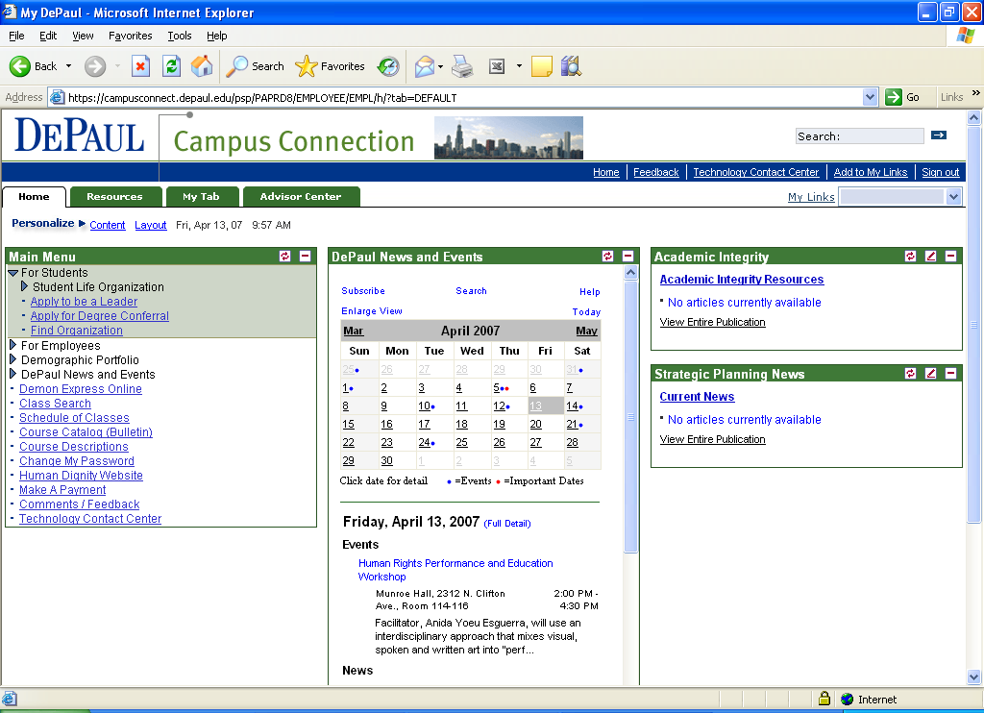

Once in Campus Connection, to access the Student Life Application begin by clicking on For Students in the Main Menu on the right hand side of the screen. A drop down menu will appear with the following option:

Student Life Organization

In order to (re)register an organization, click on Student Life Organization.
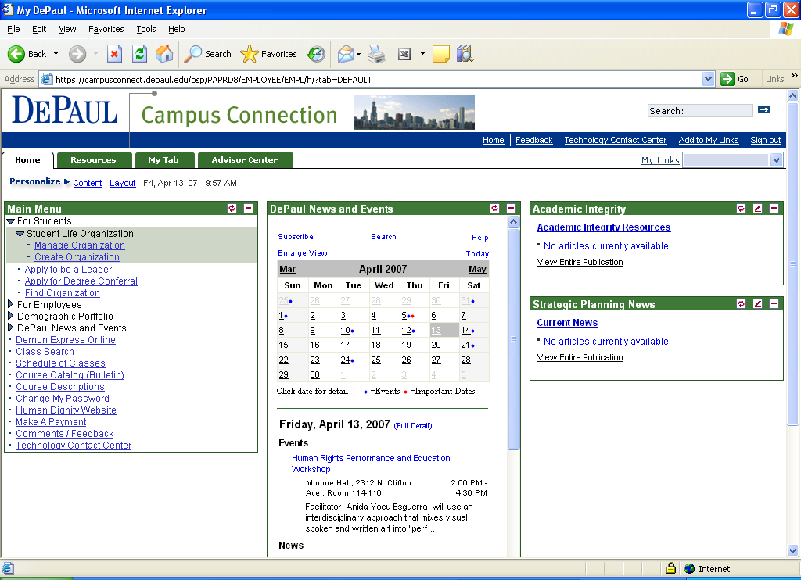

Once you have clicked on Student Life Organization a drop down menu with the options Manage Organization and Create Organization will appear. To register your organization for the first time online via the Student Life Application, click on Create Organization.

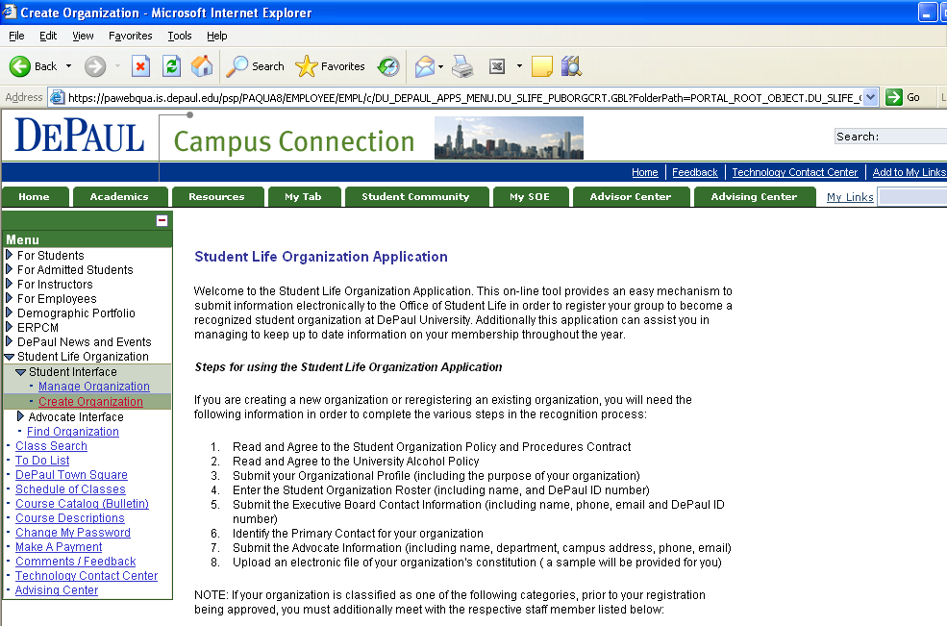
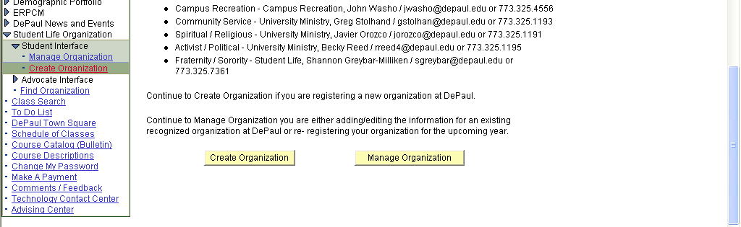
The first screen of the Student Life Application will give you a basic introduction to using the tool as well as requirements for registration. As you scroll down to the bottom of this screen, you will be given two options- Create Organization or Manage Organization. If this is the first time your organization is entering information through this on-line tool, click Create Organization.

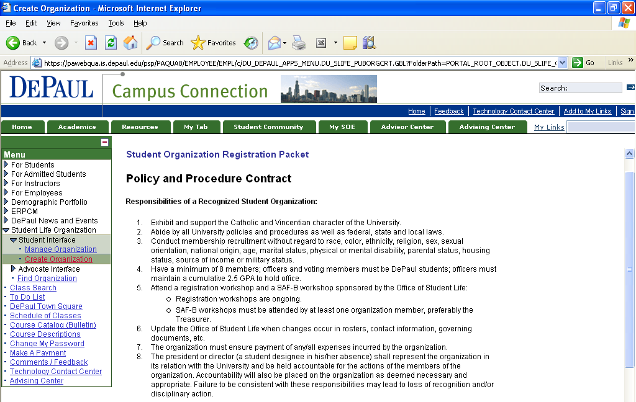
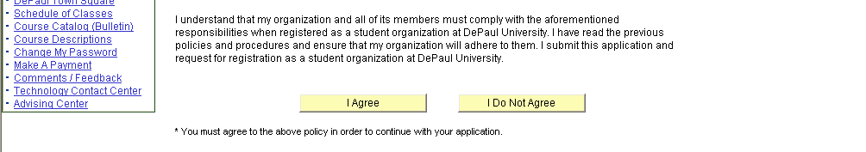
The first screen you will see is Policy and Procedure Contract which is required of all student organizations to agree to prior to student organization recognition being granted. Read over the policy and decide if your organization can agree to the statements. If so, click I Agree. Once you click I Agree it will take you to the DePaul Alcohol Policy. If you click I Do Not Agree you will be taken to a screen that explains the requirement and it will ask that you restart the application.

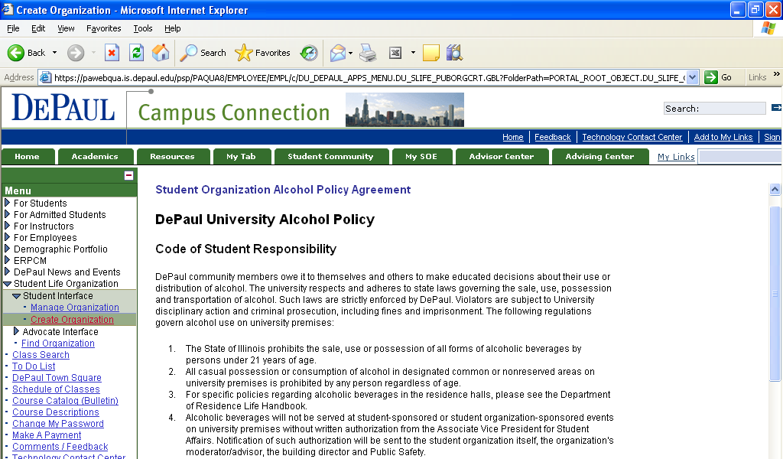
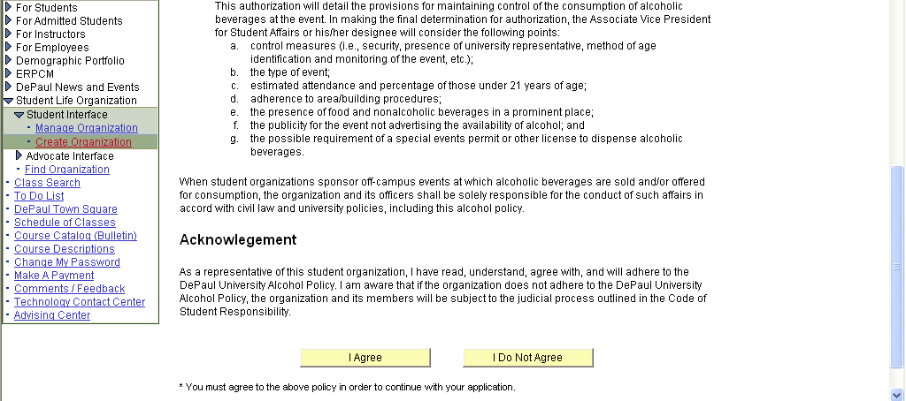

This page is the Student Organization Alcohol Policy Agreement which is required of all student organizations to agree to prior to recognition being granted. Read over the policy and decide if your organization can agree to the statements. If so, click I Agree. Once you click I Agree it will take you to the Organizational Profile page. If you click I Do Not Agree you will be taken to a screen that explains the requirement and it will ask that you restart the application.

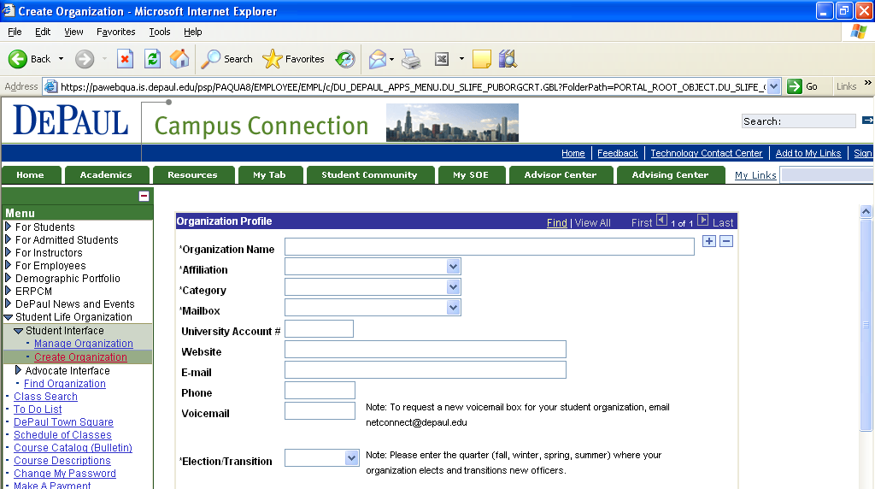
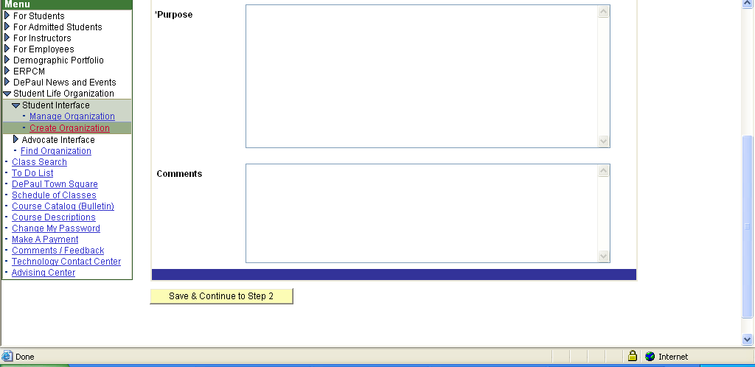
Once you have agreed to the Policy and Procedure Contract as well as the Student Organization Alcohol Policy Agreement, you will be taken to the Organizational Profile page. Organization Name, University Account # (if you know it), Website, Email, Phone, Voicemail, and Purpose are all free text boxes to type in information. Affiliation, Category, Mailbox, and Election/Transition all have drop down menus from which to choose the options that best describe your organization and its needs.

Organization Name, Affiliation, Category, Mailbox, and Purpose are all required fields that need to be entered in order to move to step 2 of the on-line registration process. If you fail to enter one of the required fields and attempt to move to Step 2, the field you missed will be highlighted in red. Select the category that best describes your organization. The purpose should describe the reason your organization exists and how it contributes to the DePaul community. Once you have entered all of the required fields, Click Save & Continue to Step 2.

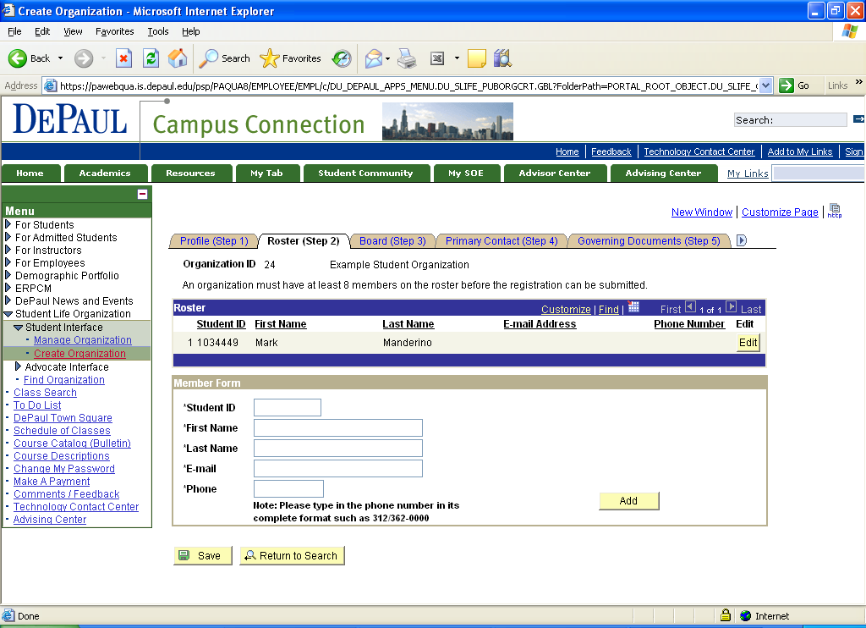
Once you get to Step 2, you will now see file tabs at the top of the screen that will move you through the application in order to submit your (re)registration information to Student Life. The first step is to submit your Roster. Prior to starting the on-line process for student organization registration, you will need to collect the following information from your members: Student ID, First and Last Name, Email Address and Phone Number. All these fields are required in order to add them to the roster on-line. Once you have collected that information you can enter the information in the fields. Click Add after each member’s information is entered in the fields. Please keep in mind Student Life’s minimum roster requirement in order to be officially recognized. PLEASE NOTE the minimum roster requirement stated on this page.

**If you are a social fraternity or sorority, when you click Add it will prompt you with a drop down menu asking to select the reason you are adding this member. In order to continue, you must select a reason.


After you click Add this pop up box above will appear notifying you that an email has been sent to the individual you just added to the roster notifying them of this information. Click Ok. This pop up box will appear after each individual’s information is entered on the roster page. This email message that is sent gives the individual added to the roster an opportunity to indicate they do not want to be included on the roster. If this is the case, Student Life will be notified.

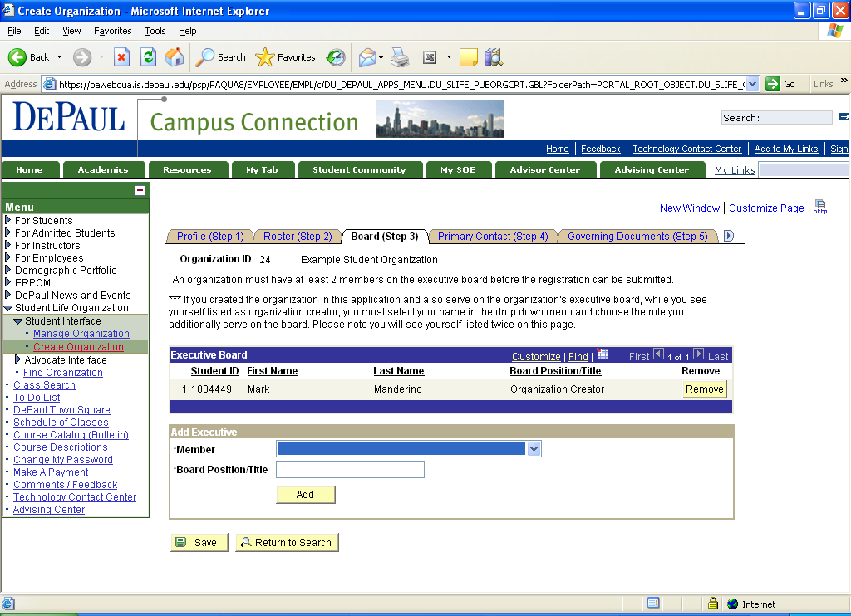

Step 3 involves identifying who is on your Executive Board. Individuals MUST first have been added to your roster in the previous step (Step 2) in order to select them as an executive board member. Use the drop down menu to select the individuals on your executive board. Then, type in the name of the individual’s position (treasurer, secretary, vice president, etc.) in the text box below. Click Add to add them to the Executive Board list. You can select an individual more than once if they hold multiple positions within the organization.

PLEASE NOTE you will automatically see your own name already pre populated on this screen as the Organization Creator if you are the individual who initiated the organizational profile. DO NOT delete yourself as the organization creator.

Remember at least two Executive Board members need to be identified in order to fulfill recognition requirements as a student organization. Any individual on your roster, who is also listed as an Executive Board Member, can access the Student Life Application to help manage your organization’s membership information. More than one executive board member can utilize the Student Life Application.

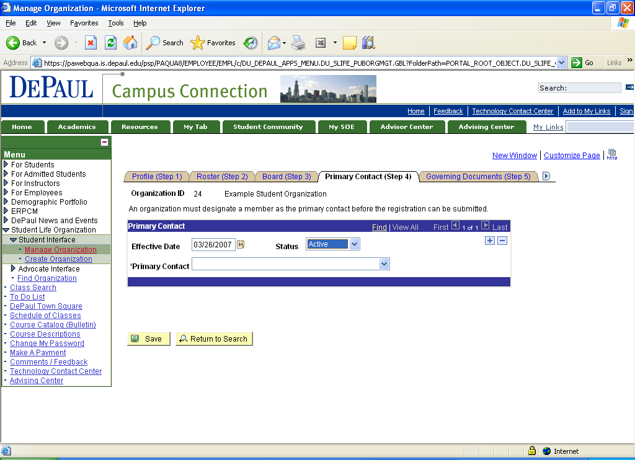

Step 4 involves identifying the Primary Contact for your organization. Use the drop down menu to select an individual in the organization that will serve as the primary contact for the Office of Student Life. Typically the Primary Contact is the president of the organization. You can only select one primary contact. Effective date will default to the date you are logged into the application and adding the Primary Contact

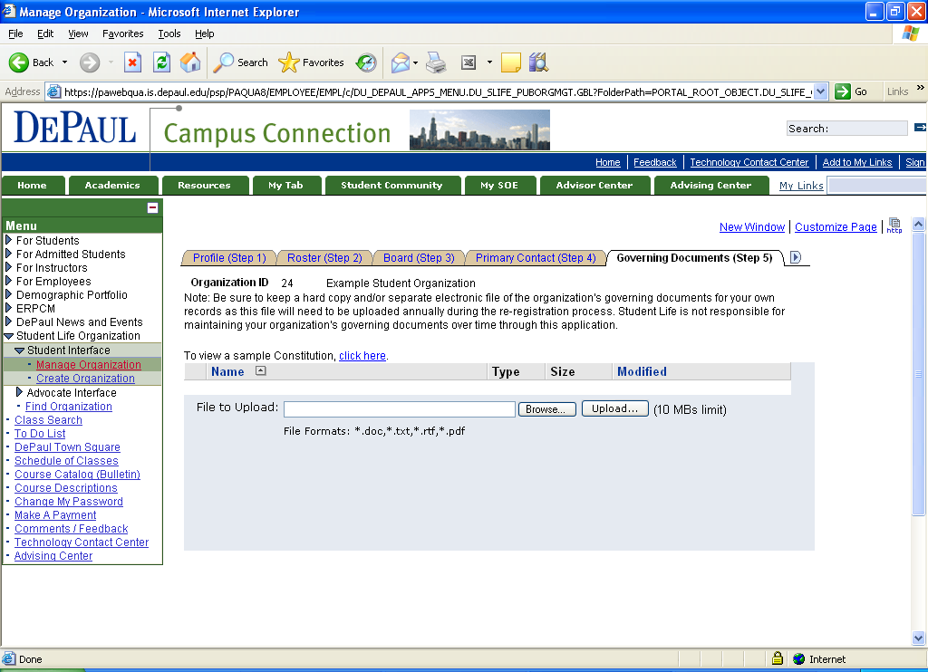
Step 5 involves submitting the organization’s Governing Documents (Constitution/By-laws), which is a requirement of the recognition process. Only electronic copies will be accepted. You can upload your organization’s constitution on this page. If you need to see a sample constitution in order to create one for your organization if you do not have one yet, you can access the example from this page as well.

PLEASE NOTE: As you upload your document you may get an error message saying the file format is not accepted. We are trying to correct this message, but as long as your file is .doc, .txt, .rtf, or .pdf, it will be accepted and upload regardless of the message.

Once you have uploaded a constitution/by-laws, you will be able to access this document on-line. After the constitution/by-laws is uploaded, click on the arrow icon near the top right part of the screen next to the tab, Governing Documents (Step 5). This will take you the next set of steps in the recognition process.

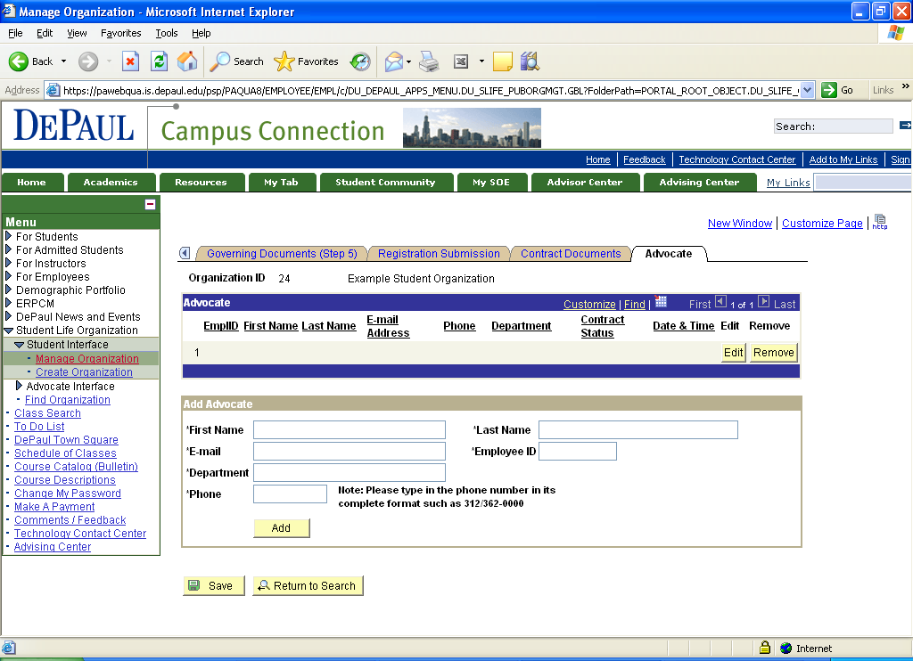
The last tab you will see on the page is to add the Advocate for your club or organization. Advocates must be DePaul Faculty or Staff members to be eligible. You must have the name, email, employee ID number, Department Name, and phone number. Advocates are encouraged, but not required. Once you have entered the information for the organization’s advocate, click Add.

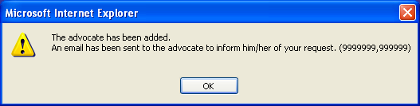

Once you have added the Advocate’s information, this pop up box will appear notifying you that an email has been sent to the Advocate in order for them to complete the advocate contract. The advocates are responsible for completing the actual contract on-line. The identified Advocate will receive instructions in the email.
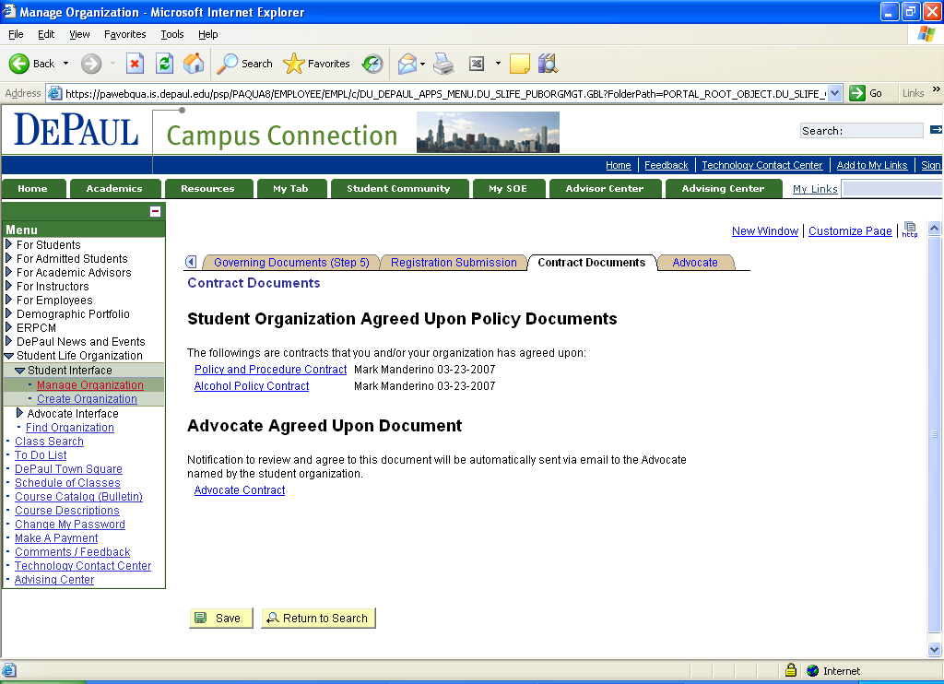

The Contract Documents tab contains copies of the policy documents that were agreed upon during registration. You will see the date the policy was agreed upon as well as the name of the person that agreed to the policy on behalf of your organization.

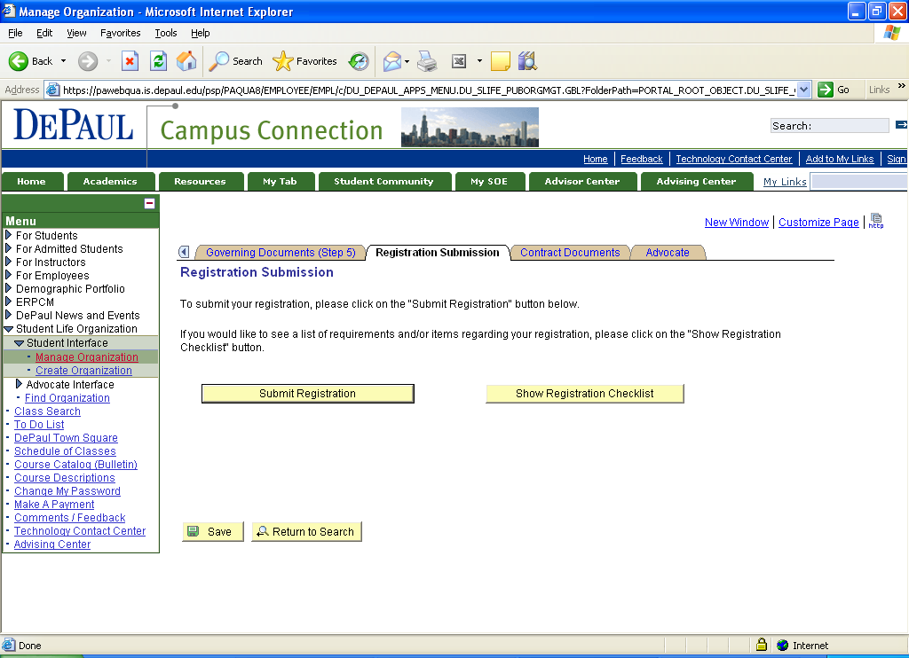
Once you have completed all steps of the on-line registration process and provided all of the required information, you will be ready to submit your organization’s application for registration. Before doing so, to see that you have completed all necessary steps, click on Show Registration Checklist.

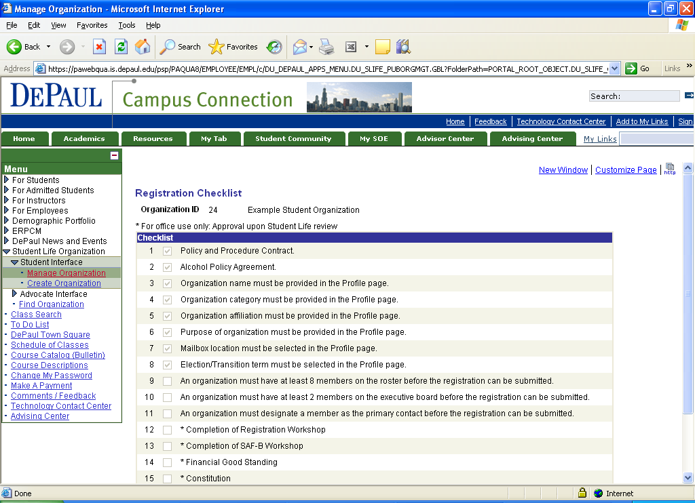
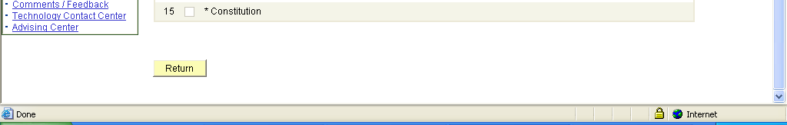
This checklist will let you know what information has been submitted. In order for you to submit your organization registration, items 1 through 11 must be checked. Items 12-14 will be manually reviewed by Student Life staff upon review of the application and attendance of workshops. Please note you can submit the application prior to attending either a Re-Registration Workshop or a SAF-B workshop. After you have confirmed your application is ready for on-line submission to Student life, click the yellow Return icon at the bottom of the screen to take you back to the previous page.

Click Submit Registration to official submit your (Re) registration material to Student Life. Staff members will then review your application material and check your attendance at our (Re) Registration Workshop and Treasurer’s Workshop, as well as verify your organization’s financial good standing with the university.

Upon approval of your student organization, an automatic email will be sent to your organization’s identified Primary Contact notifying them that the organization has been granted recognition.

How to Manage and Make Updates to your Organization’s Information

Managing your organization’s information and keeping it up to date will create a historical file of your organization’s membership and executive board leadership. Utilizing the Student Life Application to manage your organization’s information is very similar to the process and steps to create the organization on-line. In this section, access to the Manage Organization tool, updating your Roster, and updating your Executive Board information will be covered. If there are other steps that you do not understand, please refer back to the section, “How to (Re) Register an Organization On-Line for the First Time.”

Log into Campus Connection in order to access the Student Life Application. Begin by clicking on For Students. You will see Student Life Organization appear right underneath For Students in the Main Menu on the right hand side of the screen.

Click on Student Life Organization

To access your organization’s file via the Student Life Application, click on Manage Organization.
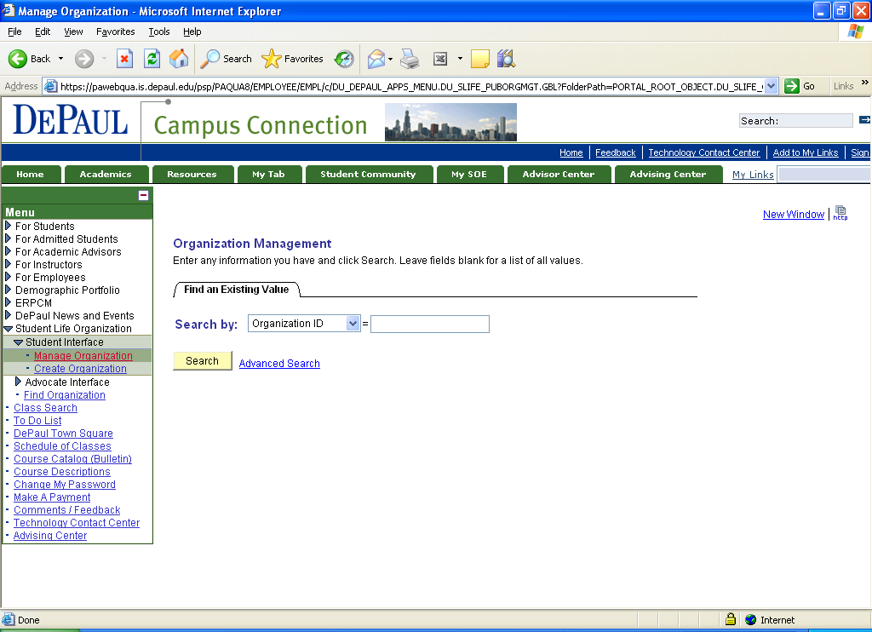

Once you click on Manage Organization the application should take you directly to your Organization’s profile page. If you see this page, you are probably listed as an Executive Board member to more than one registered student organization at DePaul. If this is the case you will need to choose which organization’s file you want to access to manage.
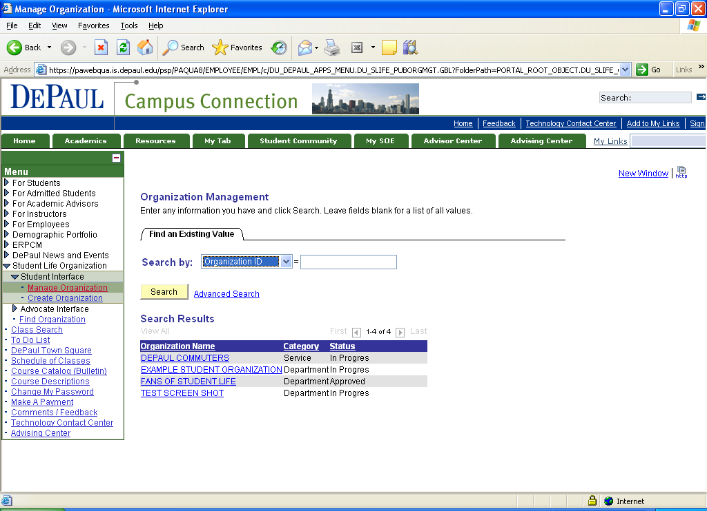
If you are an executive board member in more than one registered student organization, the above screen will appear. You will need to select which organization’s file you want to update. You can search your organizations by Organization ID, Category, Organization Name, or Status. Click on the file that you want to update.

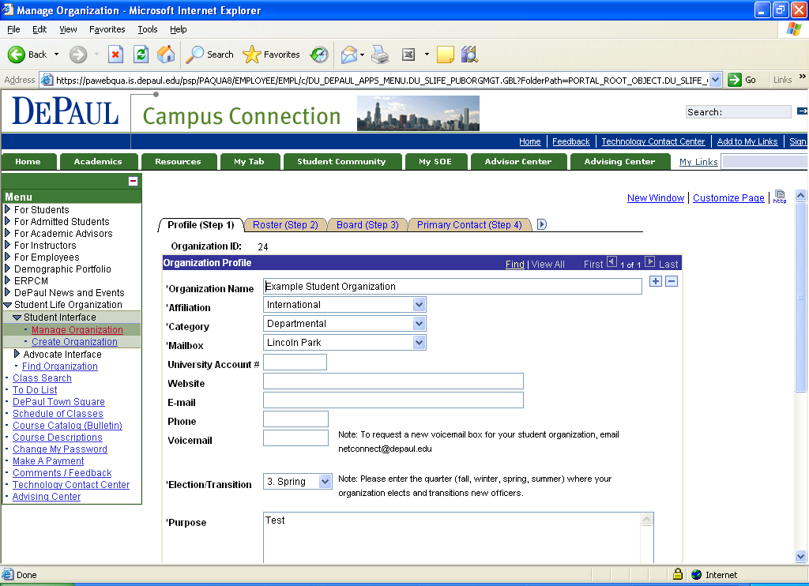

Once you have accessed the Student Life Application, you can review, modify, and update information that you had previously submitted as well as add new information that you did not enter the first time. The most common updates will be to the Roster, Board, and Primary Contact.

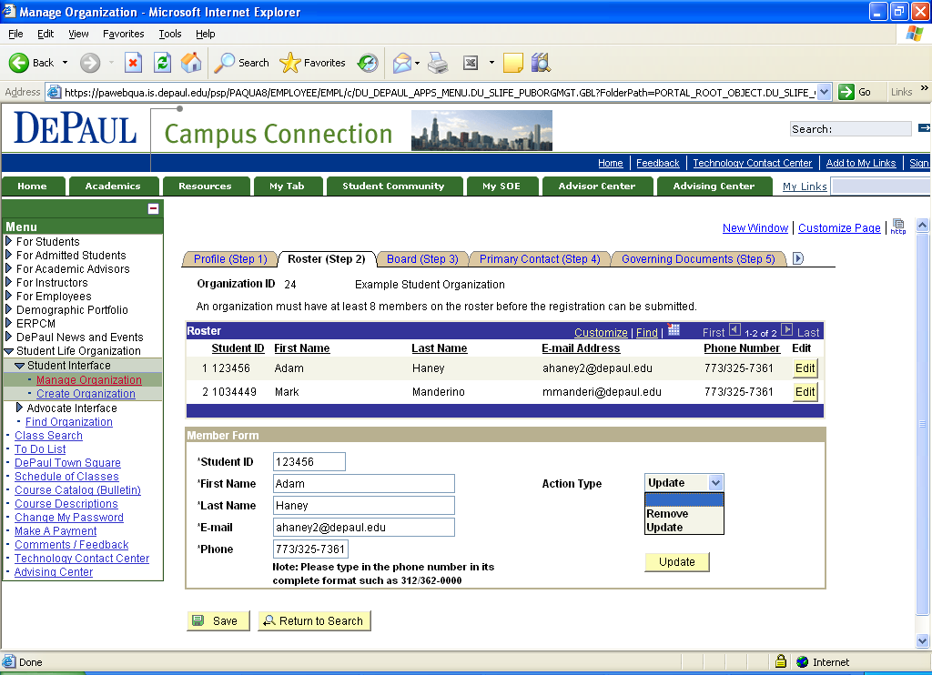

If you want to update a member’s information you would click on the yellow Edit icon on the right hand side of the member’s information. Once you click on Edit, the member’s information will prepopulate in the Member Form section. You are given two options- you can either Update a person’s existing information (i.e. new or different phone number or email address) or Remove if an individual is no longer a member of the organization.

If you are just updating a member’s information, you can make edits within the text boxes for each of the criteria: Student ID, First Name, Last Name, E-mail or Phone. Type in the new information and click on the Save icon at the bottom of the screen.

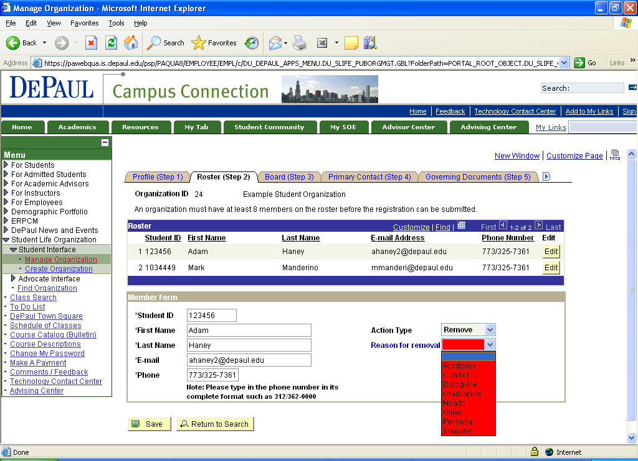
If you want to remove an individual from the roster, you would click on the yellow Edit icon on the right hand side of the member’s information. Once you click on Edit, the member’s information will prepopulate in the Member Form section. To remove someone from the roster you would choose Remove from the Action Type section.

Immediately a red drop down menu will appear asking for the reason the individual is being removed from the roster. The following options are provided: Academic, Conflict, Discipline, Graduation, Health, Other, Personal, or Transfer. In order to successfully remove an individual from the roster, one of these reasons must be selected. Once the selection is made, click on the Save icon at the bottom of the screen.

You can repeat this process for any other removals.
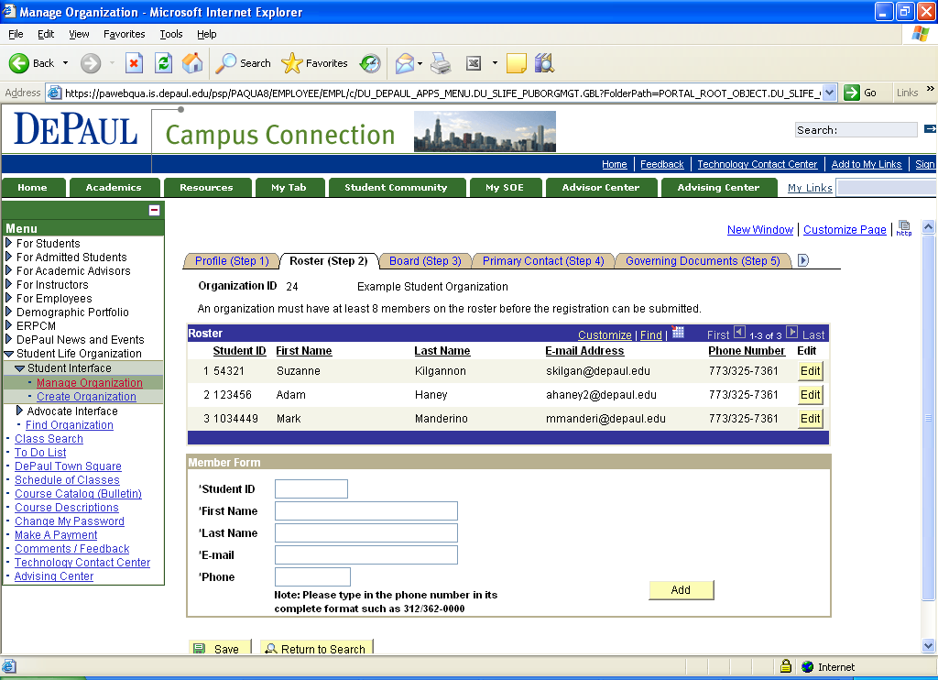
If you need to add a new member to your organization you can enter the information in the fields in the Member Form section. Click Add after each member’s information is entered in the fields.
After you click Add this pop up box above will appear notifying you that an email has been sent to the individual you just added to the roster notifying them of this information. Click Ok. This pop up box will appear after each individual’s information is entered on the roster page. This email message that is sent gives the individual added to the roster an opportunity to indicate they do not want to be included on the roster. If this is the case, Student Life will be notified.
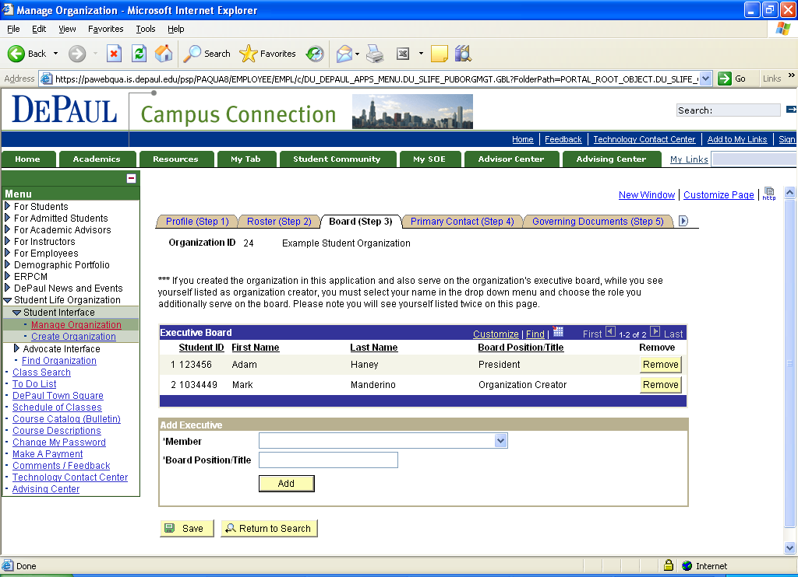
You can either add or remove individuals to the Executive Board at any time. You can add an individual to your Executive Board, simply by selecting the member’s name in the drop down menu within the Add Executive section and typing in their position title. You would complete this by clicking the Add icon and then Save.

If you needed to remove an individual that no longer is on your executive board you would click the Remove icon on the right hand side of the member’s executive board information.

PLEASE NOTE someone should always be listed as the Organization Creator.

How Students Can Express Interest in Joining your Organization through the Student Life Application

Another feature of the Student Life Application is that students can log into Campus Connection and see which student organizations are registered at DePaul, get information on the purpose of the organization, and enable them to get in contact with the primary contact of the organization to express interest in joining or find out more information about the student organization. Contacts are limited to only those with access to Campus Connection, which means DePaul students, staff, or faculty. This section will explain how this feature works.

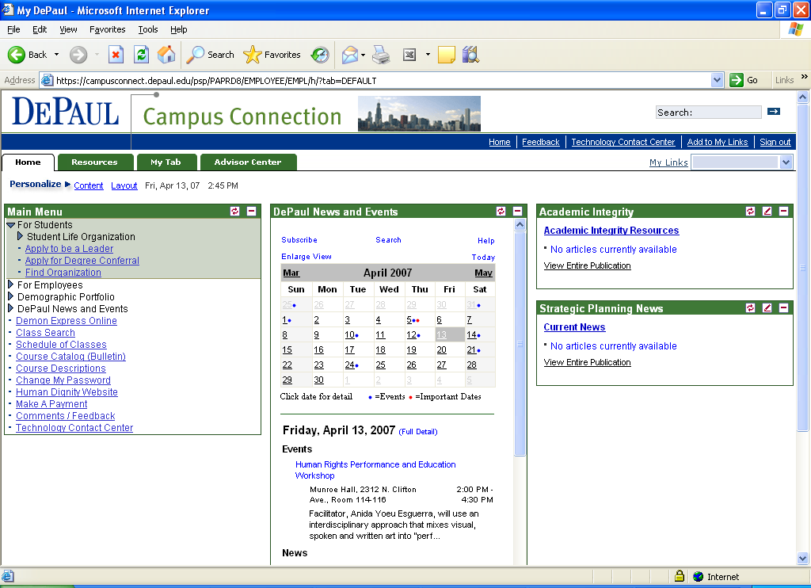
Once in Campus Connection in order to access the Student Life Application begin by clicking on For Students and then Student Life Organization in the Main Menu on the right hand side of the screen. A drop down menu will appear with the following options:

Find Organization

In order to see a list of DePaul’s registered organizations and contact the organization, click on Find Organization.

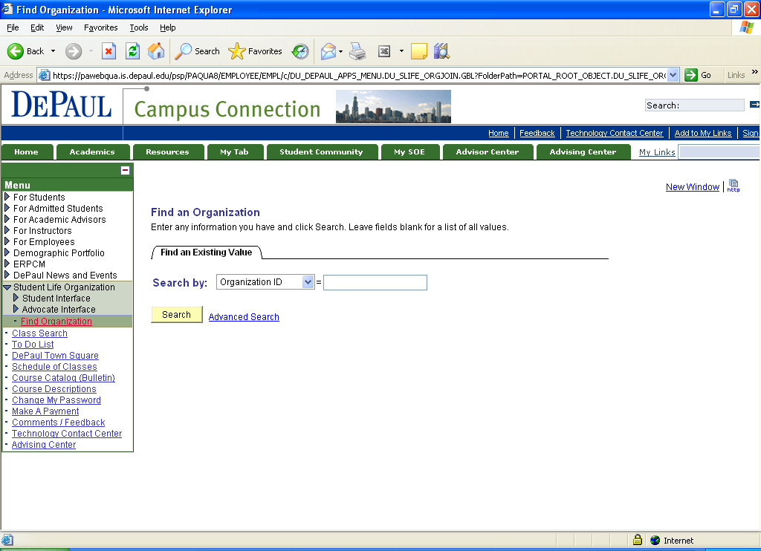
Use the drop down menu and you can search by Affiliation, Category, Organization ID or Organization Name. You do not need to type anything in the text box. Once you have selected your search mechanism, click Search.

Please Note: Organization Name or Category is the most likely search mechanism.

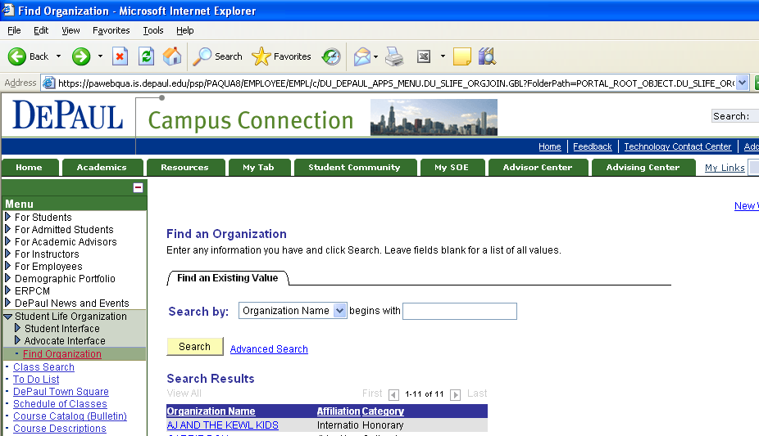

In order to get information about an organization, click on the name of the organization in the list.
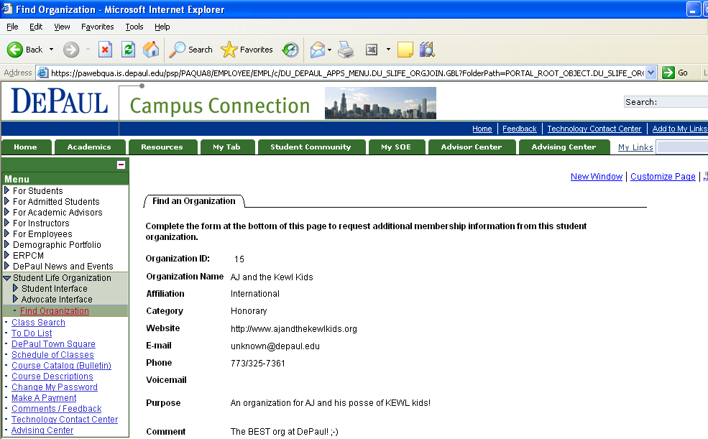
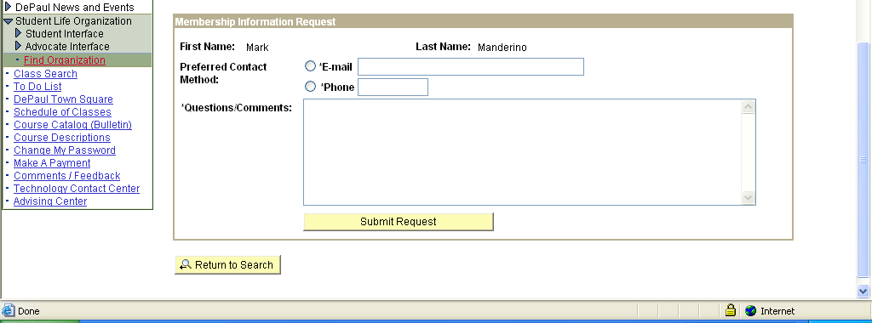

On this page you will see basic information about the registered student organization. Additionally there is the section, Membership Information Request, in which you can enter comments, request information about the organization and/or membership. This request will be automatically sent to the primary contact of the organization. Type in your preferred contact method as well as any questions or comments in the text boxes. Click Submit Request and an email will be sent to the organization.

