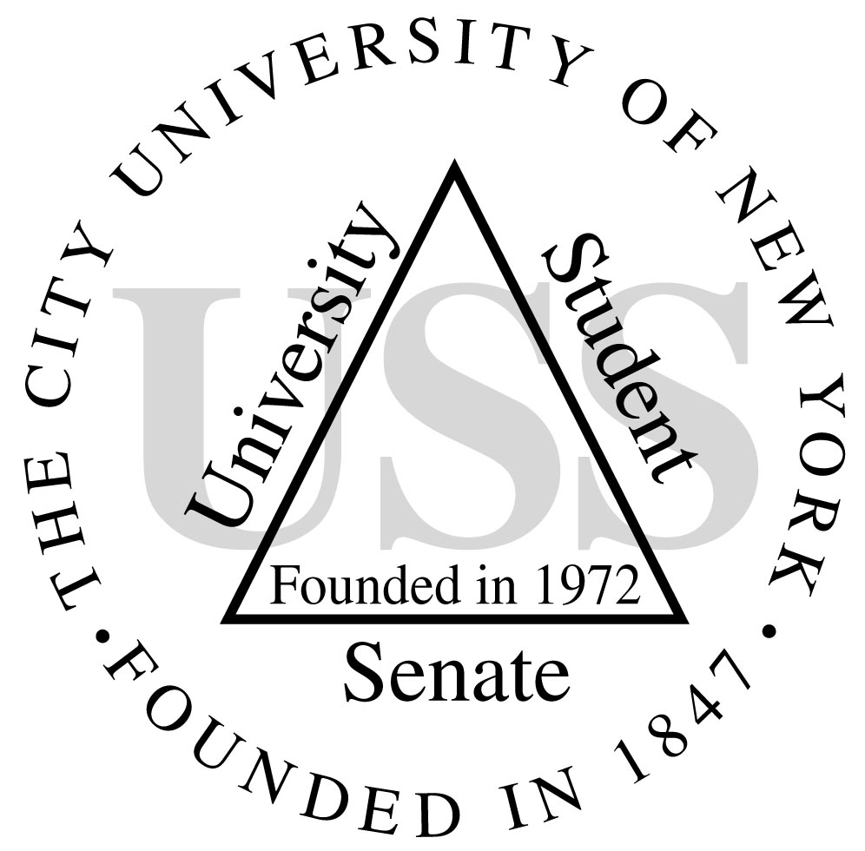

UNIVERSITY STUDENT SENATE

The 2012 USS Donald and Mary Ellen Passantino

International Students and Students with Disabilities Scholarship

and the Ernesto Malave Merit Scholarship

Application Packet

Overview:
Established in 1995 by the University Student Senate of the City University of New York, the USS Merit Scholarship was renamed the Ernesto Malave Merit Scholarship in 2010. The scholarship awards one student per campus, per academic year for demonstrating outstanding academic and leadership performance under extraordinary circumstances.

In 2003, the University Student Senate of the City University of New York established the Donald & Mary Ellen Passantino Scholarship; which was renamed the USS Donald and Mary Ellen Passantino International Students and Students with Disabilities Scholarship in 2010. The scholarship recognizes international students and students with disabilities who have demonstrated outstanding scholarship and enthusiastic leadership and service under extraordinary circumstances. Two students per campus, per academic year are awarded the scholarship.

USS requests that each campus sends four (4) candidates for the Ernesto Malave Merit Scholarship and four (4) candidates for the Don and Mary Ellen Passantino Scholarship. USS will award one (1) Ernesto Malave Merit Scholarship per campus in the amount of $1,000.00, which will be paid in one disbursement. USS must also award one (1) Passantino Scholarship to an international student and one (1) Passantino Scholarship to a student with a disability, per campus in the amount of $500.00 each.

Procedures

- The USS Scholarship Committee is required to distribute an application packet that includes 1) procedures, 2) application and, 3) a Declaration Form verifying the applicant’s GPA and credit/enrollment information. Applications for this year are available on individual campuses at an office designated by the Chief Student Affairs Office.

- The President of each college, the Chief Student Affairs Administrators, the Office of Student Life, the Office of Services for Students with Disabilities, and the Office of International Student Services are scheduled to receive all scholarship materials by the proposed filing date.

- The USS Scholarship Committee will notify all campus Student Affairs Offices of the specific deadline dates to file for all applications. No application will be accepted by the USS Scholarship Committee after said date. The filing period for applications is during the current semester. Applicants will be approved in the following semester and scholarships will be distributed the semester after . All completed applications are to be submitted to the campus Office of Student Affairs. Applicants can apply to only one scholarship per academic year (either the Ernesto Malave Merit Scholarship or the Don and Mary Ellen Passantino Scholarship).

- The Chief Student Affairs Officer of each college campus will oversee the application and selection process by forming a committee that consists of an existing honors/scholarship committee or a specific scholarship review committee that includes two staff, two faculty members, and four student representatives.

- The appointed committee members must verify GPA and enrollment information of all applicants before selecting finalists. The committee is responsible for forwarding the names to the Chief Student Affairs Administrator or designee at each college. In addition, extracurricular activities, community work, and essay should be used in support of, but not in place of the academic criteria.

- The Chief Student Affairs Administrator, or designee, will submit the applications of the selected finalists to the USS Scholarship Committee. Submissions received later than the deadline will be returned to the campus Chief Student Affairs Administrator or designee.

The Chief Student Affairs Administrator or designee shall send the complete finalist applications and necessary documentation to:

The Office of Student Affairs
USS Scholarship
101 West 31st Street, 12th Fl.
New York, NY, 10001

- Once the applications of the finalists are received, the USS Scholarship Committee and key staff of the Central Office of Student Affairs must confirm that the selected students are eligible to receive the scholarship. If any applications are received with ineligible applicants, said applications will be returned to the college’s Chief Student Affairs Administrator.

- The President of each college, the Chief Student Affairs Administrators, the Office of Student Life, the Office of Services for Students with Disabilities, and the Office of International Student Services will receive a list of scholarship-winners via e-mail once decisions have been made. Final decisions are expected to be declared by the spring semester.

- Subsequently scholarship award letters will be sent to the winners. The scholarships will be presented to recipients at a USS scholarship awards dinner, which will take place at a formal reception, at a place and time to be announced.

- USS delegates and alternates are not eligible to apply for any USS sponsored scholarship. If any scholarship recipient subsequently becomes a USS delegate or alternate after being nominated for a scholarship and all criteria are met, scholarship disbursement will not be withdrawn.
- Any applicant, who does not abide by all scholarship terms and conditions, will forfeit their scholarship.

- A “suspension” period, which will allow scholarship recipients to suspend the disbursement of scholarship funds for reasons of health, family crisis, etc., may be requested as needed. The scholarship recipient must notify the USS Administrative Office as soon as possible before the award ceremony, of intention to “suspend” said disbursement. The suspension period may not exceed twelve (12) months. Any unclaimed scholarship funds will remain in the USS scholarship account.

THE FOLLOWING CRITERIA MUST BE MET BY ALL APPLICANTS IN ORDER TO BE CONSIDERED FOR ANY USS Scholarship:

- During the current semester in which he/she applies for a scholarship, applicants shall be matriculated students, in active attendance:

- Undergraduate applicants must be registered for a minimum of six (6) credits.

- Graduate applicants must be registered for a minimum of three (3) credits.

- Applicants shall also meet the same requirements during the semester which the scholarship is awarded. Therefore, graduating seniors are not eligible.

- Students who meet the above registration criteria and are fulfilling internship requirements, but are not in active attendance on their campuses, are still eligible.
- Undergraduate applicants must have already completed a minimum of twenty-four (24) credits and no more than eighty (80) credits at a CUNY college.

- Graduate applicants must have completed a minimum of six ( 6) credits at a CUNY college and no more than twenty-four (24) credits total. Students of graduate or professional programs with credits requirements of more than 30 credits must have completed a minimum of 12 credits and no more than 80% of the credits required for a degree. (For example, if 90 credits are required for a degree, the student must have no more than 72 credits completed to be eligible.)

- Applicants from The CUNY School of Law must include a letter from the Chair of the Scholarship Committee validating that their GPA meets the requirement of the scholarship being applied for. Additionally the letter should explain why the GPA does not appear on the transcript and should describe how first semester grades will appear.

For example: I certify that, at the end of the semester, the student’s GPA exceeds 3.5 cumulative. CUNY School of Law does not calculate class rank or publish a student’s cumulative grade point average. In addition, the first semester grades appear on transcripts as “CR” for all passing grades (A, A-, B+, B, B-, C+, C, C-, and D) or “NC” if the student has failed the course.

- All applicants must be permanent residents, citizens, or NYC residents to apply for any USS scholarship (the only exception being international students).

Each Application Must Be Accompanied By:

- Two letters of recommendation indicating evidence of good character, academic achievement, and/or service to the community. At least one of the letters must be from a CUNY faculty member.

- Two original, typed, personal essays of no more than three hundred words each:

- Three hundred (300) words stating why you would benefit from this scholarship and how do you believe you have earned it?

- Three hundred (300) words stating your field of interest, current projects, future plans, etc.

- Resume

- An official letter verifying enrollment of the current academic year.

- An official transcript (first semester graduate students must include both graduate and undergraduate transcripts).

- Bursar receipts for the current and upcoming semesters.

- A signed Declaration Form that will enable the college Chief Student Affairs Administrator to verify the applicant’s GPA and credit/enrollment information.

Additional Requirements for International Students:

- International students must be in valid F-1 or J-1 immigration status during the semester in which they are applying for the scholarship, and during the semester in which the scholarship is awarded.

- International students are required to maintain full-time credit and course-loads.

- The following documents must accompany their application packet:

- I-20
- A copy of the F1 Visa
- A copy of the I-94 Card
- A letter of verification from the International Student Advisor.
- Form RF 702 * (which can also be found at: http://www.uss.cuny.edu/opportunities/rf-702.pdf )
- Form W-8BEN * (which can also be found at: http://www.irs.gov/pub/irs-pdf/fw8ben.pdf )

* Both forms can be found attached to the application or at the links posted above.

Additional Requirements for the USS Donald and Mary Ellen Passantino International Students

and Students with Disabilities Scholarship:

Only undergraduate and graduate students with disabilities and/or international students are eligible.

- Applicants to the USS Donald and Mary Ellen Passantino International Students and Students with Disabilities Scholarship must have attained a minimum grade point average of 2.5.

- For students with disabilities, applications shall be accompanied by a letter of verification from the college’s Director of Disability Services.

Additional Requirements for the Ernesto Malave Merit Scholarship:

Applicants to the Merit Scholarship must have attained a 3.5 GPA average

The 2012 USS Donald and Mary Ellen Passantino

International Students and Students with Disabilities Scholarship

and the Ernesto Malave Merit Scholarship

Application

INSTRUCTIONS

- Filing period is during the spring semester. All completed applications are to be submitted to the office of Chief Student Affairs Administrator of your campus by March 16th 2012.
- Only typed or legibly printed application forms will be considered.
- All essays must be typed.
- One application per person.
- Incomplete applications will not be considered.

Please indicate which scholarship you are applying for:

- The Don and Mary Ellen Passantino Scholarship (for INTERNATIONAL students)
- The Don and Mary Ellen Passantino Scholarship (for students with DISABILITIES)
- The Ernesto Malave Merit Scholarship

I. PERSONAL DATA

Name: _______________________________________________________________________________
Last Name First Name Middle Name

Mailing Address: ______________________________________________________________________

______________________________________________________________________

Telephone Number(s): ___________________________________________________________________

Email: _____________________________________________________________________________

Social Security Number or Student Identification Number: _____________________________________

II. ACADEMIC INFORMATION

Current College: ______________________________________________________________________

Matriculation / degree program: _________________________________________________________

Current college attendance dates: ________________________________________________________

Total credits needed to complete degree: _______________________________________

Number of credits you are currently enrolled for (current semester): _________________

Number of credits you plan to take in the spring semester: _________________________

Number of credits earned towards your degree (including current fall semester):
________________________________________________________________________

Grade Point Average: _______________________________________________________

III. FINANICIAL ASSISTANCE INFORMATION:

Please state any other type of scholarships or financial assistance from any other sources you have received this semester: If none please leave blank.

Scholarship/Financial Aid | What Type? | Amount
(Example) CUNY Scholarship | CUNY Leadership Award | $200.00

If more space is needed, please add an additional page.

IV. PERSONAL ESSAYS:

Include two typed original essays of no more than three hundred words each:

- Three hundred (300) words stating why would you benefit from this scholarship and how do you believe you have earned it?

- Three hundred (300) words stating your field of interest, current projects, future plans, etc.

V. RESUME:

Please attach your resume to the application.

VI. DOCUMENTATION:

Each international student application must be accompanied by:

- I-20
- A copy of the F1 Visa
- A copy of the I-94 Card
- A letter verifying eligibility from the International Student Advisor.
- Form RF 702 * (which can also be found at: http://www.uss.cuny.edu/opportunities/rf-702.pdf )
- Form W-8BEN * (which can also be found at: http://www.irs.gov/pub/irs-pdf/fw8ben.pdf )

* Both forms can be found attached to the application or at the links listed above.

Each application for students with disabilities must be accompanied by:

- A letter verifying eligibility from the Director of Disability Services.

Each application from The CUNY School of Law must be accompanied by:

- A letter from the Chair of the Scholarship Committee validating that their GPA meets the requirement of the scholarship being applied for. Additionally the letter should explain why the GPA does not appear on the transcript and should describe how first semester grades will appear.

VII. DECLARATION FORM:

SCHOLARSHIP WAIVER

I, __________________________________________________________, agree to permit access to all my registrar and bursar records that may be needed to verify eligibility for the Ernesto Malave Merit Scholarship or the University Student Senate Donald and Mary Ellen Passantino International Students & Students with Disabilities Scholarship.

Only the Chief Student Affairs Officer and key staff of the Central Office of Student Affairs, or designee, may have access to this information.

___________________________________ __________________
Applicant Signature Date

APPLICANT’S DECLARATION

I, __________________________________________________________, declare that the information contained in this application is accurate and that I have not knowingly or willfully made false statements, or omitted information in connection with this application. I am well aware that if this information is found to be false or misleading, my application will be rejected and not considered for review.

___________________________________ __________________
Applicant Signature Date

CHECKLIST

The following is a list of items necessary to complete the application for a USS scholarship. It is important that the applicant submit all the documentation required in order to ensure proper completion of application.

- Application

- 2 Letters of Recommendation

- 2 Personal Essays

- Resume

- An official letter verifying enrollment of the current academic year.

- An official transcript (first semester graduate students must include both graduate and undergraduate transcripts).

- Bursar receipts for the current spring and upcoming fall semesters.

- Signed Declaration Form

FOR INTERNATIONAL STUDENTS ONLY

- I-20

- A copy of F1 Visa

- A copy of I-94 Card

- A letter verifying eligibility from your college International Student Advisor

- Form RF 702 (which can also be found at: http://www.uss.cuny.edu/opportunities/rf-702.pdf )

- Form W-8BEN (which can also be found at: http://www.irs.gov/pub/irs-pdf/fw8ben.pdf )

FOR STUDENTS WITH DISABILITIES ONLY

- A letter verifying eligibility from your college Director of Disability Services

FOR GRADUATE STUDENTS ONLY

We will require a copy of your degree audit. (For next year’s applications)

Submit completed application to your campus Chief Student Affairs Administrator.

