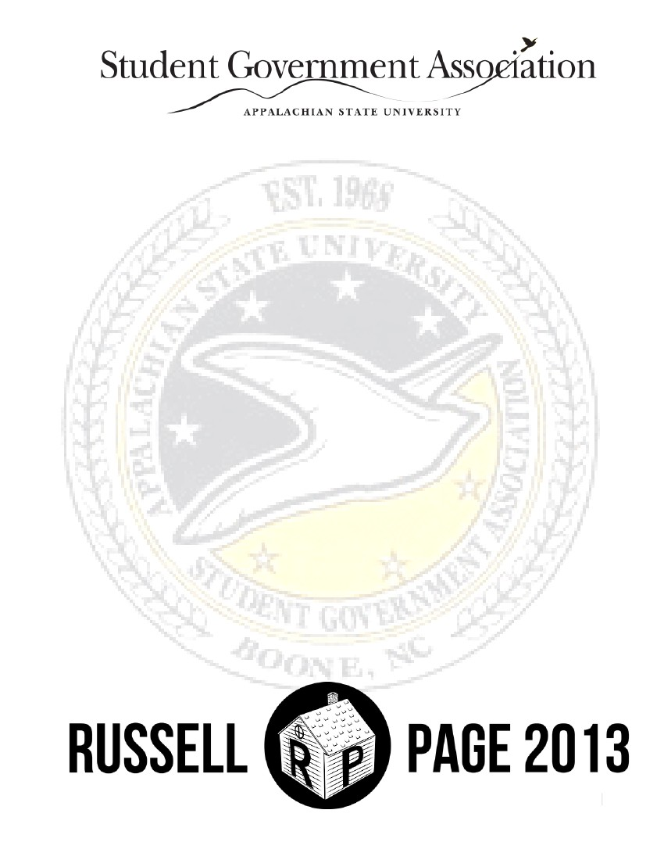
SGA CABINET REPORT
APPALACHIAN STATE UNIVERSITY
THE RUSSELL-PAGE ADMINISTRATION
IN THIS THE 47TH SESSION OF THE
STUDENT GOVERNMENT ASSOCIATION
1

STUDENT GOVERNMENT ASSOCIATION APPALACHIAN STATE UNIVERSITY
47th SESSION, 2013-2014
Table of Contents
Welcome
President and Vice President
Cabinet
Delegated Platform
President’s Update
Vice President’s Update
Chief of Staff Update
Treasurer’s Update
Secretary’s Update
External Affairs Update
Academic Affairs Update
Legislative Operations Update
Campus Outreach Update
Sustainability Update
Cultural Affairs Update
Marketing Update
Student Affairs Update
Elections Update
Proclamation – Gun Bill
Letter of Concern – Gun Bill
Letter of Concern – Board of Elections
3
4
5
7
9
16
19
21
23
25
27
28
30
32
34
37
40
43
44
46
47
2

STUDENT GOVERNMENT ASSOCIATION APPALACHIAN STATE UNIVERSITY
THE OFFICE OF THE STUDENT BODY PRESIDENT
Hello Mountaineers,
On behalf of the Russell-Page administration of the Student Government Association, we are thrilled to
present you with our Fall Semester Report. Michael and I ran off of an idea and a promise – we pledged to
bring the student body of Appalachian back home. Our platform was unique in the fact that the student body
created it. We sought out the ideas of thousands in order to create a platform that promoted a better
Appalachian.
We have listened to these concerns and we firmly believe that in every situation we have responded
diligently, accordingly and appropriately. Our number one priority has been to advocate for the wants,
needs, and desires of the student body.
However, changes are coming to this place we call home. Changes from the General Assembly,
administrative changes, and the restructuring of this Student Government Association. Home is about to be
radically different. Now more so than ever, the student body will be looking towards leaders to bring them
home. That is where our administration takes great pride. Throughout the past academic year our
administration has tried to provide leadership to the student body of Appalachian.
We take great pride in our accomplishments! We sincerely hope you will be proud of all the work that the
Russell-Page administration has accomplished this past year. This report is an update from each of the
cabinet members to the student body. It is the Cabinet’s responsibility to support and assist the President and
Vice President in their endeavors for the academic school year. We hope you are proud of the ways in which
we have made Appalachian feel more like home!
With Unending Black and Gold Pride,
G. Dylan Russell
Student Body President
Student Government Association
3

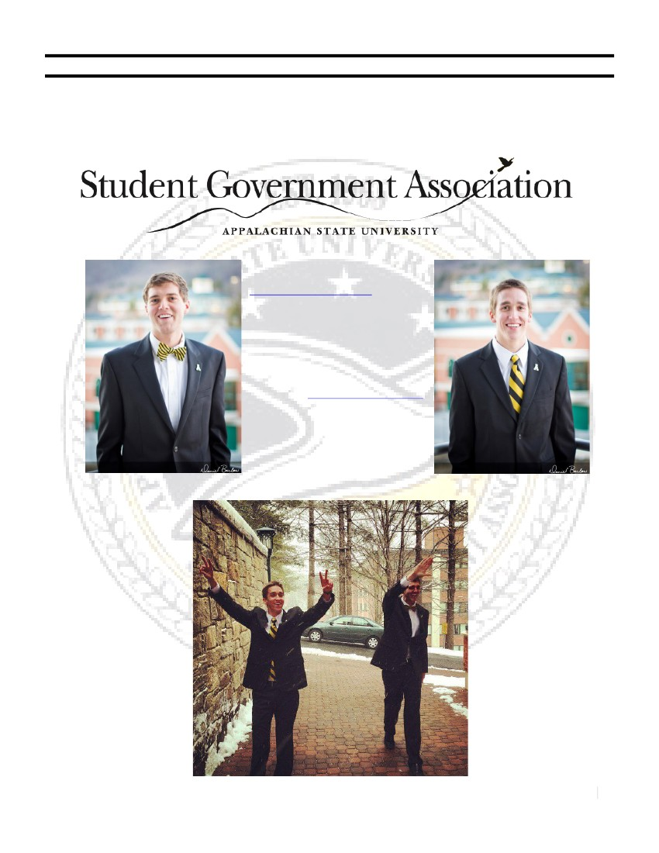
STUDENT GOVERNMENT ASSOCIATION APPALACHIAN STATE UNIVERSITY
THE PRESIDENT AND VICE PRESIDENT
of the
President G. Dylan Russell
russellgd@appstate.edu
(828) 964-3144
Education
Hometown: Boone, NC
Vice President Michael J. Page
pagemj@appstate.edu
(336) 337-0479
Finance and Banking
Hometown: Greensboro, NC
4

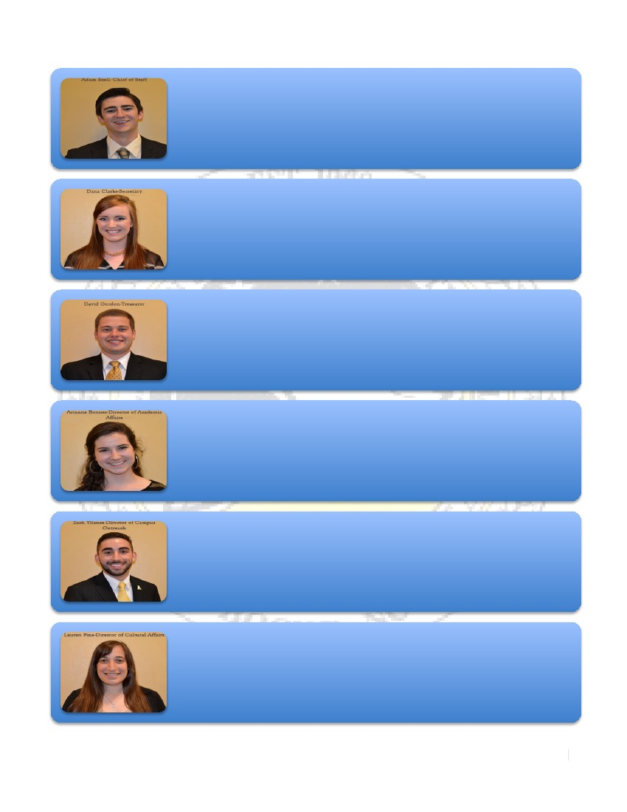
The Cabinet of the Russell-Page Administration 2013 – 2014
Adam S. Ezell - Chief of Staff (Executive Branch)
ezellas@appstate.edu
(828) 964-3144
Public Administration
Hometown: Boone, North Carolina
Dana M. Clarke – Secretary (Executive Branch)
clarkedm@appstate.edu
(919) 412-8446
Public Relations
Hometown: Wake Forest, North Carolina
David B. Gordon - Treasurer (Executive Branch)
gordondb@appstate.edu
(704) 301-9459
Finance and Banking, Risk Management and Insurance
Hometown: Charlotte, North Carolina
Arianna C. Bonner - Director of Academic Affairs (Legislative Branch)
bonnerac@appstate.edu
(704) 996-2640
History, Secondary Education
Hometown: Huntsville, Alabama
Zachary Yllanes - Director of Campus Outreach (Executive Branch)
yllanesz@appstate.edu
(919) 802-4830
Risk Management and Insurance
Hometown: Holly Springs, North Carolina
Lauren H. Fine - Director of Cultural Affairs (Legislative Branch)
ﬁnelh@appstate.edu
(704) 778-7663
Communication Studies
Hometown: Charlotte, North Carolina
5

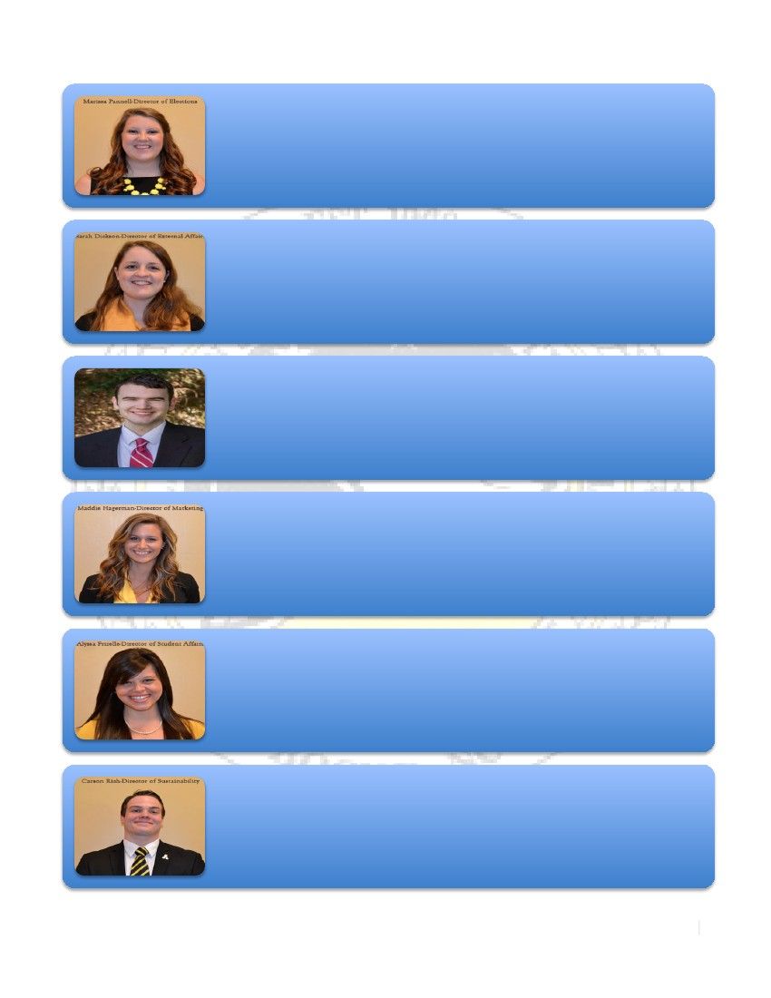
The Cabinet of the Russell-Page Administration 2013 – 2014
Marissa L. Pannell - Director of Elections (Legislative Branch)
pannellml@appstate.edu
(828) 964-3144
Business Management - Human Resources
Hometown: Boone, North Carolina
Sarah R. Dickson - Director of External Affairs (Executive Branch)
dicksonsr@appstate.edu
(704) 618-3598
Communication Studies
Hometown: Charlotte, North Carolina
Jon Secrest- Director of Legislative Operations (Legislative Branch)
secrestjc@appstate.edu
(336) 624-3017
American Politics, Economics
Hometown: Winston Salem, NC
Maddie G. Hagerman - Director of Marketing (Executive Branch)
hagermanmg@appstate.edu
(704) 773-6041
Advertising
Hometown: Charlotte, North Carolina
Alyssa Frizzelle - Director of Student Affairs (Legislative Branch)
frizzelleta@appstate.edu
(336) 260-8503
Business Management - Entrepreneurship
Hometown: Burlington, North Carolina
Carson D. Rich - Director of Sustainablity (Legislative Branch)
richcd1@appstate.edu
(980) 253-5037
Theatre Performance, Film Studies
Hometown: Weddington, North Carolina
6

STUDENT GOVERNMENT ASSOCIATION APPALACHIAN STATE UNIVERSITY
47th SESSION, 2013-2014
Delegated Platform Goals
Each Cabinet Member
Students are emailed what their respective senator is working on and how they voted through the
Glass Door Campaign
Campus Outreach
Senators and Cabinet members would visit clubs and organizations to gather information on a
regular basis, as well as let these clubs know the current direction of SGA. Shared with the
Secretary
Ensure a sustainable and safe beeper system
Looking into the plausibility of Club Storage
Secretary
Senators and Cabinet members would visit clubs and organizations to gather information on a
regular basis, as well as let these clubs know the current direction of SGA. Shared with the
Director of Campus Outreach
Students are emailed what their respective senator is working on and how they voted through the
Glass Door Campaign → A bi-weekly newsletter
Legislative Operations
Reforming of Senator Research
Successful implementation of iClickers
Student Affairs
Implementation of a smartphone “Lifeline App” to ensure student safety
Better salting of roads especially on Bodenheimer and near Mountaineer
Improving counseling services and mental health at Appalachian
Printers in Residence Halls
Sustainability
Elimination of Styrofoam
Continuation of the EcoBox
Implementation of human-powered transportation
Eliminating plastic bags
Expansion of food labeling and options including Gluten-Free, Kosher, Halaal, and Vegan options
shared with Cultural
7

Treasurer
Coffee Kiosk at Raley Hall and West-Side
Cultural Affairs
Extend ASUnity towards Gender Neutral Housing
Support of multicultural clubs on campus
Expansion of food labeling and options including Gluten-Free, Kosher, Halaal, and Vegan options
shared with Cultural
Elections
Amend the Elections By-laws
Stay at maximum capacity for Senate
External Affairs
Transportation for APH Residents
An Ex-Officio Seat on Appalachian’s Board of Visitors
Marketing
Increase transparency through a newsletter to admin and student body
Academic
Making classrooms paperless. Submitting assignments online
24/5 Library Hours
Tech Services Expansion - expand Wi-Fi and Appalnet/ASULearn smartphone app
Student to sit on Faculty Senate’s committee of Welfare of Students
8

STUDENT GOVERNMENT ASSOCIATION APPALACHIAN STATE UNIVERSITY
47th SESSION, 2013-2014
STUDENT BODY PRESIDENT
PRESIDENT G. DYLAN RUSSELL
EMAIL: RUSSELLGD@APPSTATE.EDU  CELL: (828) 964-3144  OFFICE: 215 A, PLEMMONS UNION
The Executive Branch of the Student Government Association
OVERVIEW OF RESPONSIBILITIES
The Student Body of Appalachian State University elects the Student Body President. It is the President’s
responsibility to provide leadership to the general student body, and act as an upholder of the Student Bill of
Rights, as articulated in the Student Government Constitution. The Student Body President also provides
leadership and serves as the Chair of the Executive Branch of the Student Government Association.
My specific duties include signing or vetoing legislation passed through the Student Senate within 10 days of
passing, forwarding all passed legislation to the appropriate administrator, presenting a “State of the
University” address, presenting a progress report to the Student Senate on each piece of legislation,
university committee appointments, and serving as a voting member on the Board of Trustees. Once a
month, I travel the state and serve as a delegate for the Association of Student Governments and sit on the
Council of Student Body Presidents. The Chancellor (Dr. Kenneth Peacock) has appointed me to serve on
the Chancellor Search Committee.
It has been an extreme honor and privilege to serve in this unique leadership position. The more time I
spend interacting with the students, the administration, and the community – the more I can’t help but fall in
love with Appalachian. I have spent the first half of my administration being very externally focused and
driven. During the remaining months of my presidency, I look forward to focusing on internal issues and
continuing to advocate for the student body.
BOARD OF TRUSTEES
It has been a true honor and blessing to serve alongside the members of the Board of Trustees. So far, I
have attended two Board meetings.
At the meeting in June we discussed:
- the Strategic Plan (to be voted on by the BOT)
- the successful completion of the SACS accreditation process
- leasing the roof of Garner Hall for the installation of a cell phone tower
- Alcohol Summit Report
- University Housing Analysis (surplus of housing in Boone)
- The Appalachian Campaign
At the meeting in September we discussed:
- Enrollment Management (the highest enrollment in the history of the University)
- Bids for the demolition of Winkler Residence Hall
- Borrowing and reimbursing for Belk Residence Hall
- The International Solar Decathlon
- Adoption of the University’s Mission Statement
- Program Prioritization
The biggest challenges that our administration faces with the Board of Trustees will be advocating for
9

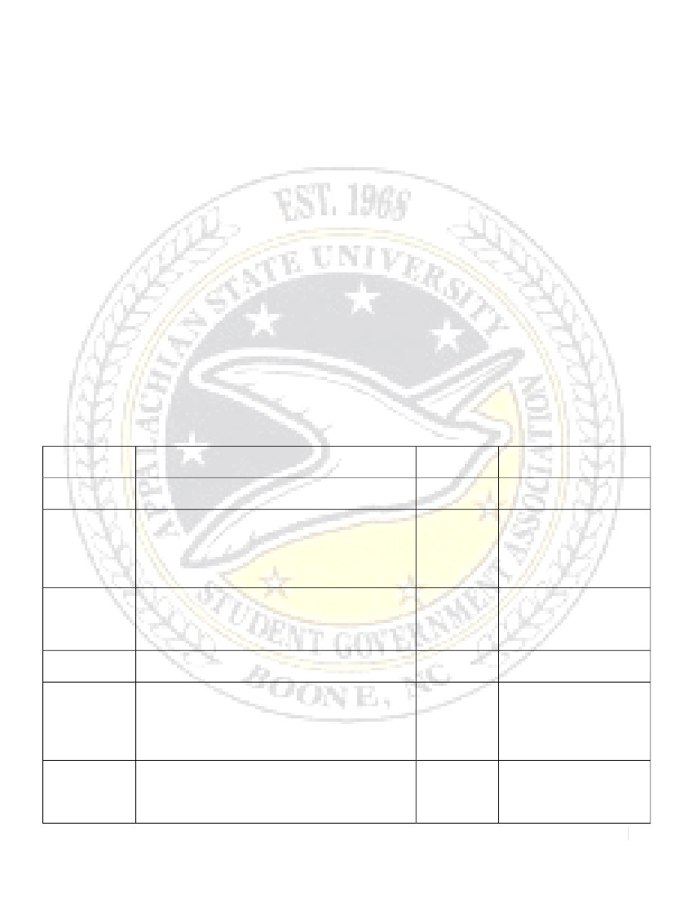
the library’s operational hours to be restored to 24/5, as well as providing the students a voice during
program prioritization.
CHANCELLOR SEARCH COMMITTEE
This past semester I was nominated to serve as the only student representative on the Chancellor
Search Committee. It is my duty and responsibility to represent the undergraduate and graduate student
body in regard to selecting the next Chancellor of Appalachian. I take this task very seriously, our Chancellor
is beloved by all and it is imperative that his replacement be another individual who loves Appalachian as
much as Dr. Peacock. In order to solicit student opinion during the process we hosted a Chancellor Search
Student Forum. Many members on the Committee reported that the student forum was the most
enlightening about what qualities and characteristics the next Chancellor of Appalachian needs to embody.
Our administration also led a social media campaign to garner student input and feedback.
Currently, we are waiting for the search committee to select candidates for our interviews to take place
in January. I defend the Committee’s decision to hold a closed search process for it is my intention to bring
the top candidates to this university. I believe the best candidates are those who are not looking to leave their
current home institutions, therefore a closed search helps give the candidate a push to see what we are about
here at Appalachian. While I am the only student on the committee, it is my full hope and intention to
continue to solicit not only student input, but faculty and administration input as well (specifically among the
Colleges that feel marginalized for not having direct representation (Music, Education, Fine and Applied
Arts)). The Committee will name three individuals and then send those three individuals to be vetted through
the Board of Trustees. The Trustees will then approve or disapprove the three candidates and send them to
President Ross. President Ross will then select and hire (with the approval of the Board of Governors) the
next Chancellor of Appalachian State University.
LEGISLATION PASSED BY THE STUDENT SENATE

SB 047-001 AN ACT TO ESTABLISH THE 2014 SGA
PRESIDENT AND VP ELECTION DATES
SB 047-002 AN ACT TO ESTABLISH THE 2014 SGA
SENATORIAL ELECTION DATES

SB 047-003 AN ACT TO ESTABLISH THE
INSTALLATION OF ANIMAL DISPOSAL
STATIONS
SB 047-004
AN ACT TO ENCOURAGE
INSTRUCTORS TO CANCEL MIDDAY
CLASSES ON ELECTION DAY TO
PROMOTE CIVIC ENGAGEMENT

AN ACT TO CHANGE THE LIBRARY
REFERENDUM VOTING TIMELINE

AN ACT TO MAKE THE
REPRESENTATION OF ACADEMIC
COLLEGES EQUAL ACROSS CAMPUS BY
GIVING THE HONORS COLLEGE SEATS
IN STUDENT GOVERNMENT

AN ACT TO GIVE THE HONORS
COLLEGE EQUAL REPRESENTATION
ON THE DEAN’S COUNCIL
Passed by
Senate

Passed By
Senate
Passed By
Senate
Signed and acted upon
by SGA President

Signed and acted upon
by SGA President
Signed and acted upon
by SGA President
(Communication with
the Administration and
Physical Plant)

Signed and acted upon
by SGA President (Sent
to the Provost and
Faculty Senate Chair)

Signed and acted upon
by SGA President

Signed and acted upon
by SGA President,
referred to Elections to
establish Referendum
Dates

Vetoed by SGA
President, due to outside
interest of Student Body,
overstepped boundaries,
10
Passed by
Senate
Passed by
Senate

Passed by
Senate
SB 047-005
SB 047-006
SB 047-007
Passed by
Senate

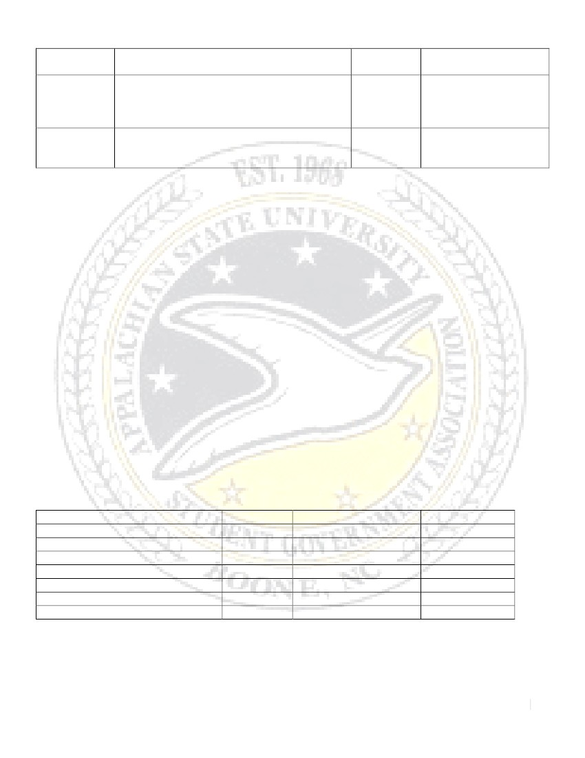
SB 047-008
AN ACT TO SUPPORT THE CREATION
OF A BIKE CENTER ON THE CAMPUS OF
APPALACHIAN STATE UNIVERSITY
AN ACT TO EXTEND THE VOTING
PERIOD FOR THE 24/5 LIBRARY
REFERENDUM
Passed by
Senate
Passed by
Senate
no conversation with the
administration
Signed and acted upon
by SGA President,
referred to Sustainability
and Director Moody

Signed and acted upon
by SGA President
SB 047-011
TUITION AND FEES
As Student Body President, it is my responsibility to appoint three other individuals to serve on the
Tuition and Fees committee with myself. I appointed the Vice President (Michael Page), the Treasurer
(David Gordon), and the Director of Elections (Marissa Pannell) to the committee. The Chancellor then
approved my appointments. The reason I appointed these individuals was because of their strong
background in business. I firmly believe that these appointments were diverse enough to represent as many
students as possible in conversation. There will be no increases in Tuition as mandated by President Tom
Ross.
Barry Sauls presented for the Transportation fee. The current fee is $105.00 and a $9.00 increase was
requested. The increase in funding to AppalCART will provide for the following services. $96,600 to add a
second bus on the Teal Route. This route primarily serves The Cottages of Boone, and as that complex
approaches capacity, the one bus running currently will be completely overwhelmed, resulting in students
being left behind. $20,703 is the University’s portion of the local capital match to purchase three (3)
replacement buses for aging vehicles. $19,040 to add two (2) operating hours each day to the State Farm
Shuttle. Route will begin at 730am instead of 930am.
Charlie Cobb presented for the Athletic fee. The Athletics General fee is currently $665.00 and a
$33.00 increase was requested. This will be utilized to help cover several items in the operating budget such
as an inflationary increase of existing scholarship costs ($225,000), new sales tax on meal plans ($25,000),
anticipated State staff salary increases ($125,000), additional student seating at football games ($50,000), and
to assist with increased costs of team travel ($100,000).
The Athletics Debt Service fee is currently $147.00 and a $33.00 increase was requested. This will
replace the existing revenue from the club seats and suites, which will allow for a more stable funding model
and use that revenue to enhance needed athletic projects. Bond rating agencies are more comfortable with a
revenue stream from fees as opposed to more uncertain gate receipts. ASU currently has an Aa3 rating from
Moody’s.
FeeIncreaseTotalVote

Education and Tech Fee $6.00 $495.00 Unanimously
Athletics General Fee $33.00 $665.00 Pass 10 to 1
Ed, Rec, REI Fee $10.00 $358.00 Unanimously
Athletics Debt Service Fee $33.00 $180.00 Unanimously
Housing Fee $170.00 $4,170.00 Unanimously
Food Services 5% Standard Plan - $2,150 Unanimously
Transportation Fee $9.00 $114.00 Unanimously

The General Fee increase was 2.4%. The increase was capped at 6.5% per the Board of Governors.
Using the standard plan amounts for Housing and Meals, the total increase was $531.00, which included a
$150.00 increase for the new sales tax legislation. For an undergraduate resident student, the total increase is
4.1% including the sales tax effect and 2.91% excluding the sales tax effect.
ASSOCIATION OF STUDENT GOVERNMENTS
11

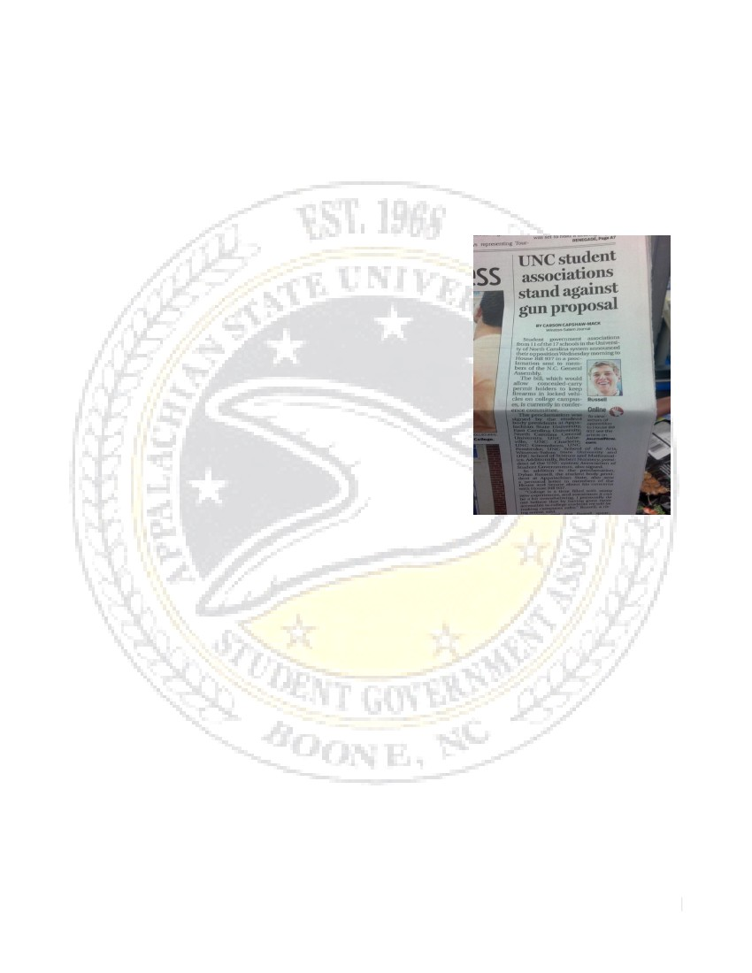
One of my duties and responsibilities is to attend the monthly meetings for the Association of Student
Governments. My first task was to appoint the Appalachian Delegation. I appointed the Vice President
(Michael Page), the Chief of Staff (Adam Ezell), and the Director of External Affairs (Sarah Dickson) as the
official delegates of Appalachian for ASG. The Treasurer (David Gordon) serves as the official proxy and
steps in when a delegate cannot attend a meeting.
I have sponsored and written several pieces of legislation passed by the General Assembly at ASG. The
resolutions passed have all been the Association taking a proactive stance to the negative changes occurring
to higher education and to the state of NC.
Despite the questions of the effectiveness of the Association, I still believe that ASG is a good
organization and in today’s day and time – we need to do everything we can to stand together.
THE GUN BILL (HB 937)
Our administration responded to the actions of the ominous
gun bill by releasing a Proclamation drafted by our office and signed
by Student Body Presidents in the UNC System. Before our
administration released the Proclamation, we made several trips to
advocate for the safety of the students and express our concerns with
legislators. The Proclamation and Letter of Concern received
national attention, when the Winston Salem Journal picked the story
up, followed by The Associated Press. The Gun Bill set our
administration as a leading player in advocating not only for the
needs of the students of Appalachian, but of the entire UNC system.
While the Gun Bill ultimately passed, our administration sent a clear
message to legislators and set our administration as a leader within
the UNC System.
VOTER ID BILL
This summer, our administration also spent time trying to advocate on behalf of students in regard to
the Voter ID bill. Our actions included meeting with legislators and speaking with members of the press
against the bill’s decision to not allow our state issued campus ID’s to serve as valid means of Voter ID. While
the Voter ID bill ultimately passed, our administration with the support of ASG and several Senators are
working with legislators to adopt a uniformed policy in which campus identification cards will be distributed.
FEDERAL RELATIONS
During this past summer, Congress threatened to double the interest rates of loans from 3.4% - 6.8%.
Our administration responded by joining a coalition of over 100 Student Body Presidents (representing over
1 million students) from higher education all across the country. Our actions were featured in the Huffington
Post. The only other Student Body President to sign on within the UNC System was Christy Lambden (SBP
of UNC-CH).
STATE RELATIONS (PROVIDED BY UNCGA)
On July 26th, 2013, both the House and Senate adjourned for the year. The 2013 legislative session
saw a number of significant policy issues being discussed with the potential for wide-ranging impact on the
University. We saw a number of victories in Raleigh, but many of these victories were from playing defense.
Consistent with recent budgets, the University budget had higher levels of cuts compared to our
education peers. The University of North Carolina was cut by 4.7% (not adjusting for continuation growth),
while DPI and the community colleges faces cuts of under 2%. In the final budget, we had a number of
successes, such as:
- Fully-funding our continuation request, including enrollment growth
12

Fewer line-item cuts with significant Management Flexibility
Removed Facilities and Administrative “line-item” reporting requirement
Increased university research campuses authority on disposition by lease, which is important to our
research campuses
- Confining legislatively-mandated out-of-state tuition hikes to undergraduate students
- Authorization for the UNC School of the Arts and NC School of Science and Math to charge certain
fees
- $60m in Repair and Renovations funding
- Allowing “compensation increases” for retention and equity issues
- NC Guaranteed Admissions Program (NC GAP) was moved to a study from a $12.6m cut in 2014-
2015
We were not able to secure items in the budget, such as:
- In-state tuition for transitioning veterans
- $15m appropriation for the UNC School of Medicine
- Retain full $50m funding for the University Cancer Research Fund (UCRF)
Outside of the budget, we were able to secure wins on a number of legislative items. These include:
- Passage of S. 485 – E-commerce legislation
- Passage of S. 480 – UNC Capital Improvements Projects (as approved by the BOG)
- Passage of S. 547 – Energy Savings Contracting Amendments (amended to retain authorization to
self-perform at one campus and added another)
- Passage of H. 232 – State Health Plan compliance law, which saved the UNC System over $15m
- Stopped legislation to claim state-ownership over Intellectual Property created on state property
We also suffered a few legislative setbacks late in the session, including:
- Inclusion of Student Attorney legislation in the Regulatory Reform bill (H 94)
- Passage of Omnibus Gun legislation which allows concealed carry permit holders to bring guns onto
campus, which is opposed by all Chancellors and the campus Chiefs of Police (H 937)
COMMUNITY RELATIONS
During my time as Student Body President I have been asked to provide remarks and address the
community, faculty, and student body. I began the year by addressing the class of 2017 at the Black and
Gold Ceremony where I stressed the importance of clinging to our traditions despite change. I also addressed
the faculty at the annual faculty meeting where I spoke on what is the essence of an excellent education; I
received a standing ovation after my remarks to the faculty. I also was asked to be a keynote speaker at the
Walk for Awareness, where I spoke in honor and remembrance of one of my heroes, Mrs. Leigh Cooper
Wallace. I was also asked to deliver the keynote address at the LGBT’s annual Candlelight Vigil and speak
on the importance of the LGBT Center at their 10th year anniversary. Throughout the course of my time as
President I have also spoken with several college classes on civic engagement and leadership. I was the
keynote speaker at several Elementary Schools graduation in Watauga County Public Schools this past year
as well.
CIVIC ENGAGEMENT
During a press conference I was quoted saying the following: “any revisions to voting policies and
procedures should only serve to make voting more accessible and guarantee civic participation. We find this
issue to be deeply troubling. We study in our textbooks that the shared history of America is about the
expansion of democracy, the belief that each individual’s voice holds inherent and intrinsic value and it is our
moral duty to defend that.” Through this fundamental belief, our administration has responded diligently
and accordingly to restore the polling place back to campus.
After the announcement of moving and combining of the Boone polling place into one super precinct
our administration released a Letter of Concern to the State Board of Elections. The Chief of Staff, The
13
-
-
-

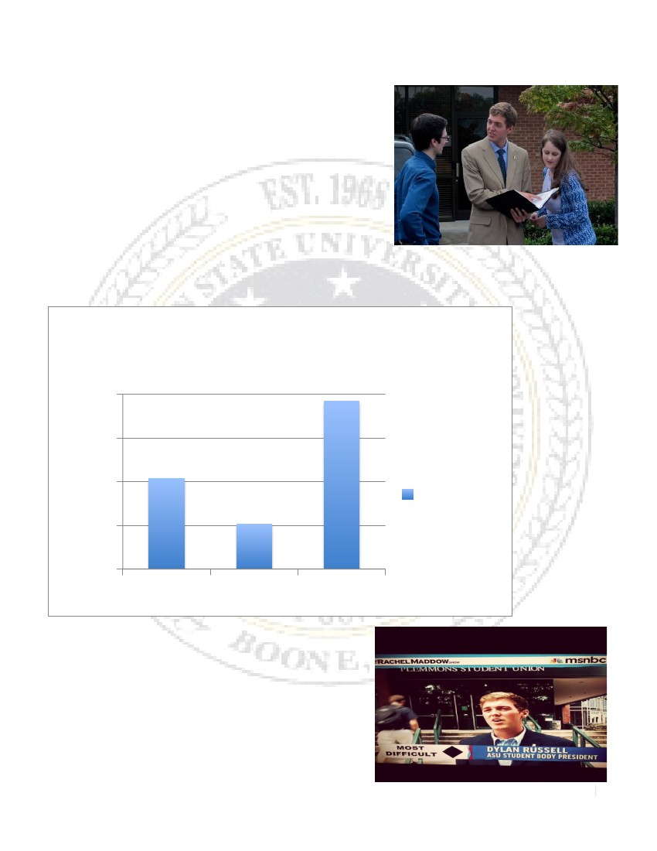
Director of External Affairs, and myself traveled to Raleigh to represent the students in front of the State
Board of Elections. After the Board hearing, our administration continued to advocate for the student body
with members of the Elections Board directly.

Our administration saw many successes in regard to civic
engagement at Appalachian State University. During the first
week of our voter registration drive; we successfully registered
close to 1,000 students (on top of the thousands of students
registered in correspondence with the College Republicans and
College Democrats during Freshmen Move-In). Our
administration ambitiously sought out a $7,000 grant from the
Association of Student Governments. We used the money to
purchase 2,000 megaphones, 1,000 t-shirts, publicity for election,
food for the polls and forum, and financial support to the
College Democrats and Republicans. We also hosted a Municipal Candidate Forum where all the candidates
up for election spoke directly to the concerns of the student body. The actions of our administration resulted
in an increase of voter turnout in the municipal election.
Voter
Turnout
Municipal
Elections
2000
1500
1000
500
0
2009
2011
2013
Votes
Cast
PRESS RECEIVED
The national and local media has featured our
administration on multiple occasions. Below is a non-
comprehensive list of the press that the Russell-Page
administration has received.
MSNBC – The Rachel Maddow Show
NBC News
The Associated Press
USA Today
14

The Huffington Post
CBS Atlanta
The San Francisco Gate
The San Francisco Chronicle
The Boston Herald
The Raleigh News and Observer
The Winston Salem Journal
The Charlotte Observer
The Watauga Democrat
The High Country Press
Campus Newspapers (Including The Technician, The Daily Tar Heel, The Appalachian, and more)
NC TV and News Stations (WBTV, WCNC, and more)
PERSONAL PERSPECTIVE
It has been an extreme honor and privilege to serve as the Student Body President of Appalachian
State University. This unique leadership position has challenged me in ways I could have never imagined. I
have tried to lead our University and Student Body through unchartered waters that were new to others and
me as well.
Besides learning about my leadership style, I have also been blessed to learn and discover more about
my character and resilience. Something that I take great pride in is our administrations ability to respond to
difficult situations. I firmly believe that when faced with adversity we have always responded by acting calm,
cool, and collected.
I have been extremely blessed by the relationships that I have been able to be a part of while serving as
President. Whether it is with Cabinet, Senators, Legislators, the Administration, or the Faculty, my life has
been touched by all of you. You have all provided a support network that has allowed for me to take risks
and feel the safety of your support. I am also indebted to the leadership of our SGA Advisors –Kim and
Jamar are incredible and have made this journey that much better.
When I was sworn in as the 47th President of this Student Government Association I said that I would
do everything in my power to act willingly, accordingly, and diligently to every concern that faces the student
body. I also promised the student body and myself that I would make Appalachian feel more like home. And
while we still have a lot of work to do next semester, but for the first time in a while, SGA is making
Appalachian feel more like home!
Hi Hi Yikas!
15

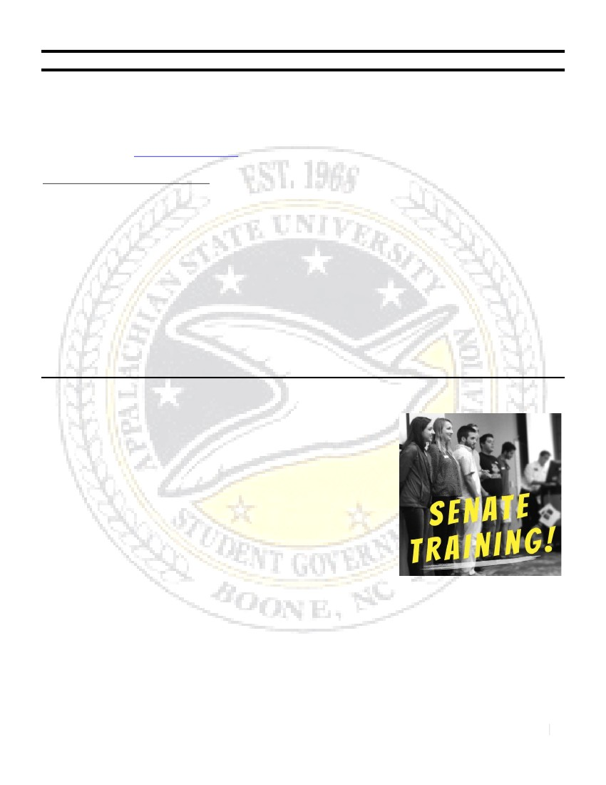
STUDENT GOVERNMENT ASSOCIATION APPALACHIAN STATE UNIVERSITY
47th SESSION, 2013-2014
STUDENT BODY VICE PRESIDENT
VICE PRESIDENT MICHAEL J. PAGE
EMAIL: PAGEMJ@APPSTATE.EDU  CELL: (336) 337-0479  OFFICE: 215 B, PLEMMONS UNION
The Legislative Branch of the Student Government Association
OVERVIEW OF RESPONSIBILITIES
As the Vice President of the Student Government Association, I have been elected by the undergraduate
student body along with the President, to serve as a commanding voice in student matters in the university
and community. My core responsibility as the Vice President is to serve as President of the Senate and to
carry out the duties of said position, as outlined in the Student Government Association Constitution. These
duties include overseeing the legislative branch, assuming role of the President in his absence, overseeing
recruiting and retention of Senators, and many more administrative duties.
In regards to the Student Senate, I chair our Senate meetings by following Robert’s Rules to Parliamentary
Procedures. I also assign and remove Senators from committees as deemed necessary, break tie votes on the
Senate, and have appointed and approved a Pro-Tempore, Parliamentarian, and Sergeant at Arms for the
current term. In addition, my duty is to forward all legislation to the President within three school days after
its passage.

UPDATE ON STUDENT SENATE
As of November 25, 2013, our Senate consists of 71 active
Senators who hold voting power in our Senate via iClickers. This has
been a great semester for our Senate so far. Recruitment and retention
has been very successful due to a few changes being carried out by the
Russell Page Administration. The new Director of Elections position has
enabled a revamping of recruitment in the fall followed by a streamlined
communication for following through with Senator Attendance. These
new communications include iClicker record-keeping, well-organized
google drives, one-on-one meetings with Senators, weekly reports on
attendance, etc. In addition, we filmed our senate training this year and
posted it to ASULearn with online quizzes in order to ensure that all
Senators, even late joiners, receive training on their role in SGA.
Looking ahead, next semester will include another push to recruit
Senators to finish out the semester. In addition, we’ll be looking for Senators to run in the new spring
elections for the fall 2014 term, as outlined in the SGA Constitution and in concordance with the Spring
2013 Senate Restructuring initiated by the Cox Barnes Administration. In addition, we’ll be looking for a
strong legislation push from our Senators, specifically for legislation they have been working tirelessly on to
fulfill the completion of the platform initiated by the student body.
SENATE SOCIAL EVENTS AND PROFESSIONAL DEVELOPMENT EVENTS
One aspect of SGA I have been leading this semester is the implementation of social programs and
professional development for our Senators. One of the most vital aspects to the success of SGA is the
commitment our Senators have to the organization. Recognizing their importance and providing
16

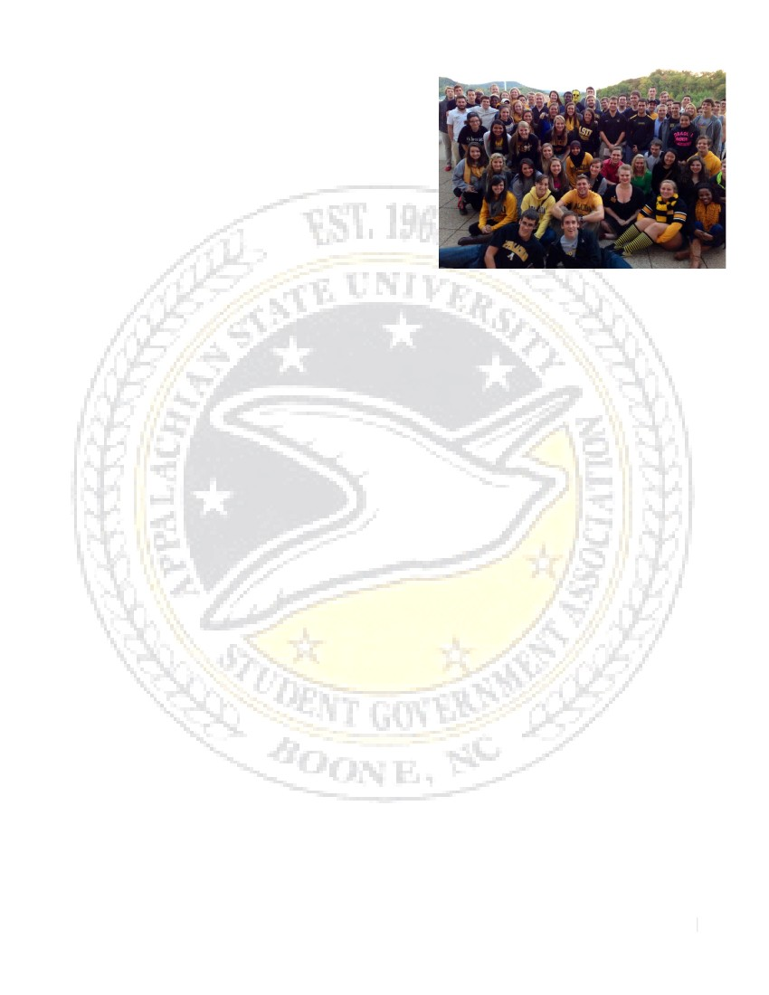
opportunities for them to be engaged has been a key part of
the fall semester. I organized a kick off social at Bo’s for all
Senators to attend. The President, myself, our Chief of Staff,
and another cabinet joined as well, and enjoyed battling the
Senators in some bowling and laser tag. During October,
David Gordon and I worked with the Department of
Athletics to allow SGA to hold Senate at the football
stadium. At this meeting, we convened in the football team’s
meeting room, spent time hearing from our Athletic
Director, and toured the stadium. To close out the fall
semester, all Senators interested will be meeting at
Appalachian Ski Mountain to enjoy some skiing and
snowboarding.
An important project for me this semester has been the implementation of professional development
for our Senators. For this initiative, I have implemented two professional development events for the fall
semester and two professional development events for the spring. The Senators are required by our
administration to attend at least one event in the fall and one event in the spring.
This fall, I worked on the first event with Cathy Bates, the University’s CIO, to bring her in to lead
on “Online Reputation Workshop.” At this event, Senators worked with google+, Facebook, LinkedIn, and
other social media platforms to build their online network. For the other event, I partnered with CSIL to
have our Senators attend the Appalachian Leadership Forum, which was an all-date event that included a
keynote speaker and various catered seminars on being an effective leader. After holding these events, I gave
out surveys to the Senators to gauge their effectiveness, and the responses have been very positive. Looking
towards next semester, I am excited to work with David Gordon, our Treasurer, on budgeting program and
we will pair with the department of finance to implement it. I am still working with the advisors to determine
what our final event will be in the spring. I look forward to announcing it to the Senate soon.
FALL SENATE BILLS
At this point in the semester, our Senate has passed nine bills on the floor. The titles and voting on these bills
is listed below:
SB 047-001: AN ACT TO ESTABLISH THE 2014 SGA PRESIDENT AND VP ELECTION
DATES
Passed: Favorable Votes: 58 Unfavorable Votes: 0 Abstentions: 1
SB 047-002: AN ACT TO ESTABLISH THE 2014 SGA SENATORIAL ELECTION DATES
Passed: Favorable Votes: 58 Unfavorable Votes: 0 Abstentions: 1
SB 047-003: AN ACT TO ESTABLISH THE INSTALLATION OF ANIMAL DISPOSAL
STATIONS
Passed: Favorable Votes: 41 Unfavorable Votes: 9 Abstentions: 4
SB 047-004: AN ACT TO ENCOURAGE INSTRUCTORS TO CANCEL MIDDAY CLASSES
ON ELECTION DAY TO PROMOTE CIVIC ENGAGEMENT
Passed: Favorable Votes: 47 Unfavorable Votes: 1 Abstentions: 4
SB 047-005: AN ACT TO CHANGE THE LIBRARY REFERENDUM VOTING TIMELINE
Passed: Favorable Votes: Unfavorable Votes: Abstentions:
SB 047-006: AN ACT TO MAKE THE REPRESENTATION OF ACADEMIC COLLEGES
EQUAL ACROSS CAMPUS BY GIVING THE HONORS COLLEGE SEATS IN STUDENT
GOVERNMENT
Passed: Favorable Votes: 38 Unfavorable Votes: 4 Abstentions: 2
SB 047-007: AN ACT TO GIVE THE HONORS COLLEGE EQUAL REPRESENTATION ON
THE DEAN’S COUNCIL
17

Vetoed by President: Favorable Votes: 37 Unfavorable Votes: 5 Abstentions: 2
SB 047-008: AN ACT TO SUPPORT THE CREATION OF A BIKE CENTER ON THE
CAMPUS OF APPALACHIAN STATE UNIVERSITY
Passed: Favorable Votes: 34 Unfavorable Votes: 9 Abstentions: 0
SB 047-011: AN ACT TO EXTEND THE VOTING PERIOD FOR THE 24/5 LIBRARY
REFERENDUM
Passed: Favorable Votes: 54 Unfavorable Votes: 0 Abstentions: 0
COMMITTEES AND ASSOCIATION OF STUDENT GOVERNMENTS
This fall, I have served on two specific committees and have also participated as a delegate
representing Appalachian State University in the Association of Student Governments. The Student Fees
Committee and The Media Board are the two committees I have worked on this semester. For Student Fees,
I sat as a student representative alongside SGA’s President, Treasurer, and Director of Elections. As a
committee, we reviewed the proposed fees for school year Fall 2014-Spring 2015 and voted to approve the
fees. In regards to the Media Board, I appointed Brittany Cabe, a SGA Senator, to serve alongside myself on
this board. The Media Board is chaired by Jamar Banks, the Director of CSIL. The goal of the board is to
meet and review and approve positions for the student media organizations. These positions up for approval
include the WASU Station Manager, Editor of The Appalachian, Editor of The Peel Magazine, and Business
Manager of The Appalachian. For the Association of Student Governments, I attended the session taking place
at North Carolina Central University and I also hosted the session that took place at ASU in November. At
these meetings I collaborated with other ASU delegates to vote on several bills. I also developed positive
relationships with other UNC system SGA members. Our SGA President and the other delegates will
expand more on the accomplishments of ASG this semester.
PERSONAL PERSPECTIVE
I would like to sincerely thank you for taking the time to read through our SGA Report for the Fall of
2013. It is the very interest you take in SGA that drives us to continue towards productivity and success as a
student organization. As you have read, it has been a challenging, but successful semester for the Russell-
Page Administration. Our Cabinet has been working diligently to carry out our platform and promises made
to the student body. In addition, we have given every effort this semester to respond appropriately to external
issues as they have come our way. It has truly been a humble privilege to serve as your Student Body Vice
President this semester. I am excited about what we have accomplished this fall and am proud of our
Senators for the commitment they have displayed toward our SGA. Looking ahead, I am excited to see what
our administration is able to accomplish in the spring. I am also excited to see a new election process kick off
in the spring for the next SGA Administration.
With an Abundance of Mountaineer Pride,
Michael Page
SGA Vice President: Fall 2013-Spring 2014
18

STUDENT GOVERNMENT ASSOCIATION APPALACHIAN STATE UNIVERSITY
47th SESSION, 2013-2014
CHIEF OF STAFF
CHIEF OF STAFF MR. ADAM S. EZELL
EMAIL: EZELLAS@APPSTATE.EDU  CELL: (919) 4099  OFFICE: 215, PLEMMONS UNION
The Executive Branch of the Student Government Association
OVERVIEW OF RESPONSIBILITIES
The Chief of Staff serves as a resource of the Student Government President and Vice President. This
position is primarily responsible for carrying out any duties requested by the President while also assisting the
Vice President, as necessary. The Chief of Staff serves as an advisor to the President and Vice President,
while also staying involved and connected to all Cabinet members as a consultant. The Chief of Staff
schedules and chairs all Cabinet meetings and serves as a resource and advisor to all committees.

SUMMER PROGRESS
Over the summer, I worked on preparing the office and administration for the year. This included
things such as buying Cabinet the necessary attire and office necessities, talking with the student union about
the upcoming office renovations, and helping prepare the Cabinet training notebook.
Outside of helping organize internal operations, I actively helped with recruiting senators at orientation, and
accompanied Dylan to multiple meetings outside of the office including a Board of Trustees dinner.
CABINET ONE ON ONE’S
One on One’s is an idea that all Cabinet members meet with me once a month to go over legislation,
senator progression, and all other aspects that their job entails. This was implemented to make sure that
Student Government was performing in the most efficient way. It helps prevent job overlap and gives
someone the knowledge to understand where each individual Cabinet member is at during that time. So far,
it has been efficient to make sure that everyone is on the same page. Next semester, I hope to make it even
more beneficial and fruitful in its outcome.
IMPLEMENTATION COMMITTEE
This year, I came up with the idea to create and chair the Implementation Committee. This
committee’s sole purpose was to look back on previous legislation and see what progress has been made in
the legislation implementation process. Six senators volunteered to help look back at the past two years, and
we have been making progress on making sure that the majority of our recommendations to the school are
heard and processed effectively.
I have also been working with Cindy Wallace to help create a procedure that all Presidents will follow
in the future to make sure the process is streamlined and consistent. The reason for creating such a process is
due to the confusion that has arisen over the past few years with how implementing a bill should be done. It
has impeded the productivity of Student Government, and I am confident that this problem will be resolved
shortly.
WEBSITE ISSUES
One issue that is currently in the works is that of the website for Student Government. We are
currently trying to make the website easier to navigate, as well as more accessible. I have been in talks with
19

getting it linked to the front page of App State’s home page, while our Secretary, Dana Clarke, has been in
contact with the webmaster to help set our webpage on the right direction to being more user friendly.
CABINET MEETINGS
Cabinet Meetings occur on a weekly basis and require all Cabinet attendance. I lead these meetings
and make sure that the entire Cabinet is on the right track for the week. Each Cabinet member updates the
rest of Cabinet on what they are working on as well as their plan for the upcoming weeks. Overall, these
meetings are vital to making sure that Cabinet is performing in an efficient and effective manner.
CLUB COUNCIL COHESION
Dustin Evatt of CSIL brought it to my attention that Club Council and SGA once had a much
stronger relationship with how things worked on campus. I am currently working on strengthening and
streamlining a process about how these two organizations can act and unify the campus in a stronger and
more precise manner.
SENATE CONSTITUTION AND BY-LAWS
After speaking with the Director of CSIL, Jamar Banks, on the state of SGA’s Constitution and By-
Laws, I contacted the newly appointed Director of Legislative Operations, John Secrest, to help ensure that
the new referendum to the Constitution was properly instituted and consistent with the Senate By-Laws. We
are currently in the progress to make sure that they are both easily accessible and consistent.
ASSOCIATION OF STUDENT GOVERNMENTS
Although this is my third year with Student Government, this was the first year I ever participated in
the Association of Student Governments (ASG) and it has been quite the experience. I was involved with the
legislation writing process on many of their bills, but the most important thing that I accomplished through
this organization was the acquisition of a seven thousand dollar grant for civic engagement. We spent this
money to help provide students with the knowledge and access to vote. Despite the seemingly low turnout,
we actually had one of the higher turnouts for a municipal election in recent history.
20

STUDENT GOVERNMENT ASSOCIATION APPALACHIAN STATE UNIVERSITY
47th SESSION, 2013-2014
TREASURER
TREASURER MR. DAVID B. GORDON
EMAIL: GORDONDB@APPSTATE.EDU  CELL: (705) 301-9459  OFFICE: 215, PLEMMONS UNION
The Executive Branch of the Student Government Association
OVERVIEW OF RESPONSIBILITIES
The Treasurer is responsible for overseeing all financial activities of SGA and insuring that no funds are
misappropriated or misused. The Treasurer also receives and disburses all Student Government funds,
maintain control over such funds and insure that no ASU-SGA accounts are overdrawn. The Treasurer must
also be responsible to the Student Senate for all financial transactions, and additionally be required to report
to the Senate at least once per semester and at any other time when requested by presiding officer of the
Senate. The Treasurer is also responsible for organizing tailgate for the student tailgating game.
FEE COMMITTEE
Served as a student representative on the Fee committee. The committee met three times with the
final vote being a vote. The first meeting was an introduction to the process, the second and third we heard
from the various departments that were requesting an increase in fees. A vote took a place in the final
meeting where we voted to approve all of the fee increases.
The departments that requested an increase in fees were housing, food services, athletics,
transportation, and student development. These increases are the only potential increase in tuition and fees
for in state students with Tom Ross mandating no increases in tuition for in state students.
TAILGATE
This was the first year we have done the “hAPPily sober” zone and for its first year it was very
successful. Spots numbers 1-23 in Raley parking lot are designated as sober spots to create an environment
where students do not feel pressured to drinking. Throughout the year there was an increase in how quickly
these sober spots filled up and the more people tried to get these spots.
Throughout the year there were some technical problems with the tailgating system that we had to
work through. We have solved some of these problems but we are currently looking into the possibility of
doing some online maintenance to improve efficiency of the system.
BUDGET
The Student Government Association receives its money from the school through and we are
charged with spending it efficiently and in a way to benefit the students of Appalachian. This year we are
ensuring that by having a budget that got approved by our senate. This year we were also able to receive a
voter grant from the Association of Student Governments (ASG). We were able to use this $7,000 to get close
to one thousand people to register to vote, make sure people were informed about the candidates, and get
people to the polls. We will continue to make sure that efficiently spend our money to positively affect as
many students as possible.
ASSOCIATION OF STUDENT GOVERNMENT
I have served this year as an alternative delegate for ASG but I have been to three of the ASG
sessions to fill in as an alternative. At ASG I sit on the access and affordability committee where we have
21

worked on ways to react to the change to the taxation of food services as well as starting a day to increase the
awareness of ways to get student debt forgiven. Along with this I have been there to support Dylan Russell in
the pieces of legislation that he has put through.
22

STUDENT GOVERNMENT ASSOCIATION APPALACHIAN STATE UNIVERSITY
47th SESSION, 2013-2014
SECRETARY
SECRETARY MS. DANA M. CLARKE
EMAIL: CLARKEDM@APPSTATE.EDU  CELL: (919) 412-8446  OFFICE: 215, PLEMMONS UNION
The Executive Branch of the Student Government Association
OVERVIEW OF RESPONSIBILITIES
As Secretary, it is my duty to take full and accurate minutes at both the Senate and Rules meetings each
week. After each of these meetings, I am to send the grammatically correct minutes out to the corresponding
senators and put said minutes on the website along with any legislation passed on the senate floor. In
addition to recording minutes, I am also in charge of updating the website with any information pertaining to
the current year’s administration and sending emails to members of the faculty, cabinet, senate, and others as
deemed important by the Vice President and President.
MINUTES
Every Tuesday, I sit in at the Senate meetings and type minutes. I have a template of Senate
meetings saved on my laptop so that I can simply open the file before the meeting starts and not have to
worry about organization of the minutes (it’s already done for me!). For purposes of reference, I record these
meetings on my phone in case I miss something, that way I can listen back and record everything accurately.
Most of the time, since it is human nature to ramble, I try to just get the gist of what the person is saying,
making it easier on myself and those that read the minutes. After the meeting adjourns, I typically stay
seated at my laptop until I have edited the minutes and sent them out to Senators/Cabinet members. This
way, I don’t forget to send them, and everything is fresh in my head.
On Thursdays, I sit in at the Rules Committee meetings. I take the same precautions for recording
Rules minutes as I do for Senate meetings to create continuity in my minutes. After the Rules meetings have
adjourned, I stay seated at my laptop until I am done editing and sending minutes to Rules members, again,
so that I don’t forget.
LEGISLATION
As far as legislation goes, I am first given legislation before Rules meetings each week. During the
Rules meetings, I have the bills pulled up on my laptop ready for amendments. After all amendments have
been made, I save the legislation into a folder under “Legislation” that corresponds to the bill’s number (ex: a
sub folder named “SB 056-009”). By doing this, I can keep everything pertaining to that bill in one place.
After the Rules meeting adjourns, I send out the amended legislation to Senators so that they can review it
before the Senate meeting.
During Senate meetings, I follow the same procedures as above, and after the Senate meetings
adjourn, I save the final legislation to my laptop. Next, I make sure to put the bills on the website under the
current year (ex: 2013-2014 legislation). By following these steps, I ensure that I am keeping everything and
everyone up to date on legislation.
Website
This year, I have worked with the Vice President and President in reconstructing the website in order
to make it more user friendly. I have had conversations with Electronic Student Services to reconstruct the
website according to our collaborative ideas.
23

EMAILS
Every week, I correspond with senators, cabinet members, and administrators via email. I check the
SGA email daily and respond to each email as soon as I open it. After senate and Rules meetings, I email
respective senators the Minutes and legislation to be reviewed. I also send out reminder emails Mondays
before Senate.
PERSONAL PERSPECTIVE
So far, I believe I am doing my position justice. Although it was hard at first to get started, now that I
have everything set up and organized, I feel I can adequately do my job to the best of my abilities. The
hardest part of my position thus far has been working with the website. I have never done anything like it
before, and going into it blind was a little tough. I’m glad that I am savvy enough with technology to
navigate my way around the webpage to do what I need to do.
24

STUDENT GOVERNMENT ASSOCIATION APPALACHIAN STATE UNIVERSITY
47th SESSION, 2013-2014
DIRECTOR OF EXTERNAL AFFAIRS
DIRECTOR MS. SARAH R. DICKSON
EMAIL: DICKSONSR@APPSTATE.EDU  CELL: (704) 618-3598  OFFICE: 215, PLEMMONS UNION
The Executive Branch of the Student Government Association
OVERVIEW OF RESPONSIBILITIES
The position is primarily responsible for keeping abreast of issues and concerns of interest to students at the
local, state, and national levels. This position is also responsible for enhancing the quality of life for students
outside the realm of Appalachian State’s campus. General responsibilities include orchestrating homecoming,
registering student to vote in elections, host a forum for the municipal elections and educate students
regarding local elections. Further responsibilities include cosponsoring and moderating the college republican
and college democrat debates, orchestrating the housing fair, and coordinate the legalities of the Color Run.
GUN BILL
This summer the North Carolina General Assembly proposed legislation that would allow for
weapons to be in concealed compartments of cars on campus. In the best interest of students, President
Russell and I wrote in resolution against the implementation of this bill. The main concerns were regarding
student safety during tailgate, in parking areas and increased potential for using weapons.
HOMECOMING
This year for homecoming I served as the Student Government Association representative
responsible for creating and orchestrating homecoming. I worked closely with the university’s homecoming
committee to prepare for the events. Responsibilities included attaining the proper town permit and
insurance for the parade. I informed the student body of rules and opportunities regarding participation in
homecoming. I also was responsible for contacting drivers and finding the proper vehicles for the parade.
Other parade duties include organizing participants of the parade including, clubs and organizations,
community members and alumni. Further homecoming activities included helping the director of elections
with homecoming court. The day of the parade it was my job to organize the floats in Raley parking lot as
well as seeing the parade through to its completion.
VOTER REGISTRATION
This year was an important election year for the Town of Boone as it was a municipal election. This
past semester one of my main goals was to ensure that all of Appalachian State’s students were registered to
vote and were aware of the election in November. With the help of my External Affairs committee and other
senators, we worked to register students in large quantities.
POLLING LOCATION CHANGES
The Town of Boone’s Board of Elections proposed many changes to the polling locations within the
county this year. The removal of a polling location on Appalachian State’s campus was among one of those
changes. Along with president, I wrote a resolution on behalf of the Student Government to the county
board of elections and the state board of elections to combat these changes. We traveled to Raleigh in order
to lobby on behalf of keeping voting on campus and in Plemmons Student Union. Ultimately, the decision by
the county board of elections was to move the campus’ polling location from the student union to Legends.
25

While this was not the desirable location, the effort of SGA helped to move voting back to campus.
DIRECTOR’S PERSPECTIVE
This semester I feel that I have accomplished most of my goals concerning my position. However, I
would like to work on doing more outreach with the town by attending town meetings, meeting new
members of town council and working with the town and my committee for new legislation. Next semester I
plan to make an informative and effective guidebook regarding homecoming for next year. I also will be
working to orchestrate the housing fair and the color run. Another objective of mine for next semester is to
work with my committee to propose legislation to the Association of Student Governments in regard to the
Voter Identification laws that have passed through the North Carolina General Assembly. Overall, I feel that
I have accomplished most of my duties successfully this semester and I look forward to working hard next
semester.
26

STUDENT GOVERNMENT ASSOCIATION APPALACHIAN STATE UNIVERSITY
47th SESSION, 2013-2014
DIRECTOR OF ACADEMIC AFFAIRS
DIRECTOR MS. ARIANNA C. BONNER
EMAIL: BONNERAC@APPSTATE.EDU  CELL: (704) 996-2640  OFFICE: 215, PLEMMONS UNION
The Legislative Branch of the Student Government Association
OVERVIEW OF RESPONSIBILITIES
This position is responsible for representing student needs and serving as an advocate to and for the students
of Appalachian on issues, concerns, policies, services, programs, etc. of an academic nature.
PLATFORM GOALS
Work on making classrooms paperless by submitting assignments online.
Address Library 24/5 Services
Tech services expansion- Expand Wi-Fi and Appalnet/ASULearn Smartphone app
Student to sit on Faculty Senates Committee of Welfare of Students
SPECIFIC RESPONSIBILITIES:
Address Library and form a concise and conclusive survey on the direction to take.
Discern and address issues pertaining to textbook rentals, library services, registration services, and
course descriptions along with other academic matters.
Organize meaningful data on the implementation of Degree Works to fully understand its effect on
the student body.
Promote and complete the current administration’s platform goals.
Chair the Committee of Academic Affairs and guide Senators in their endeavor to research and craft
legislation.
Attend Faculty Senate meetings
Attend or send Senators from committee to University Committees pertaining to Academic Affairs.
DIRECTOR’S PERSPECTIVE
Since my appointment as Director of Academic Affairs for the Appalachian State University Student
Government Association, I have been working to accomplish the goals deemed my responsibility under the
constitution and the administrations platform. In the first semester, the committee of Academic Affairs
successfully implemented and passed a referendum to garner student support for returning the Library to
24/5 services. Senators from this committee are the current time actively researching the text book rental
system and how the system can better serve the students. They are also researching, in collaboration with
senators from the Sustainability Committee, how to move forward with “paperless classrooms.” Many of the
University Committees have senators from the Academic Affairs Committee sitting in to remain better
informed and act as liaisons between these committees and the Student Body. Next semester the committee
hopes to continue the energy and success as shown in the first. Some goals for next semester include: writing
legislation for the text book rental system, organizing the Faculty/Staff Appreciation Breakfast, organizing
the Faculty/Staff Awards Ceremony, and better representing the student body on Administrative/University
Committees.
27

STUDENT GOVERNMENT ASSOCIATION APPALACHIAN STATE UNIVERSITY
47th SESSION, 2013-2014
DIRECTOR OF LEGISLATIVE OPERATIONS
DIRECTOR MR. JOHN C. SECREST
The Legislative Branch of the Student Government Association
EMAIL: SECRESTJC@APPSTATE.EDU  CELL: (336) 624-3017  OFFICE: 215, PLEMMONS UNION
OVERVIEW OF RESPONSIBILITIES
According to the Committee on Rules bylaws and procedural manual the Director of Legislative Operations
has the primary responsibility to:
“…provide leadership to the Rules Committee. In this capacity, the Chairman is responsible for developing a well-informed and
highly motivated group of senators who will screen and research legislation and appointments for the Senate. The Chairman is
responsible for developing an unbiased committee in its role in researching and developing recommendations on legislation and
appointments.”
In addition to this mandate, the Russell/Page Administration has charged the Director of Legislative
Operations (hereafter referred to as “Leg Ops”) with:

Organizing, along with the Chief of Staff, a plan to involve all senators in an effort to reach out to all
student organizations.
Creating a documentation process in which a senator can write and record what they learn from each
club.
Reporting on a regular basis the findings of outreach operations.
Reforming the ways in which Senators are effectively researching.
UNIVERSITY PLANNING AND PRIORITIES COMMITTEE
Since August of 2012 I have been serving on the University Planning and Priorities Committee as a
student representative. This committee has been charged with crafting the next strategic plan for the next 12
years.
We are currently in the end-phase of crafting the overall Strategic Plan for the University and plan on
presenting the final product for approval to the Board of Trustees at their March 2014 meeting. Until then
we continue to refine language and make recommendations to what should be included in the final draft.
GOVERNING DOCUMENTS
Upon appointment to Cabinet, it was brought to my attention that all of our governing documents
are either out of date, contain inconsistencies, contradict each other, or a combination of the three. Some
changes were made 3+ years ago and have still not made their way into the most recent copies of our
governing documents. Thus far the Student Government Association Constitution has been updated and is
now in its correct form. The Committee on Rules Handbook and Bylaws are also up to date and will be
worked on during the winter break to make note of any inconsistencies that may be present in them, along
with Senate and Elections Bylaws. The goal is to have these governing documents in their most recent form
so that they can be looked at as whole to ensure their accuracy and that they complement, not contradict
each other. This way when the administration returns in the spring, we can quickly make any necessary
changes to the documents so they are not in conflict with one another. This has been, and will continue to
be, my main focus until the completion of this project.
28

DAY-TO-DAY OPERATIONS OF RULES
On the same note of updating governing documents, I’ve found several areas where I feel that the
Committee on Rules can improve, some of which would need changes in bylaws. With a Senate with
relatively new members there is a lack of institutional memory that prevents meaningful debate and
discussion to occur in meetings. In addition to this, the committee chairman can’t express any sort of opinion
and at times cannot answer questions that members may have. With that said, if the Rules Bylaws and
Handbook could be merged into one “operating manual” and the Handbook be something entirely new that
can exist more as a living, breathing document that can be passed down from chairman-to-chairman and be
changed at their own discretion as they discover what works and does not work for them, than institutional
memory can be better kept. It is my opinion that the current Transition Binders do not accomplish this and
this system would be more beneficial to future Directors of Legislative Operations.
To do this, the Rules Bylaws and current Handbook would need to be merged and approved by both
the Committee on Rules and Senate as a whole. This needs to be done regardless as the two documents
currently exist independently with little or no mention of each other. Under this model the chairman could
give members information and guidance that he or she could not normally give them during deliberations.
Other Responsibilities
A majority of my time has been spent being brought up to speed on the Russell/Page Administration
and what their vision of SGA looks like. During the winter break an action plan will be developed, in
consultation with the Vice President, President and Chief of Staff. This will include the responsibilities
outlined in “Overview of Responsibilities” above in addition to other responsibilities that the Director of
CSIL and I have discussed in our weekly meetings that he would like see done that includes digitizing most of
the SGA records so that they may be more readily available to Senators and Cabinet.
DIRECTOR’S PERSPECTIVE
Despite only being on Cabinet for a little over a month, the Office of Legislative Operations has
accomplished a great deal and I look forward to continuing the work that will be accomplished by school
year’s end. It’s been a pleasure serving and I’m eager to see what the next semester has in store.
29

STUDENT GOVERNMENT ASSOCIATION APPALACHIAN STATE UNIVERSITY
47th SESSION, 2013-2014
DIRECTOR OF CAMPUS OUTREACH
DIRECTOR MR. ZACHARY YLLANES
EMAIL: YLLANESZ@APPSTATE.EDU  CELL: (919) 802-4830  OFFICE: 215, PLEMMONS UNION
The Executive Branch of the Student Government Association
OVERVIEW OF RESPONSIBILITIES
The Director of Campus Outreach is a fairly new position in Appalachian’s Student Government
Association. As part of the Executive Branch, I report to our president. Responsibilities of this position
include management of university club and organization relations, the Campus Outreach Initiative, event
sponsorships, and SGA sponsored events to be described in the next section.
CAMPUS OUTREACH INITIATIVE
This program was part of the Page/Russell platform created in May 2013. The objective of this
initiative is to give university clubs and organizations an opportunity to connect and collaborate with senators
to foster a more connected and unified campus. Senators visit three clubs every other month—they ask how
SGA can provide support for them and what events they are planning. Once we gather this information, we
are able to coordinate sponsorships and delegate volunteers to those events. Due to delays in the Club
Connect system, the Outreach Initiative was not fully functional until late October. A full review of
November’s outreach will be conducted over the winter break and support legislation will be drafted in the
spring. Sponsorships and volunteer coordination will also become more apparent in the spring semester as
well.
SPONSORSHIPS
Since the start of the semester, we have coordinated two sponsorships. The first was an alcohol and
hazing awareness presentation in September and the second was a co-sponsorship of The Gobbler 5k in
November.
OXFAM HUNGER BANQUET
The Oxfam Hunger Banquet is a hunger and poverty awareness event that is coordinated and
sponsored by the Student Government Association each year. It is part of Hunger and Homelessness
Awareness Week, a weeklong string of events with various sponsors and purposes. This year, we had nearly
fifty attendees, a lower number than last year; however, the quality of the setup and presentation was
excellent. Todd Carter, Director of Development from the Hospitality House, and Amanda Moore,
President of the Appalachian chapter of Amnesty International, gave solid presentations on the state of
hunger on local, national, and global scales.
FUTURE EVENTS
PANORAMA
PANORAMA is an event in which students may share their passions and perspectives with students
in a non-persuasive environment. Presentations at this event are closely related to TED-talks. A committee of
both SGA and other students are in charge of coordinating this event, which takes place in March.
30

KNOW THE DANGERS OF “BEEPING”
SGA and the Risk Management and Insurance Society have agreed to co-sponsor an event that
outlines the dangers behind “beeping,” or the act of driving intoxicated students to and from parties or other
locations for a fee. This event will take place in late February or early March.
LGBT CONFERENCE
In an effort to reach out to our LGBT community, we are planning to partner with the LGBT Center
in co-sponsoring their conference in the spring. Details are currently unavailable for this sponsorship and will
be available in the coming months.
TIE-DYE DASH
SGA will host the Tie-Dye Dash again next semester. The funds raised from this event will be
allocated to the proposed endowed scholarship that is currently in its planning stage. It will take place in mid-
April.
YOFEST
A recent meeting with the chair of Club Council has led to a potential co-sponsorship opportunity for
Club Council’s YoFest event in the spring. Details are not yet available.
SGA ENDOWED SCHOLARSHIP
There are limited details available for this scholarship. The foundation of a new, SGA-sponsored
scholarship for students engaged in community and public service is currently in the early planning stage.
More details will be available in the spring.
PERSONAL STATEMENT
It has been a privilege to hold this position this year. In some areas we have strived; in others, there
have been some obstacles. After working with my committee and our cabinet this year, I firmly believe we
are on the right track and will have many successes in over the next six months. I look forward to another
successful semester.
31

STUDENT GOVERNMENT ASSOCIATION APPALACHIAN STATE UNIVERSITY
47th SESSION, 2013-2014
DIRECTOR OF SUSTAINABLITY
DIRECTOR MR. CARSON D. RICH
EMAIL: RICHCD1@APPSTATE.EDU  CELL: (980) 253-2014  OFFICE: 215, PLEMMONS UNION
The Legislative Branch of the Student Government Association
OVERVIEW OF RESPONSIBILITIES
This position serves as a liaison for the Student Government Association on all campus issues pertaining to
the environment and sustainability. Director Rich shall look to form meaningful relationships with many
other green organizations on campus to create a collaborative force to create a meaningful impact on our
campus. Director Rich must also look to successfully complete the following goals…
Advocate for Sustainability on campus, as voiced by the students.
Look to create awareness of sustainability that many believe define Appalachian.
Reach out to sustainable clubs, not only so that SGA may be connected, but also that the
sustainable clubs at Appalachian can be more focused and coordinated with one another.
Act as SGA’s liaison to the Renewable Energy Initiative Committee.
Chair the Committee of Sustainability and guide Senators in their endeavor to research and
craft legislation.
Promote and complete the current administration’s platform goals.
Coordinate at least one community-based cleanup each year.
Assist the Treasurer in ensuring that Student Tailgating pass holders are given green recycling
bags.
ACCOMPLISHMENTS
Hello Mountaineers, this past semester serving you all as Director of Sustainability has been an
honor, a privilege, and more than anything an experience that I wouldn’t trade for anything else. That being
said, I cannot wait to see what this next semester has in store. I would like to briefly go over a few
accomplishments from this past semester that are only possible thanks to the hard work from the SGA
Sustainability Committee, Office of Sustainability and Russell/Page Administration.
The Smoking Policy has been acted upon by encouraging the Physical Plant to increase signage
across campus, and the creation of the Smoking Area Cleanup Initiative that I started by having different
clubs/organizations clean-up the smoking areas on East and West side for a chance at winning $500.
Legislation has been passed in support of a campus human-powered transportation center (The Hub)
that will provide tools and racks for maintenance on bikes and other forms of human-powered
transportation. This center will also create no additional cost for students.
SGA has created a great relationship with the Office of Sustainability. The Universities Director of
Sustainability, Ged Moody, has worked with me and assisted me on every task that I have consulted him on.
I think that this relationship will be a great benefit to SGA in the years to come.
I have been working with the Alternative Transportation Committee on the creation of a plan to
work towards the legalization of skateboarding on campus and in the town of Boone. We feel that this will
aid in the support of human-powered transportation for students.
Research has been produced for carbon-neutral commuting, paperless classrooms, increased
composting on campus and eco-friendly containers for take-out food. The Sustainability Committee is
32

currently working towards this research coming to fruition and seeing legislation before the end of the school
year.
I have worked with Fossil Free App State as well as President Russell on the support of the Clean
Energy Resolution created by the Association of Student Governments.
SGA has looked into getting a new recycling bin for the Appalachian State University House in
Washington DC. Their previous one had been stolen, but SGA reminded Appalachian State that a new one
was needed, and it has been ordered.
I have been giving detailed reports at the university’s Sustainability Council held by the Office of
Sustainability and have encouraged them to keep forward and live out the commitment to sustainability that
is stated in Strategic Direction 6: Initiative 7.
33

STUDENT GOVERNMENT ASSOCIATION APPALACHIAN STATE UNIVERSITY
47th SESSION, 2013-2014
DIRECTOR OF CULTURAL AFFAIRS
DIRECTOR MS. LAUREN H. FINE
EMAIL: FINELH@APPSTATE.EDU  CELL: (704) 778-7663  OFFICE: 215, PLEMMONS UNION
The Legislative Branch of the Student Government Association
Overview of Responsibilities
Facilitate monthly diversity roundtable discussion, work in conjunction with the office of Multicultural
Student development on issues and projects such as the Diversity Celebration, chair the committee of
Cultural Affairs and guide Senators in their endeavor to research and craft legislation, create relationships
with all multicultural clubs and presidents and represent the Student Government Association, promote and
complete the administration’s platform goals, coordinate the Tunnel of Oppression.
TUNNEL OF OPPRESSION
Tunnel of Oppression is a cultural event that is used to inform and educate the community about
various forms of oppression and discrimination. It is open to the entire campus and greater community.
Participants are lead through the tunnel by flashlight and shown scenes of oppression with a break-out
discussion following. Topics covered include racism, women's rights, domestic abuse, LGBT issues, religious
persecution, genocide, and more. For this event, Multicultural clubs and organizations prepared skits to
display their culture’s oppression either historically or in the present. The groups involved this year were
Hillel, Asian Student Association, TRANSaction, Sexuality and Gender Alliance, Muslim Student
Association, Ladies Elite, Black Student Association, and Women's Center. Faculty and staff as well as
Leadership Educators facilitated group discussions with every group that went through the tunnel to process
what they had seen. The event took place in the Blue Ridge Ballroom of the student union on Tuesday,
November 12th from 5:00PM-10:00PM. CASE, the cultural council of APPS, co-sponsored the event. They
did a lot of advertising for the event and helped as flashlight guides. In total, there were about 80 volunteers
including actors, flashlight guides, facilitators, and counselors who were on site in case anyone needed extra
assistance. There were about 380 attendees. This was Lauren’s biggest event of the year.
CULTURAL AFFAIRS COMMITTEE
Every Monday at 7:00PM in the student union, the cultural affairs committee meets to prepare for
events, receive updates, and discuss progress on legislation. As head of the committee, Lauren facilitates
discussion about possible legislation and provides help to senators who need assistance. The goal of the
committee is to produce legislation that supports multicultural students and promotes diversity and inclusion
on our campus. The committee is currently working on a support piece for ASUnity, the LGBT-inclusive
Residential Learning Community that will be coming to campus next school year, as well as a support piece
for the LGBT Center’s addition of a tagline to their title. Other legislation in progress include more inclusive
holiday signage for AppalCart, better labeling of gender-neutral bathrooms on campus, creation of a council
of language clubs, and making a change in the Banner ID system that would allow students to submit a
preferred name.
DIVERSITY CELEBRATION COMMITTEE
The Diversity Celebration is Multicultural Student Development’s biggest event of the year. The
event showcases and celebrates a wide variety of ethnic, religious, and national cultures through music,
34

dance, art, activities, and holiday celebrations. It will take place on April 8th, 2014. The marketing committee
is responsible for all advertising for the event including posters, banners, website, radio interviews, press
release, newspaper ads, slogan competition, etc. As part of the marketing committee, Lauren represents SGA
and the student body and comes up with ways to advertise directly to students. In general Diversity
Celebration meetings, she provides a student’s point of view and helps to determine what kind of
entertainment students would prefer to see.
MULTICULTURAL PRESIDENT’S ROUNDTABLE MEETING
The Multicultural President’s Roundtable is a group of students who are presidents of multicultural
clubs and organizations on campus. The goal of the meeting is to acquaint all of the presidents which each
other so they can provide updates, support, and advice. It is a way for minority students to support each
other’s leadership. It also provides an opportunity for clubs to collaborate, create co-sponsorships, and stay
updated on the activity of other clubs. Lauren attends every meeting in order to stay actively aware of the
events and work of multicultural clubs and organizations. She is there to provide her help and to remind
these leaders that SGA is open to any suggestions for legislation that will make Appalachian feel more like
home for diversity students.
CONTACT WITH MULTICULTURAL ORGANIZATIONS
Lauren stays in constant contact with Multicultural Student Development. She regularly utilized the
Multicultural Center as a social space, attends Women’s Center weekly meetings, and volunteers as a desk
shift assistant in the LGBT Center. This allows her to stay actively involved in the events and work of all
three centers. She is also a member of the CASE (Cultural Awareness and Student Engagement) council of
APPS (Appalachian Popular Programming Society) so she can be involved in choosing the cultural
entertainment events that come to campus. She keeps an open dialogue with many multicultural clubs
including Muslim Student Association, Asian Student Association, Black Student Association and attends as
many weekly club meetings as she can including Hillel, SAGA (Sexuality and Gender Alliance), and
TRANSaction. These connections help her stay in touch with these students and their culture.
DIRECTOR'S PERSPECTIVE
I am incredibly grateful to have the opportunity to be involved not only in SGA but in Multicultural
Student Development. I love being able to provide support and help to any multicultural club or diversity
student who needs it and knowing that my committee can make positive changes on our campus to make it a
more inclusive and welcoming environment. The most rewarding part of my job so far has been Tunnel of
Oppression. It took many months of preparation and I could not be happier with the turnout and with the
work all of the volunteers put in to make the event great. I am forever grateful to everyone who provided
their time and expertise to bring to light the topic of oppression. My favorite element of Tunnel is the
involvement of Multicultural Clubs and Organizations. Nothing can substitute their first-hand experience
and I greatly enjoyed seeing their members grow and step outside of their comfort zones to act out these
scenes. Overall, Tunnel is a learning process for everyone involved and raises a great amount of awareness
on our campus. I am very proud of our work.
It has been a pleasure to work with other organizations and leaders. I have learned so much about
our campus from the incredible staff in the Multicultural Student Development office as well as in the Center
for Student Involvement and Leadership. I have also loved collaborating with other multicultural clubs and
to be a resource for them. Attending their successful events and seeing the impact they are making on
campus every day has been the highlight of my involvement. I have also greatly enjoyed being involved with
CASE and find it to be a great learning experience. They were an incredible learning experience in co-
sponsorship and advertising for Tunnel of Oppression.
Learning how SGA works has also been an enriching experience. I did not know anything about how
SGA functioned and now I feel comfortable explaining SGA to anyone who wants to know about it. I love
35

being a voice for the students and helping them accomplish goals that they could not reach on their own.
SGA has taught me a lot about civic engagement and has given me opportunities that I would not have had
if I were not involved. Cabinet has been a great support system, especially with teaching me about SGA.
Seeing the work they have done this semester has constantly inspired me to reach my fullest potential. I do
feel as though I have made an impact on our community this semester. I feel a stronger bond between
multicultural organizations and I feel as though they know they are supported. I have already started great
co-sponsorships for next semester to which I am excited to contribute. I am excited to pass important
legislation that will make Appalachian feel more like home for diversity students and look forward to seeing
what else SGA does this academic year. As a part of this administration, I am very proud of what we have
accomplished this semester.
36

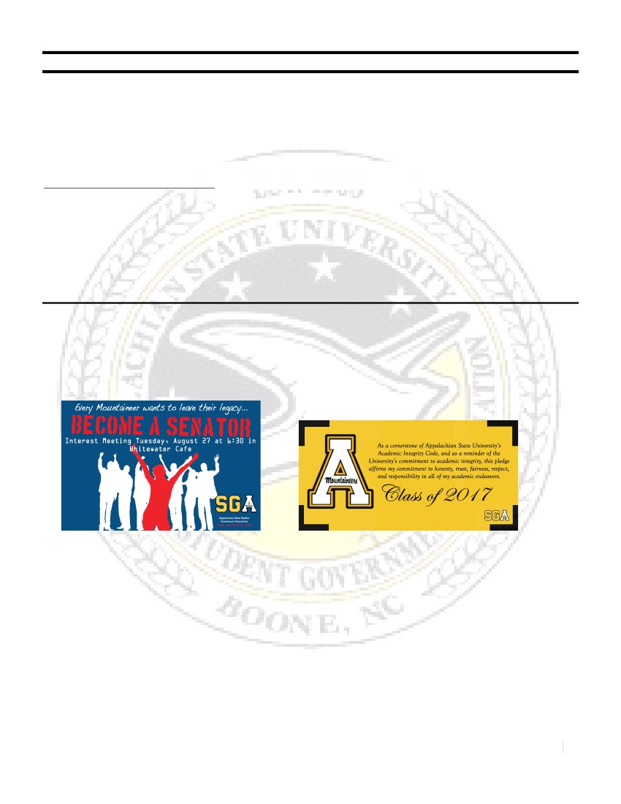
STUDENT GOVERNMENT ASSOCIATION APPALACHIAN STATE UNIVERSITY
47th SESSION, 2013-2014
DIRECTOR OF MARKETING
DIRECTOR MS. MADDIE G. HAGERMAN
EMAIL: HAGGERMANMG@APPSTATE.EDU  CELL: (704) 773-6041  OFFICE: 215, PLEMMONS UNION
The Executive Branch of the Student Government Association
OVERVIEW OF RESPONSIBILITIES
Working with each of the individual members of cabinet, my job is to promote SGA sponsored events, off-
campus matters, and increase transparency between students and Student Government Association. This
means creating forms of marketing such as fliers, posters, social media events, banners, etc. to further the
goals of SGA. This position requires intra-relational work by working with each area of the cabinet and
contributing to cabinet members’ personal committee goals. Another large part of this job is managing a
marketing committee and delegating tasks to senators that you need accomplished.
COMPLETED WORK THIS SEMESTER
This semester, I have worked on many projects to increase awareness of issues going on both off-
campus and on-campus and promoting SGA events. Here are a few examples of the work I created this
semester for various events.
Senator Information Session 8/27
Academic Integrity Banner
37

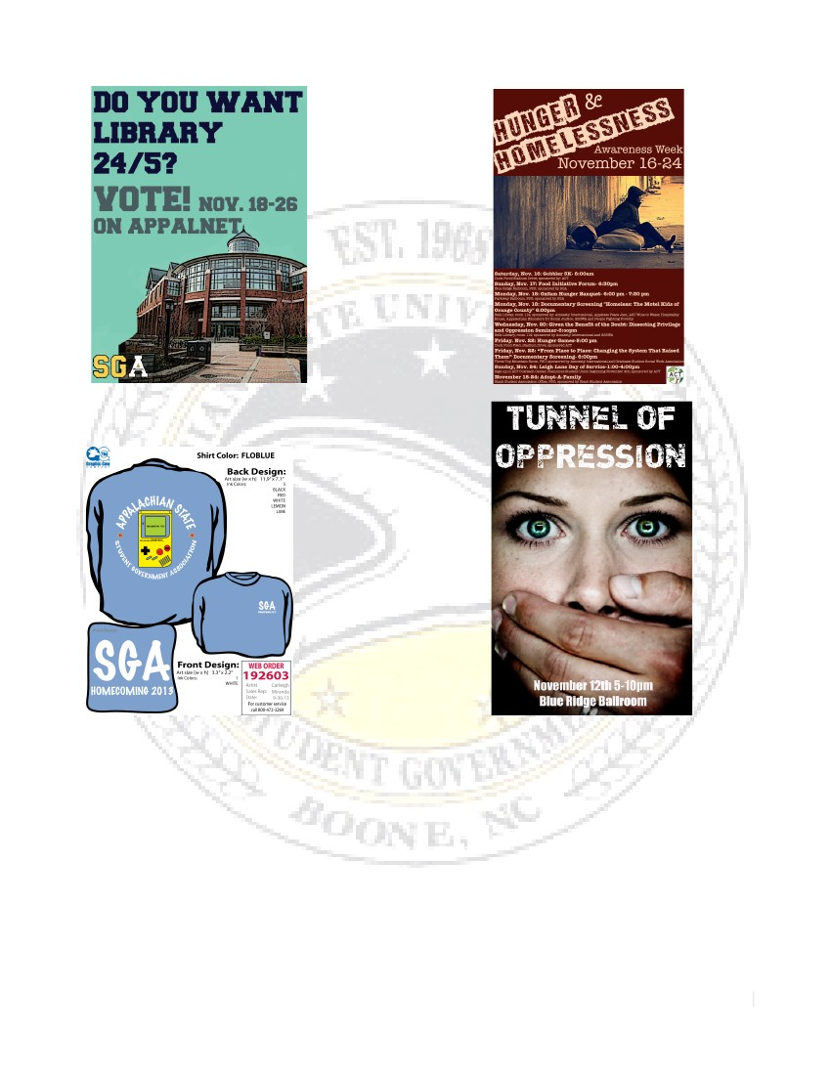
Library 24/5 Referendum Flier
Hunger and Homelessness Awareness Week Poster
SGA Homecoming T-Shirts
Tunnel of Oppression Posters
In addition to these items, I have also worked on “hAPPily sober” tailgating sandwich boards to
promote safe tailgating, the SGA homecoming banner that won 3rd place in the clubs category, and
Facebook events for all of these SGA sponsored affairs. Also, the SGA newsletter will be published at the end
of the semester to highlight all of the accomplishments both cabinet members and senators have made.
Another newsletter will be published at the end of spring semester to do a recap of the year.
The Tye Dye Dash 5K will also be a huge event next semester that the Marketing Committee will
take on along with the Campus Outreach committee. This event will be open to all students and is SGA
sponsored.
38

DIRECTOR’S PERSPECTIVE
This semester has been both challenging and meaningful to me in this position. I feel that I have
learned a lot of valuable skills and hope to work to accomplish all platform goals by the end of the year with
other members of the cabinet. I look forward to working with Student Government again next semester and
serving the student body.
39

STUDENT GOVERNMENT ASSOCIATION APPALACHIAN STATE UNIVERSITY
47th SESSION, 2013-2014
DIRECTOR OF STUDENT AFFAIRS
DIRECTOR MS. ALYSSA FRIZZELLE
The Legislative Branch of the Student Government Association
EMAIL: FRIZELLETA@APPSTATE.EDU  CELL: (336) 260-8503  OFFICE: 215, PLEMMONS UNION
OVERVIEW OF RESPONSIBILITIES
This position is responsible for a variety of duties related to student life and services under the Student
Development Division of Appalachian State University. The responsibilities of this director can be placed
under the four large divisions of food services, health services, parking and traffic, and business affairs.
SAFETY WALK
The annual Campus Safety Walk is an initiative common across University campuses held by their
respective student governments. The Walk is a chance for students, staff, and administrators to explore the
campus in the evening hours and observe and assess potential safety risks to students. This Fall we reinstated
the Walk after its hiatus the past few years and had excellent support from administration. Chief Doerr and
Captain Corley from University Police were both participants in the Walk, as were JJ Brown (Dean of
Students), Mike O’Connor (Physical Plant Director), and Dayton Cole (University General Counsel). They
along with student volunteers from Student Government, Ambassadors, and Red Flag Educators compiled a
list of three pages worth of safety concerns given to the Physical Plant to be addressed. The Appalachian also
had a news reporter in attendance that participated and interviewed participants; however an article was
never published on the event.
CHANCELLOR’S LUNCHEONS
Each month I am responsible for selecting a group of 12 students to participate in a Luncheon with
Chancellor Peacock to discuss current topics students are facing on campus. Thus far we have held three
Luncheons this semester for the LGBT Community, Safety Peer Educators, and Out of State Students. Each
Luncheon allowed students to provide valuable insights to the Chancellor and myself to take back to the
Student Affairs Committee for possible legislation ideas.
UNIVERSITY SAFETY COUNCIL
I began sitting on the University Safety Council in May of 2013 after accepting this position. The
Safety Council is compiled of administrators, faculty, and staff, as well as two student representatives, and
meets monthly to discuss safety concerns on campus. Meetings cover everything from implications of the
recent gun law passed in North Carolina to plans for stadium evacuation exercises. Thus far I have presented
on multiple occasions to the Council regarding the Safety Application for Smartphones and have met
considerable support for the idea.
TRANSFER ADVISORY BOARD
The Transfer Advisory Board meets once a semester to discuss initiatives to improve the Transfer
Student experience on our campus. The Board met in late November and discussed many upcoming plans to
work on, including the implementation of a Transfer Student Center and the expansion of the Jumpstart and
TPOP programs. Discussion of expansion of transfer student housing and scholarships were also discussed.
40

As a part of this Board, I will also be responsible for reading and selecting grant recipients for three grants
amounting the $10,000 to University departments in an effort to improve transfer student services.
WEB AND MOBILE GOVERNANCE COMMITTEE
The Web and Mobile Governance Committee was implemented by CIO Cathy Bates this past
summer and meets monthly to implement a plan of action for the creation and integration of mobile
applications for the campus. We are currently working on bringing the AsUBus application in house and
including GPS data within the existing platform, as well as creating an Appalachian application that will be a
primary source for all mobile information for the University. This group is also responsible for the
implementation of the Safety Application.
SAFERIDE EVALUATION
This summer, Barry Sauls charged SGA with researching and giving a recommendation as to the
potential change of the SafeRide system from a point-to-point service model to a route model due to heavy
ridership that are currently taxing system abilities. My committee and I worked throughout August and
September to gather student feedback, amounting to 500 surveys and a conversation with SafeRide drivers
and other students as well that led to us deciding to recommend that the SafeRide system not change its
current system model, but rather address some of the issues they currently face that are taxing the system in
other ways. I am now working with Barry Sauls to implement education on the service at Summer
Orientation, as well as improvements to their current website and the potential implementation of social
media presence and drug testing and better training for drivers. What started as a narrow objective to assess
SafeRide has grown to a larger look at the system and the ways we can improve upon it and the coming
semester should hopefully see changes to service to make it more effective.
SAFETY APPLICATION FOR SMARTPHONES
Implementing a Safety Application for Smartphones has been my primary focus since transitioning
into this job last May. After researching 13 companies, viewing demos from many of them, and discussing
the applications at length with Safety Council, Web and Mobile Governance Committee, JJ Brown, and
Chief Doerr, we have made progress on the idea, but still have a ways to go. The basic idea is to implement a
mobile blue light system that can directly connect students in need to University Police. The primary two
options are to buy this service from an outside vendor or to build the application in house. Web and Mobile
Governance has formed subgroups to work on this project to address the possible in house route and Chief
Doerr has drafted an RFP to address the outside vendor route. It is my utmost goal of this year to have this
application implemented by the end of my time in this position.
DINING HALL NUTRITION INFORMATION
Currently campus-dining services has made strides to provide students with nutrition information for
the foods offered on campus. However, there is little student education as to the current resources, as well as
no easy way to find the information when at the dining halls. To increase student awareness and help
improve the current services provided, my committee has begun working to have all nutrition information
posted into a free mobile application, MyFitnessPal. Art Kessler, Director of Food Services, is in support of
this idea and one of my senators is looking to have this completed in the spring semester.
BEEPER SYSTEM EVALUATION
Currently students at the University utilize an unofficial system of designated driving, referred to as
“Beepers.” While this system promotes students finding designated drivers when drinking and increases safety
for everyone in the community, there are some major drawbacks to the system from a legal insurance
standpoint, as well as a student safety standpoint. To address these drawbacks, I have been researching
designated driving services at other Universities to find a model that can better serve our students. In the
41

spring semester, Zach Yllanes, Director of Campus Outreach, and I will go before the University Safety
Council to present on the beeper system and its liabilities, as well as our ideas for improvement, to charge
them to address the issue in the coming year.
COUNSELING CENTER SUPPORT
As part of my duties from the platform, my committee and I have begun research on how we can best
support and improve our Counseling Center services. At present, we are doing preliminary research to assess
how our counselor/student ratio matches up to sister and peer institutions and where the current needs are
not being met. We are also working to support and provide assistance as the Counseling Center begins work
with the money received from a Suicide Prevention Grant, as well as to promote awareness of the CU Thrive
program.
DIRECTOR’S PERSPECTIVE
This has been a very busy semester for my committee and myself. Above is only a small part of the
projects we’ve been working on so far and all that we have in the works for the coming semester. I have
personally taken a big focus in promoting student safety on campus, be it feeling safe walking campus at night
or feeling that you have someone you can seek help from when you are struggling with your mental health. I
have been so pleased to have been met with such support from the administration of the University, as well
as our administration within Student Government this year and I look forward to utilizing this support to
continue to find and meet student needs in the spring semester.
42

STUDENT GOVERNMENT ASSOCIATION APPALACHIAN STATE UNIVERSITY
47th SESSION, 2013-2014
DIRECTOR OF ELECTIONS
DIRECTOR MS. MARISSA L. PANNELL
EMAIL: PANNELLML@APPSTATE.EDU  CELL: (828) 719-7399  OFFICE: 215, PLEMMONS UNION
The Legislative Branch of the Student Government Association
OVERVIEW OF RESPONSIBILITIES
Director of Elections is responsible for any electoral process; including but not limited to Homecoming,
Senator, and Presidential elections. During any election process Director of Elections is to keep accurate
records, maintaining an unbiased standing, and stay in accordance with the elections bylaws. To recruit and
retain senators, while overseeing their responsibilities and holding them accountable. I am to keep in line
with administration platform goals and reform the SGA Constitution. Throughout the year, I am to oversee
and expand the Student Discount with local community businesses, and to create awareness of the available
discounts.
ELECTION BY-LAWS
I oversaw the elections of this year’s senator candidates, followed by working through the petition in
process with Senators who were not elected or did not participate in the election. Slowing working on
implementing the reformed senator election process with the assistance of the Director of Legislative
Operations, Vice President, Chief of Staff and members who sat on the Reformation Committee. We are
currently working towards amending the election policies and procedures as well as the election bylaws to
remove any contradictions and gray areas.
RETAINING SENATORS
I have been working on making sure senators are staying on top of their requirements and
responsibilities, while trying to make a fun and inviting environment. We have looked at students who have
been, or have so potential interest, in Student Government and are reaching out to get them involved in the
47th session of Appalachian State University’s Student Government Association.
STUDENT DISCOUNT
I hope to get more response from businesses and create better relationships between the university
and business owners.
PRESIDENT AND VICE PRESIDENT ELECTIONS
Work alongside other cabinet members to work on these elections from a new stand point. Since this
is a new position, everything works a little differently, so working through the obstacles and keeping records
for those who will come after me. I am hoping to make this position easier for years to come by creating
examples, explanations, and something for others to look back on and learn from.

43

STUDENT GOVERNMENT ASSOCIATION APPALACHIAN STATE UNIVERSITY
AN OFFICIAL MEMORANDUM FROM THE OFFICE OF THE
STUDENT BODY PRESIDENT

Office of the Student Body President
Plemmons Student Union
Office: (828) 262-6254
Fax: (828) 262-6502
To:
From:
Date:
Subject:
W HEREAS,
The North Carolina General Assembly
G. Dylan Russell, Student Body President, Appalachian State University
Robert Nunnery, President, Association of Student Governments
Timothy Schwan, Student Body President, East Carolina University
Stefan Weathers, Student Body President, North Carolina Central University
Leigh Whittaker, Student Body President, University of North Carolina at Asheville
Brady Nails, Student Body President, University of North Carolina at Charlotte
Crystal Bayne, Student Body President, University of North Carolina at Greensboro
Emily Ashley, Student Body President, University of North Carolina at Pembroke
Joseph Blankinship, Student Body President, University of North Carolina School of the Arts
Parth Thakker, Student Body President, University of North Carolina School of Science and Mathematics
Bryant Bell, Student Body President, Winston Salem State University
July 16, 2013
HB 937
UNC is a multi-campus university which is comprised of sixteen university campuses and one constituent high
school dedicated and devoted to providing higher education in a safe environment; and,
In their study published in the Stanford Law Review, Yale and Stanford law professors Ian Ayres and John J.
Donohue III contend that “one must acknowledge that there are both costs and benefits to either allowing or
prohibiting the carrying of handguns, and the task for the scholar is to try to determine which effects dominate;”
and,
W HEREAS,
1
W HEREAS,
The International Association of Campus Law Enforcement Administrators, Inc., (IACLEA) in its position
statement on Concealed Carrying of Firearms Proposals on College Campuses notes that “it is concerned that
concealed carry laws have the potential to dramatically increase violence on college and university campuses that
our Members are empowered to protect. Among the concerns with concealed carry laws or policies are: the
potential for accidental discharge or misuse of firearms at on-campus or off-campus parties where large numbers of
students are gathered or at student gatherings where alcohol or drugs are being consumed, as well as the potential
for guns to be used as a means to settle disputes between or among students. There is also a real concern that
campus police officers responding to a situation involving an active shooter may not be able to distinguish between
the shooter and others with firearms;” and,
2
W HEREAS,
President of the UNC system, Tom Ross, said “all UNC chancellors and chiefs of police believe allowing guns on
campus would increase the risk to public safety and hamper our ability to protect not only our students, staff and
faculty, but also campus visitors including parents, siblings of students, and summer camp participants. Vehicle
break-ins are one of the leading crimes on college campuses, and even guns brought lawfully onto campus as
contemplated by this bill, could fall into the wrong hands and result in serious injury and death;” and,
the police chiefs of the 17 UNC campuses oppose the provision of House Bill 937 that would allow handguns on
our campuses, as they believe that passage of the bill would increase the risk to the safety of the students, faculty,
W HEREAS,

44

staff, and visitors, stating that the potential risk to those on campus far outweighs the convenience to concealed-
carry permit holders; and,
W HEREAS,
Public Policy Polling surveyed that 69% of North Carolinians are not in support of concealed weapons on
campuses: and, now, therefore, be it
PROCLAIMED, that the Student Body Presidents believe that concealed handguns would detract from a healthy learning
environment; that more guns on campus would create an additional risk for students; that shooters would not be
deterred by concealed carry permit holders; and, concealed carry permit holders are not required to have law
enforcement training; and, now therefore, be it
PROCLAIMED, that the Student Body Presidents of Appalachian State University, the Association of Student Governments, East
Carolina University, North Carolina Central University, University of North Carolina at Asheville, University of
North Carolina at Charlotte, University of North Carolina at Greensboro, University of North Carolina at
Pembroke, University of North Carolina School of the Arts, University of North Carolina School of Science and
Mathematics, and Winston Salem State University oppose the provision of House Bill 937 which allows guns on
our campuses, as it does not promote the safety and well-being of our respective constituents.
45

To the North Carolina General Assembly,
As Student Body President of Appalachian State University I do not stand in support of House Bill 937. The Office of
the Student Body President feels that this bill will increase the threat of gun violence on campus and encourage those on
university grounds to take the law into their own hands. As a student of Appalachian, I feel safe when walking around on
campus. My peace of mind is constantly reaffirmed by seeing the police officers who work diligently to ensure my safety
as well as my constituent’s safety.
As of now, Appalachian State does not permit the use of handguns on campus- in classrooms, vehicles, or residence
halls. I am confused as to how this bill will improve security on campus for students, faculty, staff and other community
members. I do not understand why the present laws in place for possessing a handgun do not suffice. Ultimately I do not
feel that it is within the university’s best safety interests to allow a handgun in vehicles on campus.
I support UNC President Tom Ross’ opposition of this bill in which he has stated, “vehicle break-ins are one of the
leading crimes on college campuses, and even guns brought lawfully onto campus, as contemplated by this bill, could fall
into the wrong hands and result in serious injury or death.” Another concern of mine is tailgating, as guns and alcohol
consumption will be mixed together. I find this to be deeply troubling and concerning.
I also call upon the recent tragedies our nation has endured in the name of gun violence. As a country we have had far
too many instances in which innocent educators and students have lost their lives to gun violence. I feel that this
proposed legislation will offer a gateway for such instances to occur on our own campus.
The present handgun laws implemented at Appalachian State have kept this university safe, and we feel that will remain
true if house bill 937 is not passed. My administration and myself stand behind the Chancellors of the UNC System, the
President of the UNC System, the Police Chiefs of the UNC System, and the municipal Police Chiefs in opposing this
provision in HB937 which would allow concealed carry permit holders to have a handgun in a car on a UNC campus.
We respectfully ask that the General Assembly remove this provision from the bill during conference.
Thank you,
G. Dylan Russell
Student Body President
Student Government Association
Appalachian State University
russellgd@appstate.edu
46

To the North Carolina State Board of Elections,
As Student Body President of Appalachian State University, I do not stand in support of the Watauga County
Election Board’s decision to move voting off campus. I firmly believe that the students and local residents will feel the
negative impact of the board’s decision come Election Day.
With the present decision students will no longer have the option to vote on campus. Three of Boone’s
precincts, two of which include Appalachian State University, will be forced to vote at the Agricultural Conference
Center. This means that 9,300 people will vote in a polling place originally designed for 1,500 people. The new polling
location only provides 35 parking spots for voters, not including parking used for election officials. There is also a
major safety concern as there is no sidewalk leading from Appalachian State University’s campus to the new designated
polling place. Another concern is that there is no public transportation available for said polling location.
Appalachian State University is the largest employer in Watauga County. This plan will inconvenience several
thousand students as well as 2,829 local community members that the university employs. More than half of the
residents in the town of Boone will be assigned to this polling place, making it the third largest polling location in the
state of North Carolina.
The result of the Election Board’s decision will make it much more difficult for students to get to the polls.
Appalachian State University offers ample parking and close proximity to not only students, but the community as
well. The university is the central precinct in Boone.
The public university system is intended to foster politically active students who will become responsible
American citizens who partake in the democratic process. As students, we do not understand why there are individuals
who seek to make voting more difficult for both students and local citizens. For many years, Appalachian State
University has worked with the Town of Boone to create a unified community. Students have been responsible for
providing countless amounts of services to the town. We are residents, and we consider the moving of this polling place
to be an extreme disappointment.
The County Election Board has not offered an adequate explanation for their decision to move voting off of
Appalachian State University’s campus. Any revisions in voting procedure should work to make voting more accessible
and ensure civic participation.
We study that our shared history of America is about expanding democracy and ensuring the voice of all be
heard. As the Student Body President of Appalachian State University, I appeal to the State Board of Elections to
47

overturn the Watauga County Election Board decision to ensure that all residents of Boone can actively participate in
elections.
Thank you,
G. Dylan Russell
Student Body President
Student Government Association
Appalachian State University
russellgd@appstate.edu

48

