Student Government Survey Fall '07


Overview
The New Student Questionnaire was conducted in the period from 22nd November 2007 to 22nd January 2008. It was sent out to a statistical sample of AUBG students. The sample consisted of 175 students and was constructed by AUBG Registrar’s Office based on General Enrollment Statistics.
Purpose
The purpose of the survey is to evaluate student perceptions about AUBG.
Goal
The goal of the survey is to enable the Student Government to better serve in its capacity to represent students’ interest.
Survey Effectiveness
The response rate of the survey is 52.6%, which qualifies the survey as successful.
Recommendations:
- Main income generators for the respondents are parents and Work and Travel programs. EUR / BGN denominated sources of incomes are relevant for about 40% of the respondents;
- Respondents are eager to consider optional meal plans only;
- Full scholarship students should be able to have work-study positions;
- Quality of internet connection and internet bandwidth are major concerns among the respondents;
- Diversity of offered courses should be discussed. There is a strong will for new majors and minors to be seen at AUBG;
- Leasing of books is found to be an efficient program and students would like to see more books available on leasing. The pricing model should be reconsidered;
- Current level of security is approved by the respondents. Students are willing to report any crime when it happens to them. More guards and improved security in the residence halls may be required;
- Faculty should be again evaluated, the students are generally satisfied, but improvement should be done in the following areas: more international faculty members and better English proficiency for the non-native speaker professors;
- All the University Offices mentioned in the survey – Health Center, Career Center and Advising center seem to be found useful generally from the students, but only a few of them are using their services. A deeper analysis should be performed on the issues with current services offered there;
- Students are generally satisfied with services offered by the library. The main issues to be taken into consideration are:
  - Number of accessories;
  - Additional subscriptions, books and electronic databases;
- Canteen/ cafés are used regularly for eating from the students. High prices and bad food quality have been shown as a problem by the respondents;
- More than half of the respondents have shown their opinion about AUBG has got worse since enrolling. Further analysis should be done on this topic;
- Respondents are satisfied with the equipment in the New Administrative Building. Additional report should be done on the division of departments between the two academic buildings;
- The administration should promote better the current situation and development of AUBG;
- Room space has been the main issue about Residence Halls. Further analysis should be done on the following issues:
  - Room inventory;
  - Laundry service;
- Respondents have shown not to be very sport active. However, the current equipment and sport activity may be obstacles. Further analysis is needed;
- Respondents are satisfied with the performance of the Student Government. There is a need for such periodical services.

Demographic profile of the respondents
- Academic standing:
The most responsive from the respondent were Sophomore (30%) and Junior students (29%). Generally, the responsive rate pretty much resembles the structure from the General Enrollment Statistics for Fall 2007 – provided by Institutional Research department.
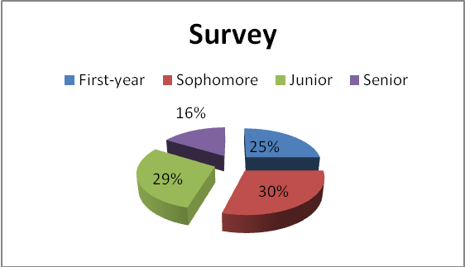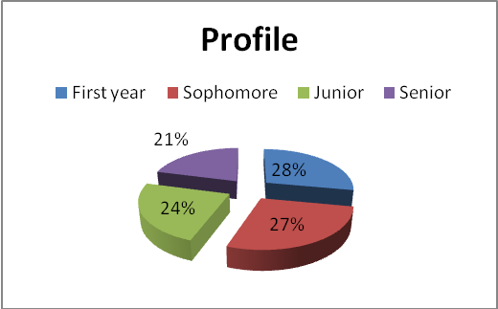
- Major:
Business Administration, Economics and Political Science are the top three major pointed out by the respondents. About 30% of respondents are studying only one major. For further analysis, it will be interesting how this apply to the currently selected majors as diversification.
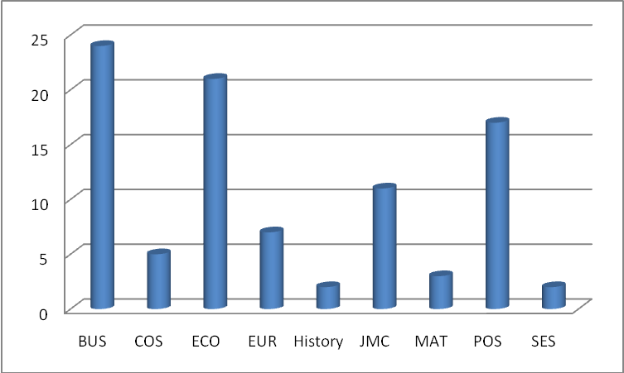
- Country of Origin:
Only 20 responses were gathered for this questions, which makes the result unsatisfactory.
- Gender:
Females respondents were slightly more active than males, but still results are close to the General Enrollment Statistics for Fall 2007.
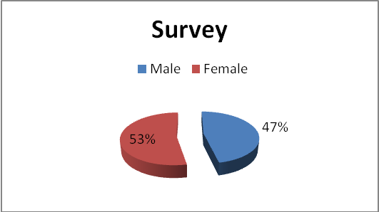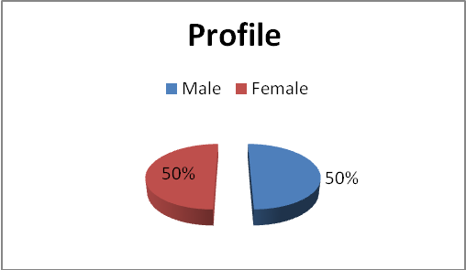
- CGPA:
The respondents with higher CGPA are about two times more responsive to the survey, still it should be taken to what profile of students, the survey was sent. The current CGPA according to General Enrollment Statistics for Fall 2007 is 3.07.
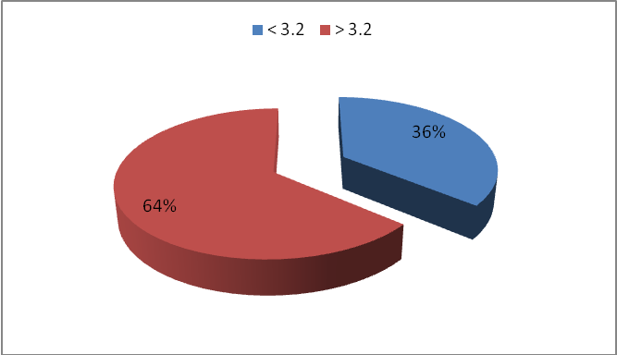
Financial Section
- Financial aid is based on both merit and need at the time of admission to AUBG. The Student Financial Affairs Committee decided to reevaluate financial aid packages after two years. Which of the following options should be used:
Review of the financial aid each two years is demanded by 86% of the respondents, however, only 14% think the financial aid should be discontinued if CGPA drops below a fixed level.
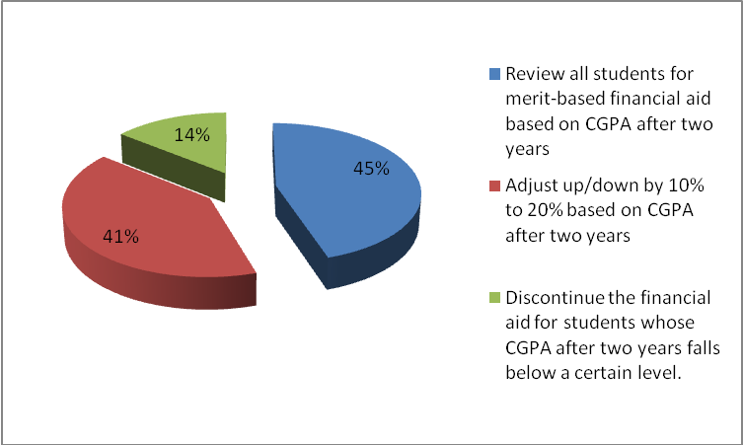
- Should new financial aid application be required after two years?
There is no clear opinion among the respondents whether a new application form should be required after two years. As respondents are not expressly against such a form it may be quite reasonable decision the AUBG Financial Department to consider whether a new form should be filled out. If it will make the process more accurate and clearer, the students will fill it out.
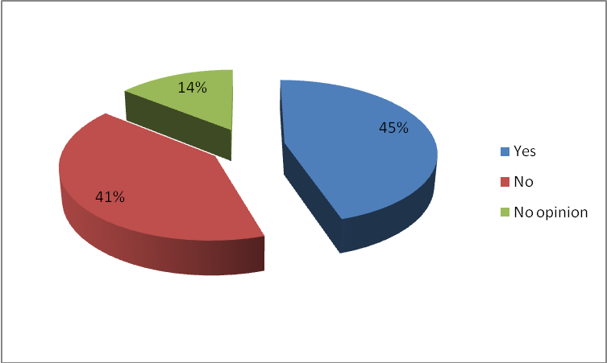
- How satisfied are you with the clarity, format, and information of your financial statement?
About 76% of the respondents are satisfied with the clarity, format and information in their financial statements. Only 2% have shown they are completely dissatisfied.
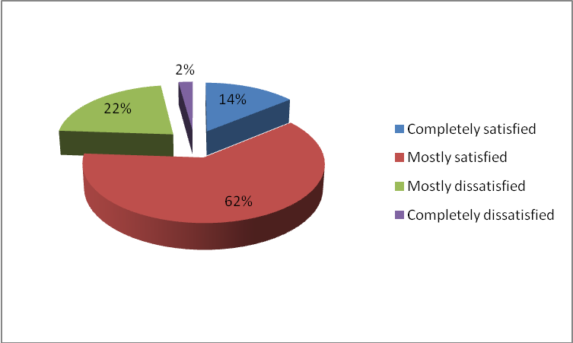
- What is your primary source of financing AUBG education?
Parents and Work and Travel programs are the main sources of financing for AUBG students. Only 4% rely on loans, which may be due to country origin of AUBG students (tougher loan conditions). 24% of the respondents rely on scholarships.
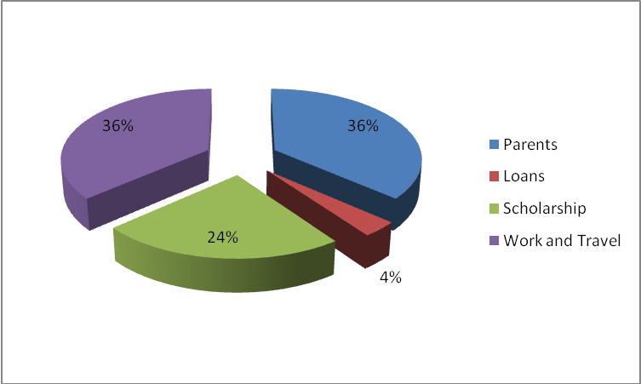
- In which currency is your income denominated primarily?
57% of the respondents have declared their incomes to be denominated primarily in US dollars. However, 43% have selected BGN/EUR denomination. This allows a possible denomination of the tuition fee from USD to EUR in the future.
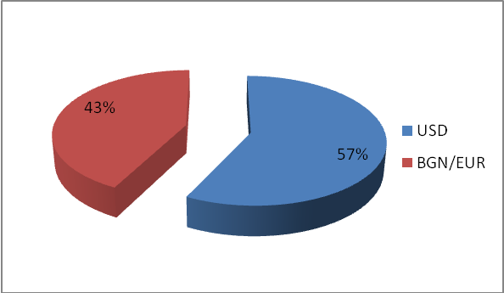
- Should there be a mandatory meal plan (nonrefundable fee prepaid in the beginning of each semester, just like the student activities fee)?
The respondents are strongly against a mandatory meal plan – 88%.
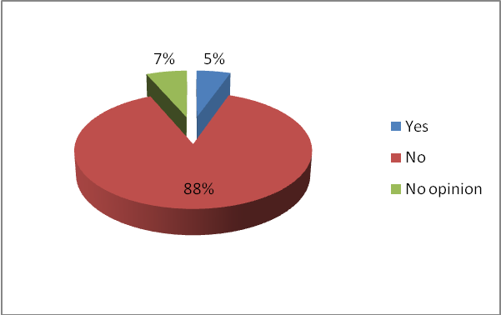
- If you support a meal plan, what form should it take:
From the respondents who support such a plan, 92% think it should be optional and 68% with a fixed dollar amount.
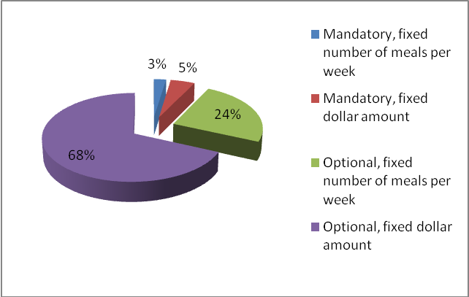
Work-Study Section
- How satisfied are you with the availability of work-study positions?
The responses show that 42% of the respondents are satisfied with the availability of work-study positions. 27% are dissatisfied and 31% have no opinion.
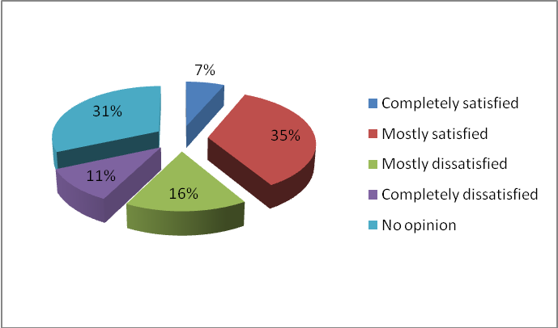
- How satisfied are you with the new work-study compensation system?
57% of the respondents show they are satisfied with the new work-study compensation system. However, only 9% are completely satisfied, which means a revision of the system may be required in order to fulfill the needs of the students.
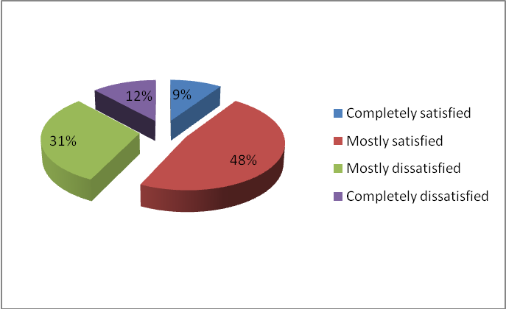
- Should full scholarship students be able to have work-study positions?
66% of the respondents agree to have full scholarship students being able to have work-study positions. However, the profile of the respondents should be taken into consideration before deciding on these issues.
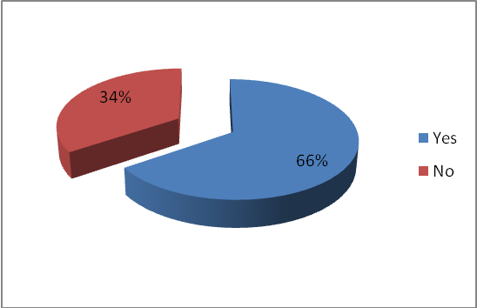
Computing section
- How satisfied are you with the quality and speed of Internet access in the residence halls?
61% of the respondents are not satisfied with the internet speed connection. 20% are completely dissatisfied and there is none – completely satisfied.
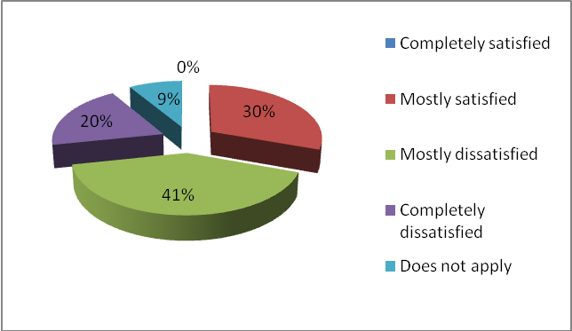
- Which of the following improvements in the computing environment should be the priority?
The increase of the bandwidth is the highest priority among the respondents (68%).
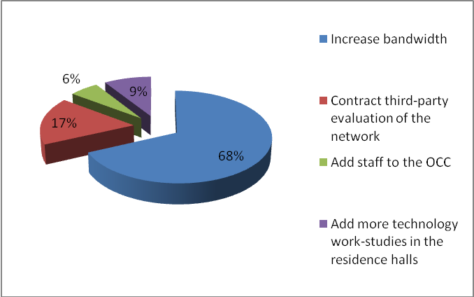
- How satisfied are you with the software (quality and selection) installed on University computers?
81% of the respondents are satisfied with the software installed. Only 1% is completely dissatisfied.
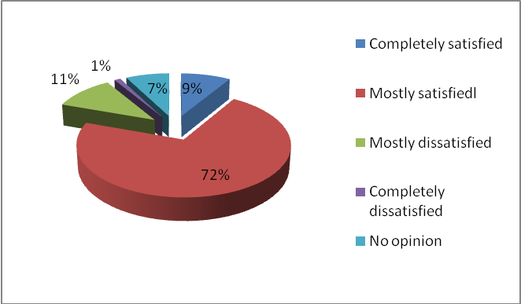
- How satisfied are you with the hardware (computers, printers, scanners, etc.)?
89% of the respondents are satisfied with the hardware. Only 1% is completely dissatisfied.
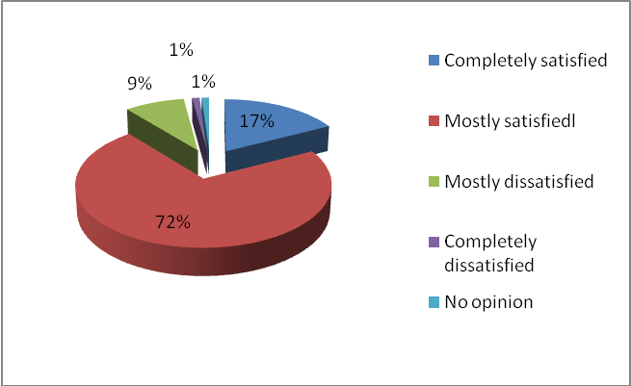
Registration & Academics section
- How satisfied are you with the current registration system?
76% of the respondents are satisfied with the current registration system. Improvements are possible since only 11% are completely satisfied.
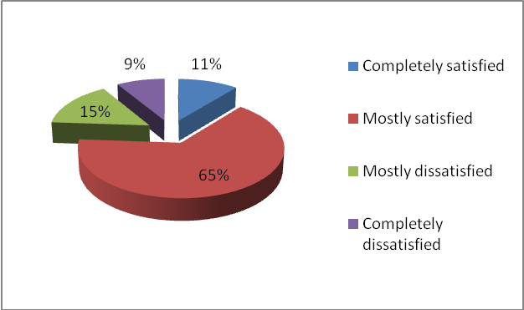
- Did you register for all the courses you wanted this semester?
77% of the respondents are satisfied with the courses they have registered this semester. 40% have registered all courses they wanted. Only 1% have not been able to select any of the courses they would like to.
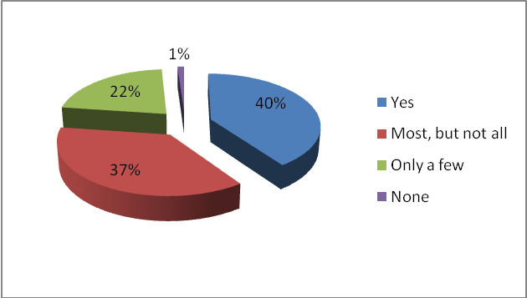
- How satisfied are you with the diversity of the courses offered?
55% of the respondents are not satisfied by the diversity of the offered courses and only 4% are complete satisfied with them. A revision of the courses may be required.
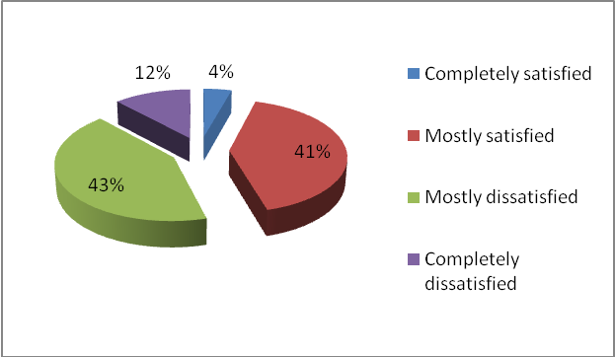
- Did you have problems fulfilling the requirements of your major, minor or GenEd because you couldn’t register for one or more courses?
41% of the respondents did not have any problems, compared to 24% who have had difficulties.
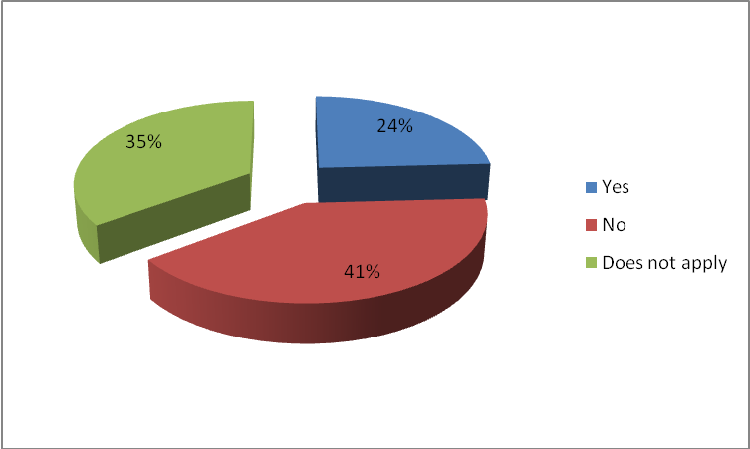
- Are there any new majors or minors that you would like to see at AUBG?
The majority of the respondents (61%) think new majors or minors will be good to have in AUBG. A list with their examples can be found in the Appendix at the end of this report.
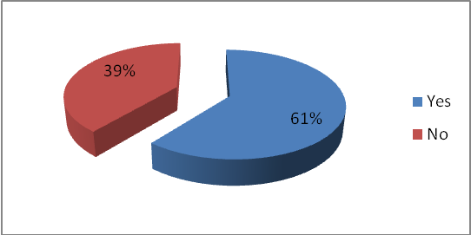
- Are there any majors, minors or courses at AUBG that you find out of date?
84% of the respondents do not find any of the majors, minors and courses out of date. A list with their examples can be found in the Appendix at the end of this report.
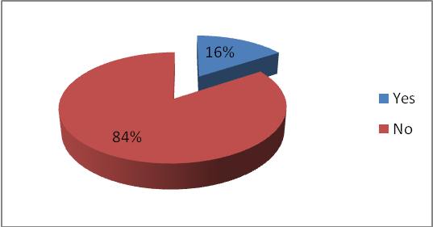
- Should changes be made to Gen Ed requirements?
60% of the respondents are on the opinion that changes should be done to Gen Ed requirements. A list with their examples can be found in the Appendix at the end of this report.
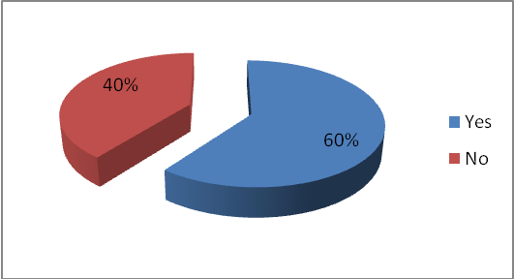
- Standards of academic integrity are fairly and consistently enforced at AUBG.
64% of the respondents agree with the statement above. Only 4% have specified as an answer – Strongly disagree.
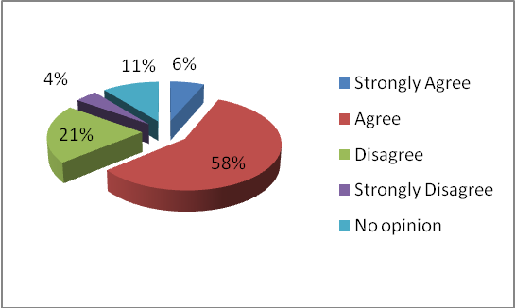
- AUBG prepares you to be a future leader.
67% of the respondents are on the belief that AUBG prepares them as future leaders. Only 6% are strongly disagreeing with this statement.
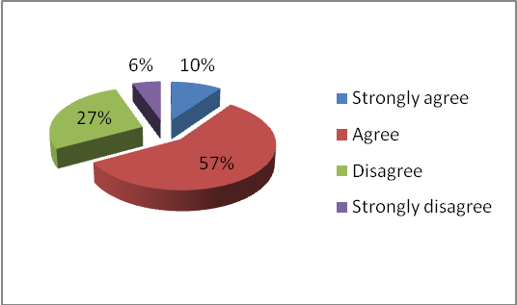
Bookstore
- How many required books did you buy from the bookstore this semester?
46% of the respondents were not able to buy any book from the bookstore this semester. 48% of respondents were able to buy at least some of them, but only 13% bought all of required books.
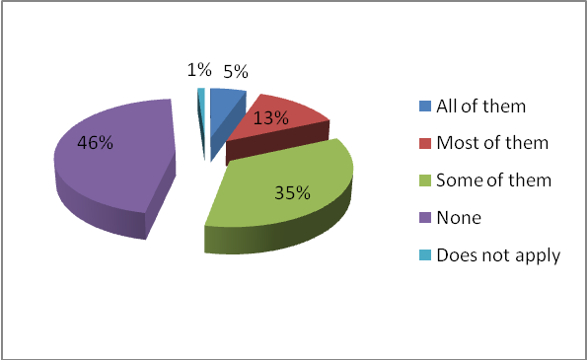
- How many required books did you lease from the bookstore this semester?
The results show that lease is more efficient than the buying of the required books. Only 23% of the respondents were not able to lease any of the required books. 10% succeeded to lease all of them and 32% most of them.
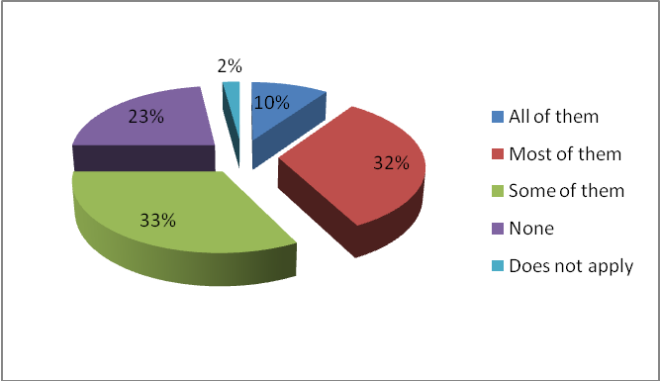
- How did you make up for the textbooks you did not buy/lease from the bookstore?
It is interesting to see that no matter with the problems with buying and leasing of the required books, only 12% of the respondents were not able to use the textbooks at all. 28% borrowed them from friends, 22% copied them and 13% used library reference.
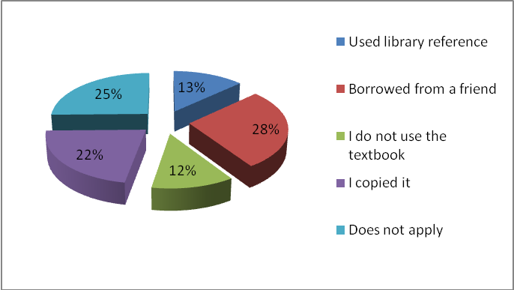
- Is the leasing program efficient?
93% of the respondents find the leasing program efficient. However, the main considerations are that books are still expensive and more books should be available for lease.
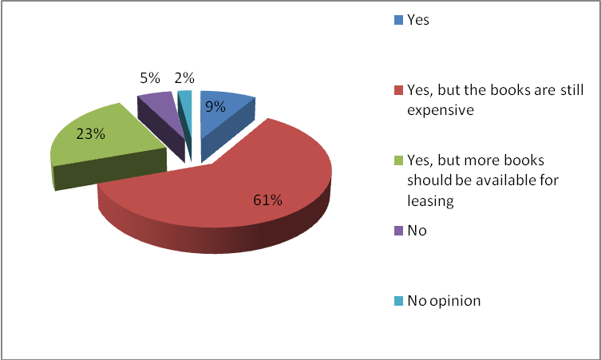

Security
- How satisfied are you with overall level of security in AUBG?
70% of the respondents are satisfied with the current level of security in AUBG. Only 26% of the respondents are not satisfied.
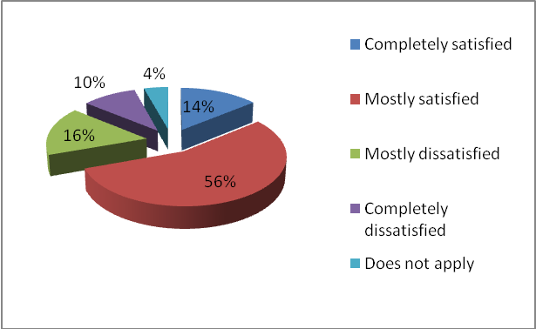
- This semester have you been a victim of (choose more than one answer if needed)
6% of respondents have been victims of a crime. None of the respondents was a victim of a sexual harassment.
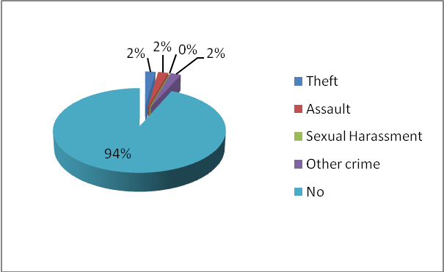
- If you have been a victim of a crime, did you report it?
Respondents are more willing to report the crime (10%), if it has happened rather than non reporting it (2%).
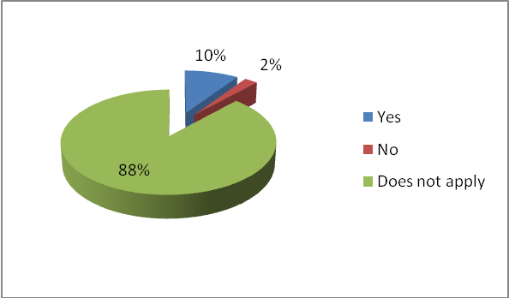
- If the university is to improve the campus security, which of the following should be the priority?
34% of the respondents think that more guards should be hired and 28% are on the belief that more cameras are required in the residence halls. However, 30% of the respondents do not want any changes connected with their security.
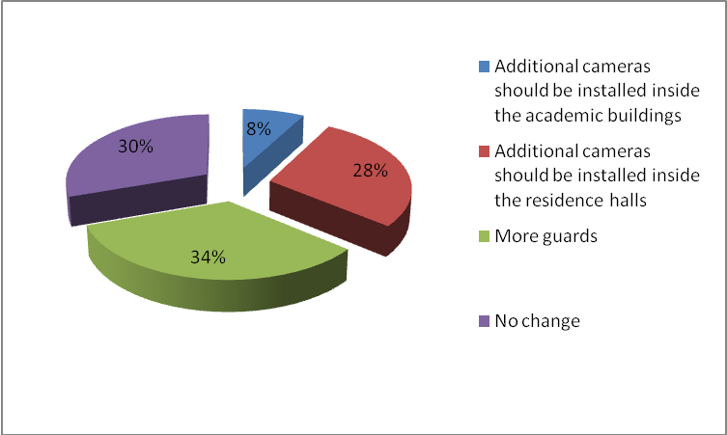
Faculty
- How satisfied are you with the number of International faculty members?
57% of the respondents are satisfied with the number of international faculty members. However, only 10% are completely satisfied, which makes a new survey on this topic a necessity.
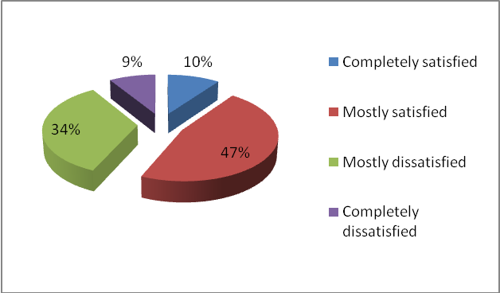
- How satisfied are you with the overall quality of teaching at AUBG?
66% of the respondents are satisfied with the overall quality of teaching at AUBG. Again only 6% are completely satisfied. A new survey should be done on this topic.
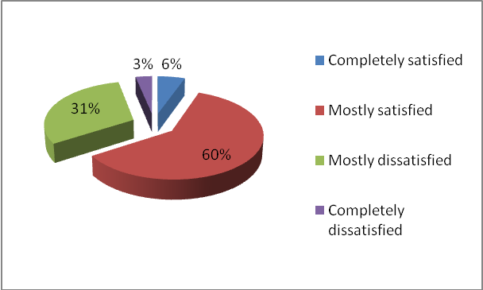
- How satisfied are you with the level of professors’ expertise?
74% of the respondents are satisfied with the level of professors’ expertise.
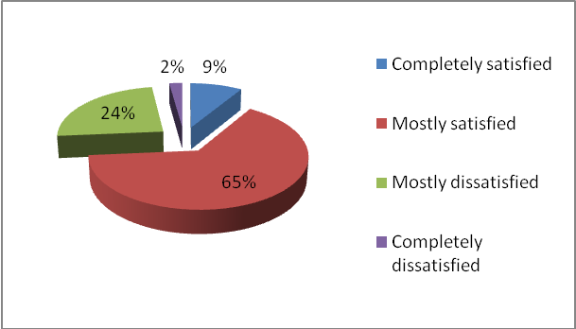
- How satisfied are you with the English proficiency of non-native speaker professors?
60% of the respondents are satisfied with the English proficiency of non-native speaker professors. However, only 9% are completely satisfied and 80% of the respondents have remarks on this topic.
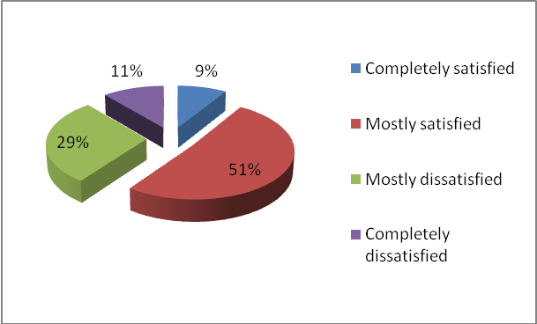
- How satisfied are you with professors’ availability and willingness to assist students?
89% of the respondents are satisfied with professors’ availability and willingness to assist students. Only 11% are dissatisfied.
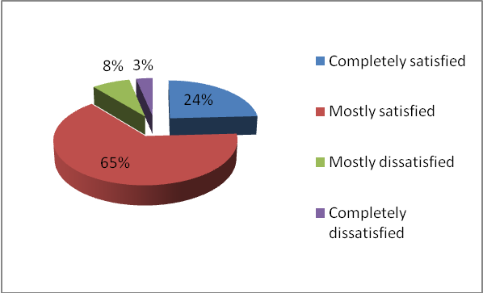
- The quality of teaching during your stay at AUBG has:
According to 48% of the respondents the quality of teaching during their stay at AUBG has decreased. Only 26% are on the belief the quality has been improved.
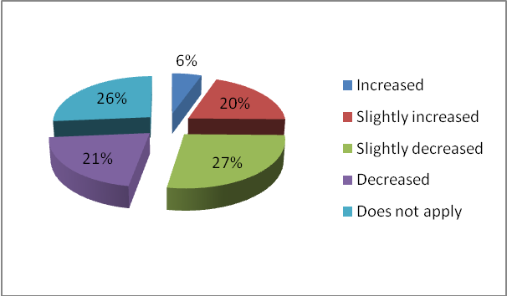
- List 3 of the best professors at AUBG
A detailed list with all professors can be found in the Appendix.
University Offices
- How often do you use the services of the Health Center?
52% of the respondents have never used the services of the Health Center. Only 11% of the respondents are using them on a regular basis.
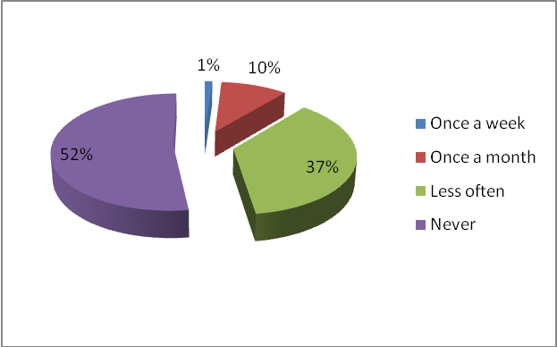
- How useful do you find the Health Center?
57% of the respondents find the Health Center not useful. Only 22% are on the contrary opinion. Only 3% find it very useful.
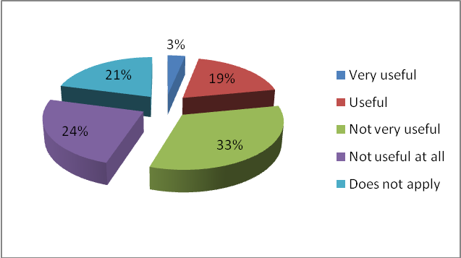
- How often do you use the services of the Career Center?
Only 6% of the respondents are using the services of the Career Center on a regular basis. 52% have never used it.
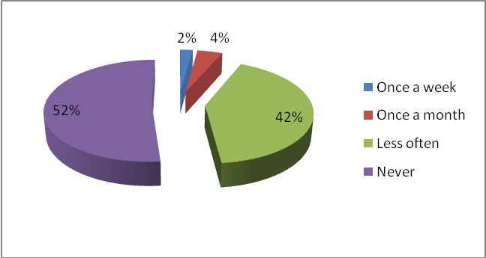
- How useful do you find the Career Center?
41% of the respondents find the Career Center useful. 28% find it not useful.
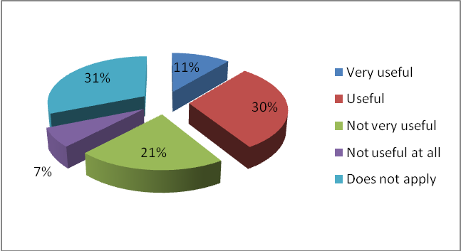
- How often do you use the services of the Advising Center?
Only 9% of the respondents are using the services of the Advising Center on a regular basis. 67% have never used it.
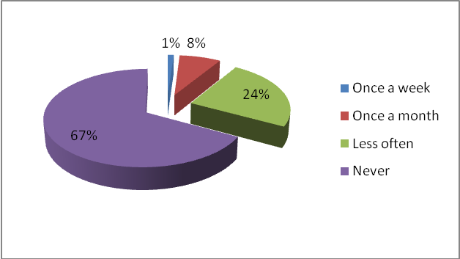
- How useful do you find the Advising Center?
28% of the respondents find the Advising Center useful and the same proportion – not useful. 44% have no opinion and this correlates with the number of respondents who have never used it from the question above.
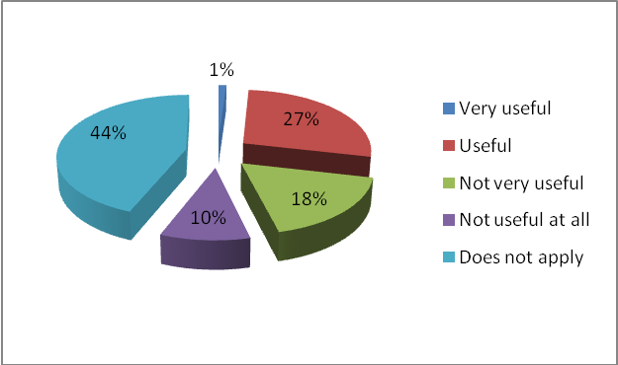
Library
- How satisfied are you with the number of newspaper and magazine subscriptions?
68% of the respondents are satisfied with the number of newspaper and magazines subscriptions. Only 14% are dissatisfied.
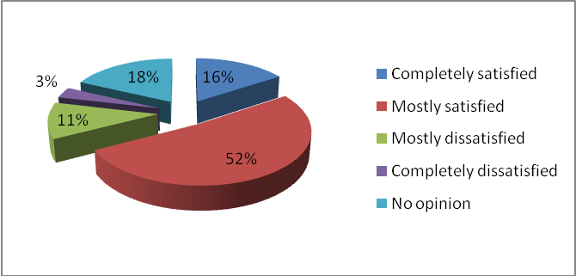
- How satisfied are you with the variety of books?
78% of the respondents are satisfied with the variety of books in the library. Only 12% are dissatisfied.
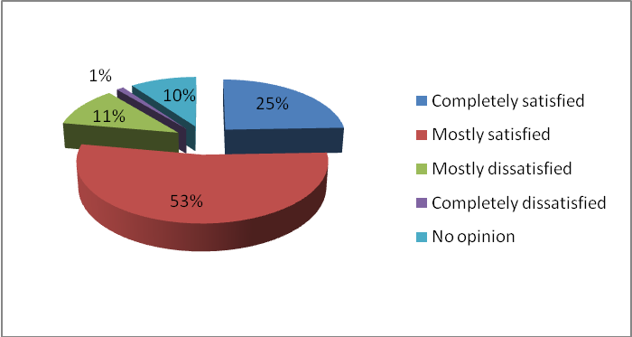
- How satisfied are you with the electronic databases offered?
74% of the respondents are satisfied with the electronic databases offered. Only 12% are dissatisfied.
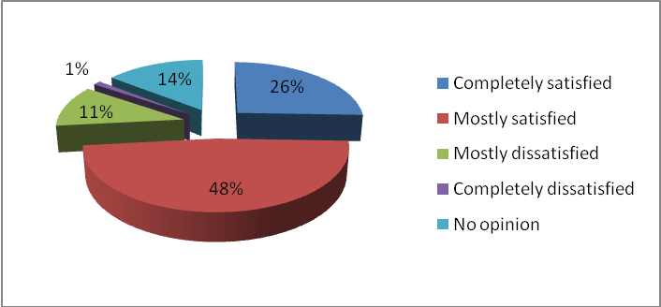
- How satisfied are you with the number of library accessories (computers, VCRs, TVs, etc.)?
57% of the respondents are satisfied with the number of library accessories. 27% are dissatisfied.
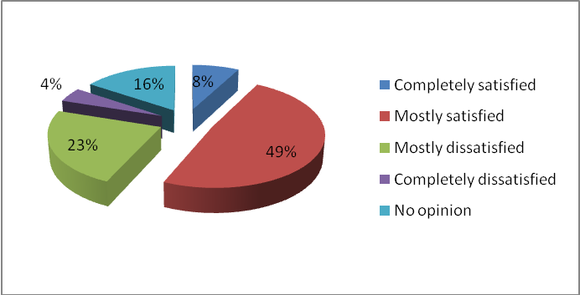
Student Clubs
- How satisfied are you with the number and variety of clubs at AUBG?
80% of the respondents are satisfied with the number and variety of clubs at AUBG.
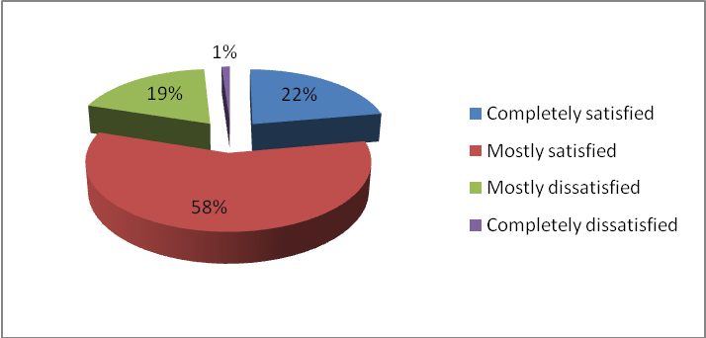
- How many clubs have you participated in this semester?
75% of the respondents have been participating in club this semester.
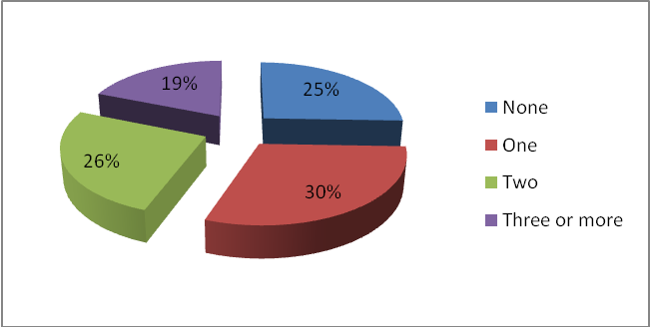
Canteen & Cafes
- How often do you eat in the canteen/cafés?
86% of the respondents are eating in the canteen/ cafés. 67% on a regular basis.
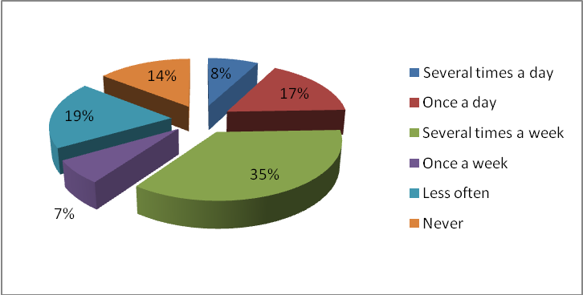
- If you are not eating in the canteen regularly, the main reason is:
According to 57% of the respondents the prices in the canteen are too high, which is a reason for them not to eat there regularly. 24% are on the belief that the quality of the food is not satisfying enough.
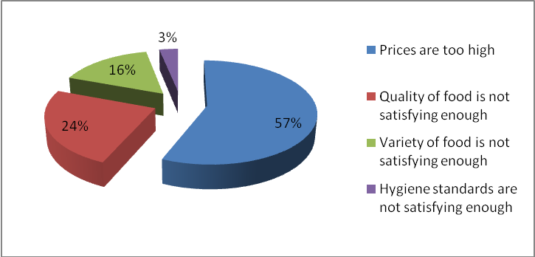
Admissions
- How has your opinion of AUBG changed since enrolling?
53% of the respondents got their opinion of AUBG worse since enrolling.
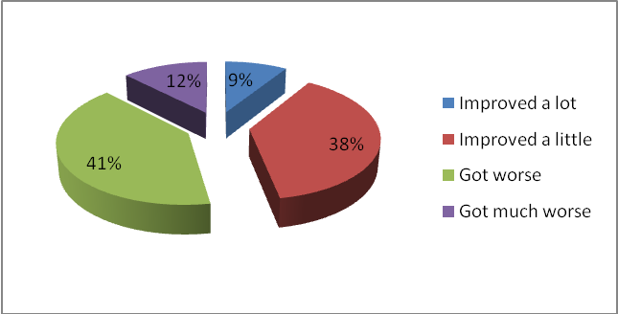
- How satisfied are you with the ratio of international students to the whole student body?
65% of the respondents are satisfied with the ratio of international students.
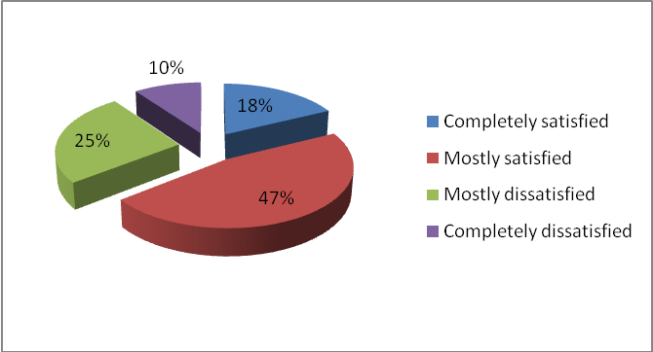
- How does the quality of the newly admitted students compare to that of the returning students?
57% of the respondents think the quality of newly admitted students is worse compared to that of returning visitors.
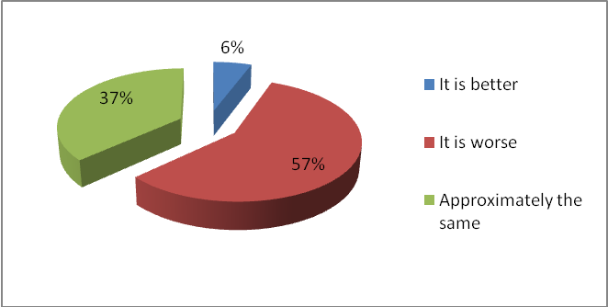
New Academic Building (NAB)
- How satisfied are you with the equipment (computers, printers, etc) in NAB?
97% of the respondents are satisfied with the equipment in NAB.
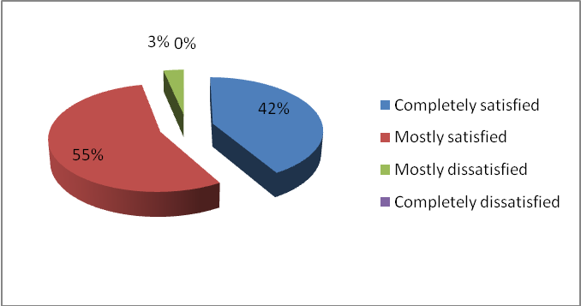
- How satisfied are you with the current division of departments between NAB and Main Building?
63% of the respondents are satisfied with the current division. However, only 7% are completely satisfied. Another research can be done on the topic in order to provide more efficient division.
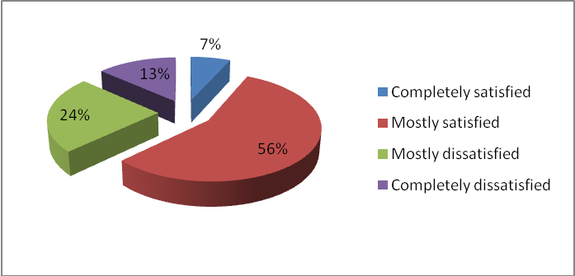
- How many times a day do you need to go back and forth between the two academic buildings?
80% of the respondents are traveling at least once a day between the two buildings. 34% are traveling more than once a day.
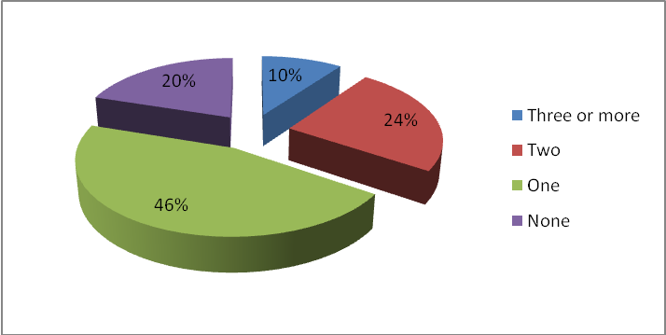
Student Life
- Is there a community consciousness at AUBG (“AUBG community”)?
67% of the respondents are on the opinion that there is a community consciousness at AUBG.
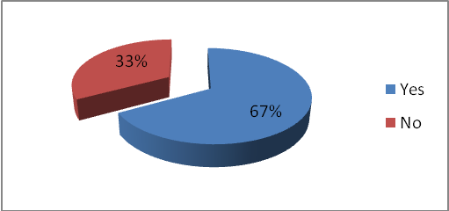
- Do SG parties bring AUBG students closer to each other?
70% of the respondents are on the opinion that SG parties are bringing AUBG students closer to each other.
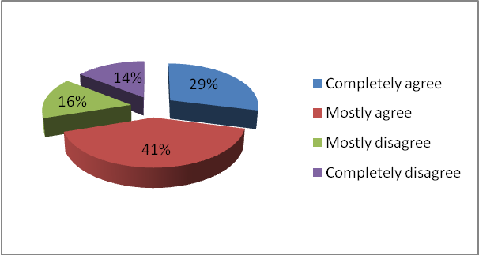
Administration
- How informed are you about the current situation/development of AUBG by its administration?
59% of the respondents are not informed about the current situation/development of AUBG by its administration. Only 8% are feeling completely informed.
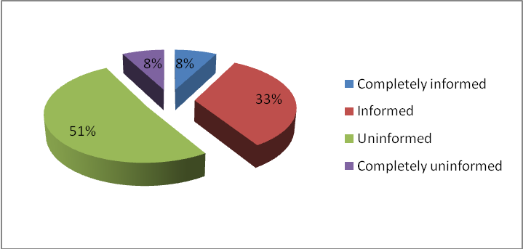
- Have you ever needed to deal directly with the administration, and how were you treated?
57% of the respondents were well treated by the administration.
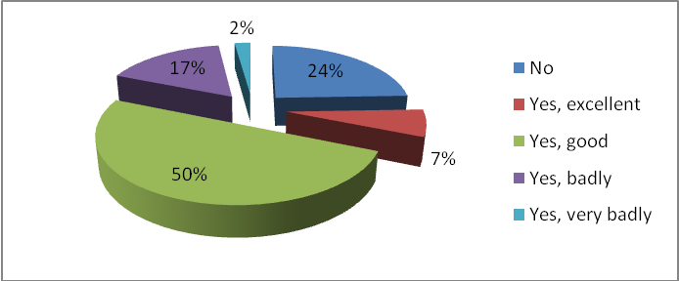
Residence Halls
- How satisfied are you with the overall living conditions in the residence halls?
72% of the respondents are satisfied with the overall living conditions in the residence halls. However, only 7% are completely satisfied. A further deeper analysis can be performed in order to meet the expectations of the students.
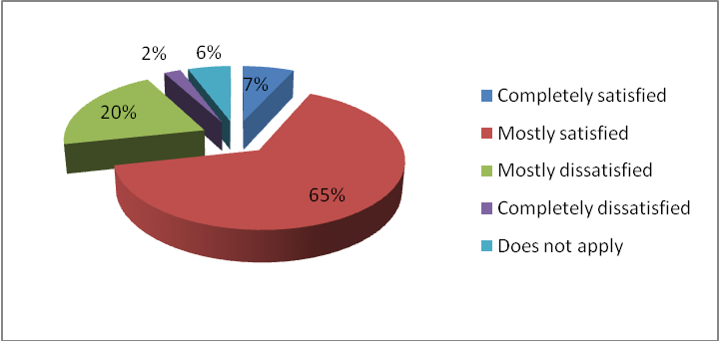
- How satisfied are you with room space in the residence halls?
65% of the respondents are not satisfied with the room space in the residence halls. Only 1% is fully satisfied. Another research is required.
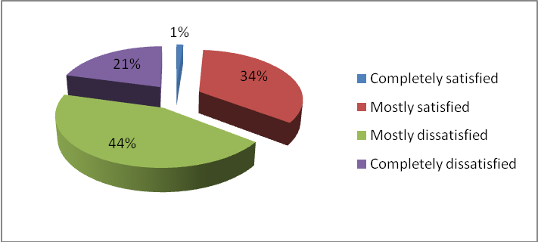
- How satisfied are you with room inventory in residence halls?
69% of the respondents are satisfied with the current room inventory in residence halls. A deeper analysis should be done in order to check the comments of not completely satisfied students (95%).
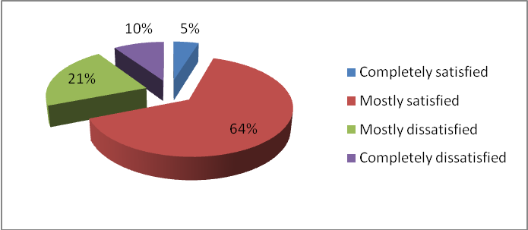
- How satisfied are you with the laundry service?
53% of the respondents are not satisfied with the laundry service.
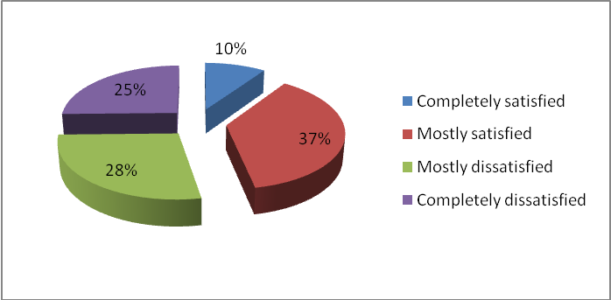
- How satisfied are you with the canteen working hours in residence halls?
88% of the respondents are satisfied with the canteen working hours in residence halls.
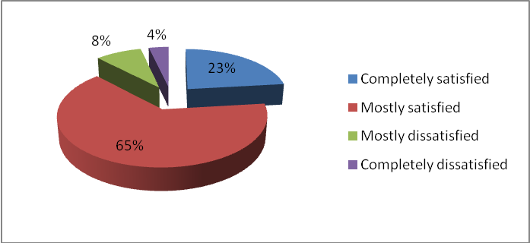
- How satisfied are you with the gym working hours in residence halls?
67% of the respondents are satisfied with the gym working hours in residence halls.
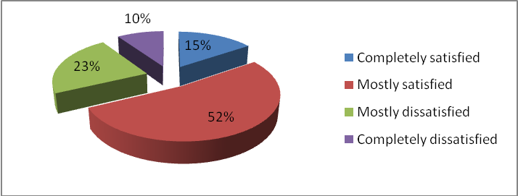
- How satisfied are you with the new computers in residence hall labs?
99% of the respondents are satisfied with the new computers in residence halls labs.
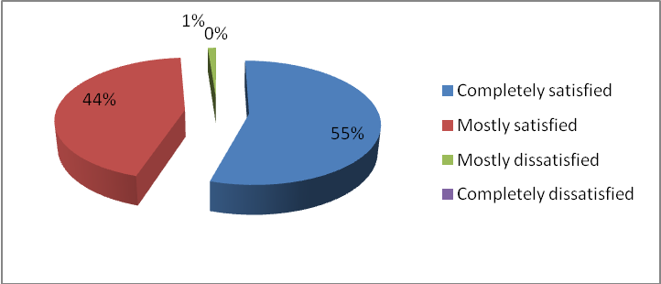
- How satisfied are you with the performance of Skaptopara 1 Residence Hall Director?
66% of the respondents are satisfied with the performance of Skaptopara 1 Residence Hall Director.
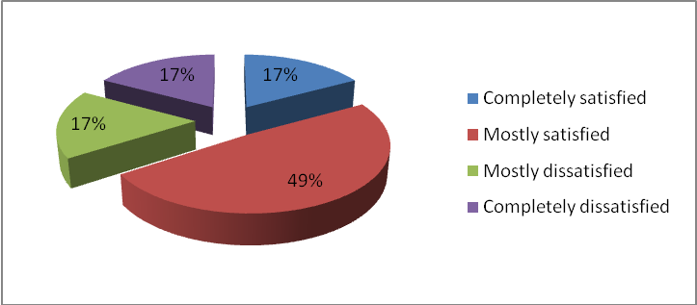
- How satisfied are you with the performance of Skaptopara 2 Residence Hall Director?
91% of the respondents are satisfied with the performance of Skaptopara 2 Residence Hall Director.
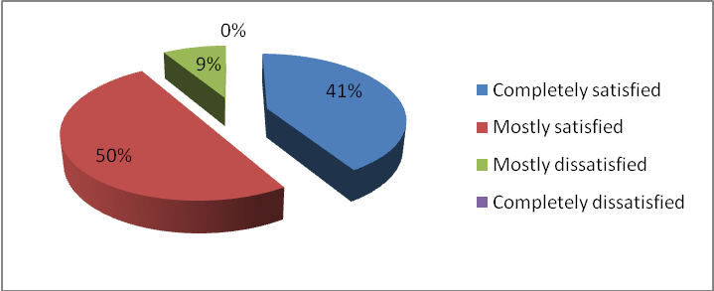
Sports
- Do you participate in any sport activity organized by the AUBG Sports Office?
Only 34% of the respondents are participating in any sport activity organized by the AUBG Sports Office.
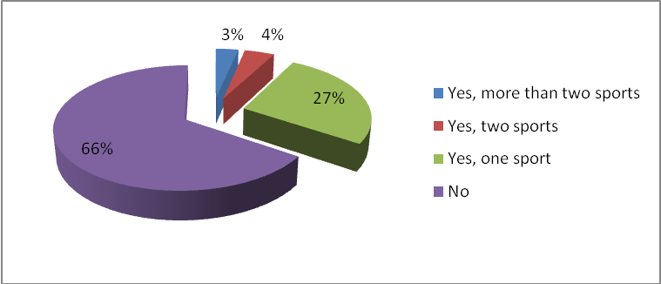
- How satisfied are you with the sports facilities in residence halls?
42% of the respondents are not satisfied with the sport facilities in residence halls. 19% are not using them.
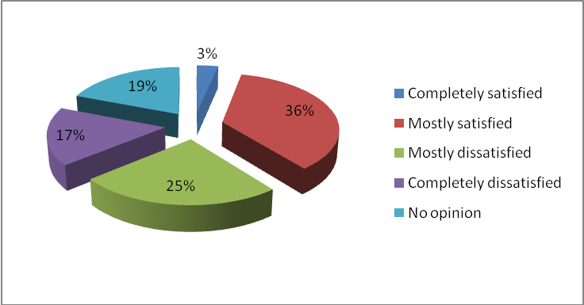
- Does AUBG need its own football field?
63% of the respondents think AUBG needs its own football field.
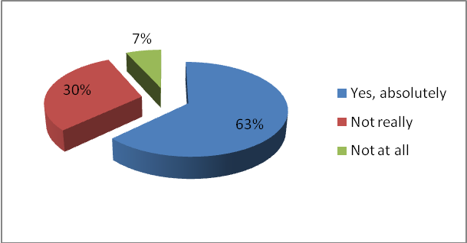
Student Government
- How satisfied are you with the overall performance of the SG this year?
80% of the respondents are satisfied with the overall performance of the SG this year.
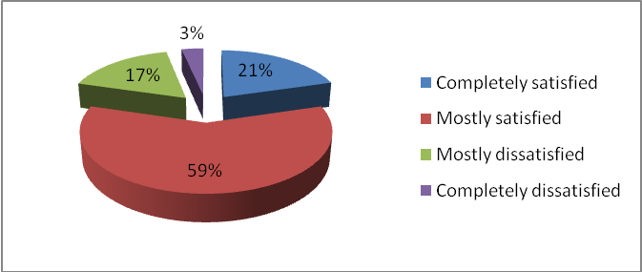
- How informed are you about the activities and achievements of the SG?
70% of the respondents are informed about the activities and achievements of the SG.
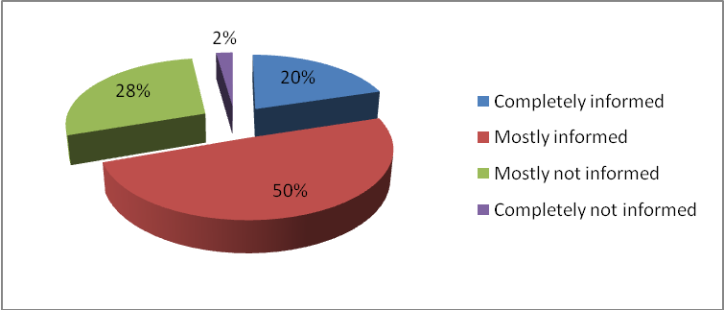
- Did you go to the last SG party?
72% of the respondents visited the last SG party.
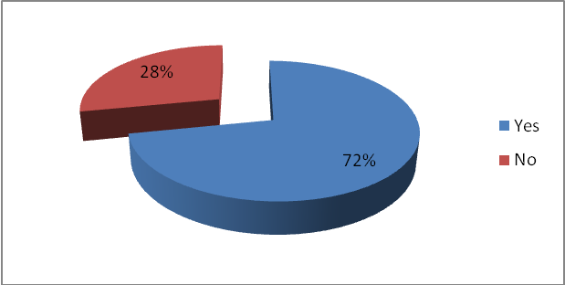
- Should surveys like this one be conducted again:
94% of the respondents think such a survey should be done again.
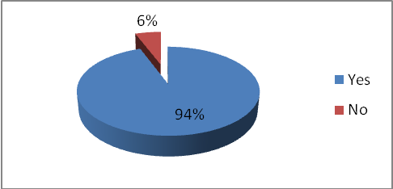

Appendix
Majors:
BUS
BUS & ECO
BUS & EUR
BUS and COS
BUS and ECO
BUS and POS
BUS, ECO
BUS, EUR
BUS, POS
BUS/ECO
BUS; ECO
Business
Business , JMC
Business Administration
Business Administration & JMC
Business Administration and Economics
Business Administration and Journalism and Mass Communications
Business Administration, Economics
Business Administration,Economics
business,economics
Bussines administration or economics
Computer Science
Computer Science; Mathematics
COS, BUS
COS, ECO
ECO
Eco & Mat
ECO and POS
Economics
Economics & Business Administration
Economics and Political Science
EUR
EUR POS
EUR, POS
European Studies
History
History, POS
JMC
JMC & POS
JMC and POS
JMC, BUS
JMC, European studies
JMC/ECO
Journalism and Mass Communicatons (undecl.)
Kazakhstan
MAT
no major yet
Not Declared
not declared yet
Political Science
Political Science and Economics
Political Science and Journalism
Political Science/International Relations and Economics
POS
POS and SES
POS, ECO
SES;POS
Undeclared
Visiting Student

What is your primary source of financing AUBG education? | Number Of Responses
Parents | 31
Loans | 3
Scholarship | 20
Work and Travel | 31
all mentioned
GRANT
Parents, scholarship and WAT
Parents, Work and Travel
Relatives

In which currency is your income denominated primarily? | Number Of Responses
USD | 50
BGN/EUR | 37
BGN
EUR
Georgian Lari
LEU

Are there any new majors or minors that you would like to see at AUBG?
a minor in Applied Dance
Advertising,PR
Balkan Studies
Biology , Chemistry, Psychology
BUS - minor and MIS – major
BUS minor
concentrations for JMC EUR BUS
Educational administration
Engineering
English
Entrepreneurship minor
Finance
Finance & Banking
graphic design
history advanced,
International Law
international relations without damn politics
JMC Advertising
LAW
Major – Psychology
Management of Information Systems
MIS, FAR
Philosophy
Philosophy minor, Psychology major
Philosophy, Psycology,etc.
Photography/PR/Sciences-Biology, Psychology
Phychology minor
PR, minor psychology
Psychology
psychology minor
Psychology, Sociology
Science majors (Physics, Astronomy)
Science: Physics, Biology
SES minor
Sociology;Psychology
Something like InformationSystems/Management Major
Something to teach advanced Microsoft of. Programs
specializations for the eco major, literature majo
Theoretical Psychology
Tourism
TV Production and other Journalism related majors

Are there any majors, minors or courses at AUBG that you find out of date?
Business Administration (too broad)
COS courses
Courses
FAR, SCI !!!
FIS
History
History Major
History, Mathematics
Physics
SES
SES, as it is right now
South-Eastern European Studies
Specialized journalism minors
Statistics

Should changes be made to Gen Ed requirements?
1 Literature,1 HTY, no science
8 subjects required instead of 12, 1 per semestar
Add some flexibility to the GE system.
Decrease the number of required Gen Ed courses
Easier courses for majors of other fields
eliminate science courses
fewer geneds,useful somehow for the major
Gen Ed 12 courses requirment should be
Gen Ed should be optional
I think the Art should be optional.
introduce specific temporal distribution: per year
it should be reduced to a minimum
juniors/seniors to take whichever lit/hty courses
less compulsory GenEd courses
Less courses
Less courses of GenEd-I had them in my high school
Less Gen Eds plz. (who need 2 english literatures?
Less GenEd courses
Less literature
Less math requirements
Low-level literature courses to be allowed for eve
math and science courses
Maybe fewer couses
More practical work, less exams/No Gen eds
more writing-intesive courses offered every semest
no maths
no restrictions on academic standing,more diversit
Not so many Gen Ed classes.
Offer Gen Ed to all students not freshmen and soph
one course from each area would be enough
one math course required, not two
One of each only:literature and philosophy courses
Phylosofy History Literature should be only1course
Reduce the number of obligatory courses
reduce the requirements for history and literature
remove natural science requirement
Remove science!It's not enriching,it's a struggle.
remove unnecessary ones, like math for HTY majors
Some cources are completely unnecessary
Standing should not be prerequisite for the Gen Ed
the choice should be more flexible, not so strict
The number of Gen Eds should be lowered
there should be more options(for math for example)
They are too much and screw your GPA easily;
to delete some of them
Too many Gen Eds
Too many Gen. Ed. Courses.
trere should be more Gen ed required
We don't need 2 courses of each category
what 2 histories for ? and 2 wic in every major !
WI requirements should be adjusted to major

List 3 of the best professors at AUBG:
- Alf Eastergard - David Durst - Diego Lucci
1. Lucia Miree 2. Jason Levine 3. Alf Eastergard
1.Van Lynden 2.DeDominicis 3.Cohen
Aernout van Lynden Delchev, Nedyalko John Mullen Tzankova, Maria
Aernout van Lynden Robert Phillips Michael Cohen
Aernout van Lynden Tamara Todorova Prof. Kotzev
Aernout Van Lynden, Phillips Robert, John Mullen
Alexander Ganchev Ljuben Mutafchiev Robert Phillips
Alf Eastergard Aernout Van Lynden
Alf Eastergard Didar Erdinc Lucia Miree
Alf Eastergard Steven Sullivan Robert Phillips
Alf Eastergard, Lucia Miree, Andrew White
Alf Eastergard, Molly Burke Kirova, Zlatina Ruseva
Alf Eastergard, Molly Burke, Popov Angel
Alf Eastergard; Nedyalko Delchev; Robert Stevenson
Andrew White Nadym Naqvi
Angel Popov Serguey Ivanov Krassimir Petrov
As a first semester student I can say that Prof. Bonev and Mutafchiev were my best prof. this semester.
Ben DeDominicis, Penny Thomson, Phillips
Benedict DeDominicis Robert Philipps Evelina Kelbetcheva
Clemena Antonova David Durst Alf Eastergard
Cosmina Tanasoiu Aernout van Lynden John Galletly
Cosmina Tanasoiu Andrew White Bobby Phillips
Cosmina Tanasoiu Robert Philips Serguey Ivanov
Cosmina Tanasoiu, Aernout van Lynden, Robert Phillips
Cosmina Tanasoiu, Michael Cohen, Didar Erdinc
Cosmina Tanasoiu, Robert Phillips, Aernot Van Lynden
Cosmina Tanasoiu,Jason Levine,Diego Lucci
Crombois Wien, Sabina Michalak, Katja
D. Durst, H. Foster, S. Ivanov
Dean Sullivan, Prof. White, Prof. Nilsen
Delchev Delchev Delchev
Diana Stantcheva, Magdalena Cutler, Volin Karagiozov
Didar Erdinc Alf Eastergard Steve Sullivan
Didar Erdinc Steven Sullivan Markus Wien
Eastergard Erdinc Sullivan
Eastergard, Cohen, Michalak
Fedhila Hassouna Jason Levine Sabina Wien
Galletly Cohen Miree
i'll abstain
It is my first semestar and i cannot give relevant answer.
Jason Levine J. Nilsen A. Ganchev
Jason Levine Steve Sullivan
Jason Levine-the best ... really Phelps Hawkins Dinka Spirovska
Julio Pontes Andrew White Jeffrey Nilsen
Kim Erdinc Todorova
Levine,Kotsev,Mutafchiev
Lijuben Mutafchiev Alexander Ganchev Robert Phillips
Marcus Wien,Nadeem Naqvi,Prof. Nedev
Michael Cohen Diego Lucci Zlatina Russeva
Michael Cohen Lucia Miree Van Lynden
micheal cohen, john mullen, cosmina tanasoiu
Miroslav Mateev Lucia Miree Tamara Todorova
Molly Burke Kirova Cohen Van Lynden
N. Naqvi A. Eastergard M. Wien
Naqvi Gradeva Mutavchiev
Naqvi,Nadeem Lucci, Diego Van Lynden,Aernout
Nilsen Erdinc Philips
Penny Thompson Stoyan Bonev Ljuben Mutafchiev
Philip Dimitrov Ivelin Sardamov Orlin Stoychev
Philips, DeDominicis, Tanasoiu
Phillips Durst Sardamov
Phillips, Gradeva, Stefanovic
Phillips, Tanasoiu, DeDominicis, Cohen
Phillips, Wien, Cohen
Prof. Clark prof. Fedhila
Prof. Hristozov Prof. Kirova Prof. Bonev
Prof. Michael Cohen, Prof. Sardamov, Prof.Ivanov
Prof. Miree Prof. Mateev Prof. Van Linden
Prof. Phillips
Prof. Phillips Aeronaut Van Lynden Phillip Szmedra (unfortunately, not permanent)
Prof. Tanasoiu,Prof. F. Mullen, Prof. Van Lynden
Prof.Koren Prof.Sooros Prof.Kim
R.Gradeva S.Nedev A.Popov
Robert Phillips Aernout van Lynden Cosmina Tanasoiu
Robert Phillips Michael Cohen Angel Popov
Robert Phillips, Didar Erdinc, Van Lynden, also Cosmina Tanasoiu
Roebert Phillips, Cosmina Tanasoiu
Sllivan Phillips Cohen
so far: Mutafchiev, Georgiev, Delchev
Steven Sullivan
Steven Sullivan Lucia Miree Vladislav Tamburkovsky
Stoyan Bonev Nedyalko Delchev Rositza Gradeva
Stoyan Bonev Philips Naqvi
Stoyan Bonev, Rositza Gradeva
Tanasoiu Van Lynden Phillips
Thompson, Naqvi, Bonev
Wien, Popov, Delchev

If you are not eating in the canteen regularly, the main reason is: | Number Of Responses
Prices are too high | 35
Quality of food is not satisfying enough | 15
Variety of food is not satisfying enough | 10
Hygiene standards are not satisfying enough | 2
all of the above
All of the above... sorry ;(
Generally I want to eat normal food
I go and eat at my granny's place
I have special preferences for food.
i live off campus so i cook my own food-cheaper
Prices are too high and food is not good enough
Quality AND the price are not satisfying
You spend the same money if you go to a restaurant

