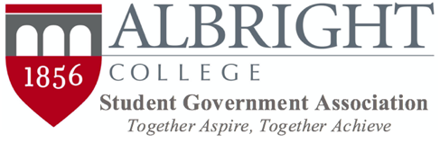

ALBRIGHT COLLEGE STUDENT GOVERNMENT ASSOCIATION
ISSUING FUNDS TO STUDENT ORGANIZATIONS AFTER ALLOCATIONS

Mission: The Albright College Student Government Association recognizes that student organizations may encounter new opportunities or challenges during the course of a semester that require funding beyond that which was granted to them by the SGA during the allocations process. The SGA will utilize the following rules and procedures when organizations request additional funding.

Section I: When an organization determines that they require additional funding after the allocations process, they must complete the following tasks to submit a formal request for funds.

- The organization must submit a formal letter to SGA explaining what they need funding for, and why the funds were not requested during the initial allocations process or during re-allocations.
- The organization must attach documentation to the submission reflecting the price of the items they are requesting funding for.

Section II: When all of the required documentation has been received by the SGA:

- The President of the SGA will put the funds request forward for a vote by the SGA Executive Cabinet.
  - If the President is not in attendance at the meeting, the Recording Secretary will be responsible for putting the funds request forward for a vote.
    - If the President is not in attendance, the Recording Secretary will make a motion during New Business to vote on the funds request.
- In order for the request for additional funds to be approved, the following conditions must be met:
  - If the amount of money requested is $500.00 or less, then the motion requires a simple majority vote of the Executive Cabinet to pass.
  - If the amount of money requested is $500.01 or more, then the motion requires a 2/3 majority vote of the Executive Cabinet to pass.

Section III: Amending this policy requires a 2/3 vote of the SGA Executive Cabinet.

Disclaimer: Any reference to “submitting or submissions” should be done via the appropriate form on the SGA page on aLink.

Updated November 2017

