 | American University in Bulgaria Student Government  Internal Document
Name: Bylaw on SG logo
Period/Date: 16/11/2011

This bylaw is to officially approve logo for the Student Government at AUBG for the term of five years.
The official logo of the SG will be:
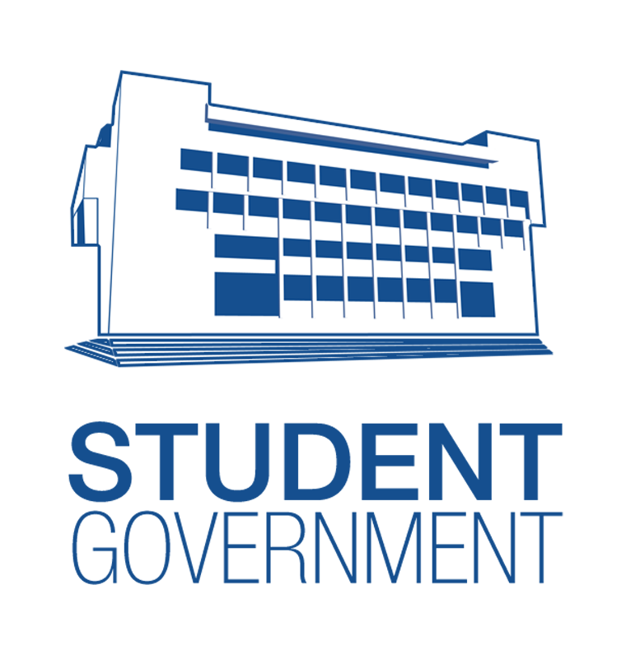
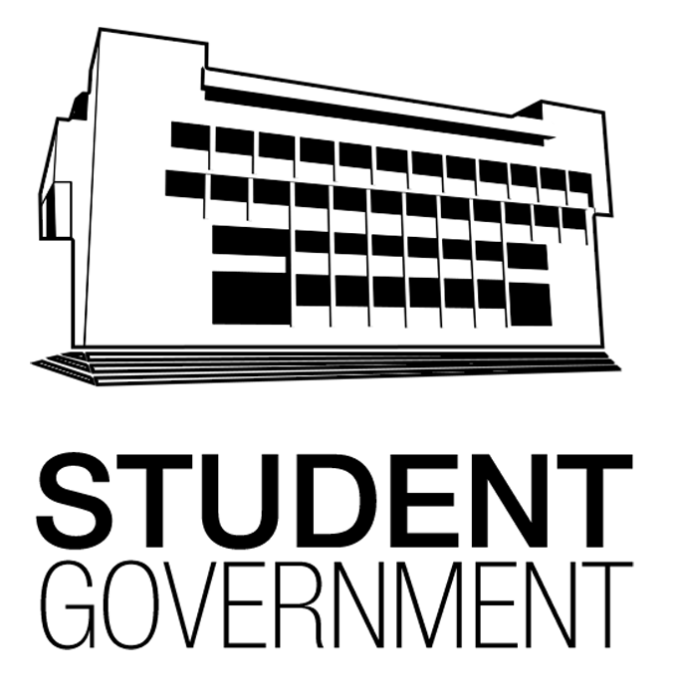

Information about the logo:
Color: #154f8f # 000000
Ratios: 1 (W) : 1.026 (H)
Author: Simeon Simeonov
Only this logo should be used as the official SG logo and only in the colors and ratios specified above.
The logo will be approved by the senate with 2/3 of the votes of the senators present at the meeting.
The logo will be active from the moment it is approved and will be valid till the start of 2016 academic year. At this point, the same logo may be re-approved by a simple majority of the senators present at the first senatorial meeting. The senate may also decide to change the logo in the start of 2016 academic year – for this 2/3 of the votes of the senators present at the meeting will be needed.
When the logo is approved by the senate it will become the property of AUBSG.

