Instructions for joining the AOMA Yahoo Group email listserv:
- Go to: www.groups.yahoo.com


- Enter term AOMA and select “Search”. 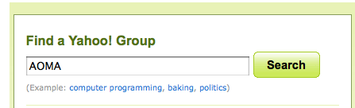

- The top result is the group: AOMAStudents. Select Join this group!
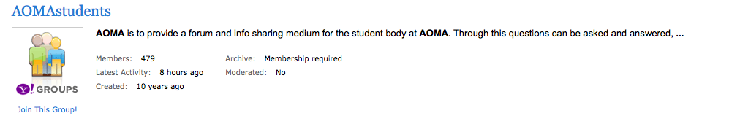

- (If you have not logged into your Yahoo account) You will be prompted to log in or create a Yahoo account. Once you are logged in, you will be directed to the group page.

- All requests for membership must be approved by the group moderator. Explain who you are and why you would like to join in the provided box.
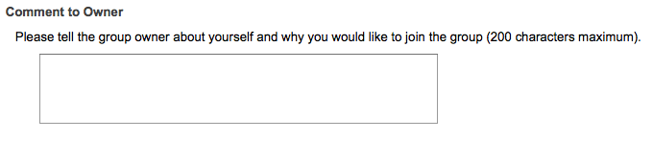

- Select how often you would like emails from the group. 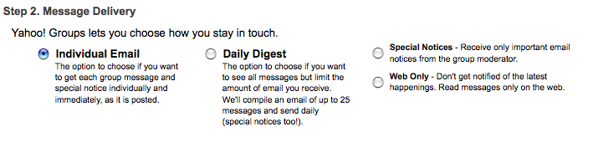
- Select what type of email features you would like and press Join. 