

**Contact**

*ASO Advisor:* Robert Crossley

*TEL:* (818) 364-7820

*EMAIL*: [crosslr@lamission.edu](mailto:crosslr@lamission.edu)

*ASO:* [lamcaso@outlook.com](mailto:lamcaso@outlook.com)

*TEL:* (818) 364-7600 EXT. 7124

[www.lamission.edu/aso](http://www.lamission.edu/aso)

*Location:* Campus Center Lower Level

**Follow Us on:**

@aso_lamc

&

LAMCASO- Facebook

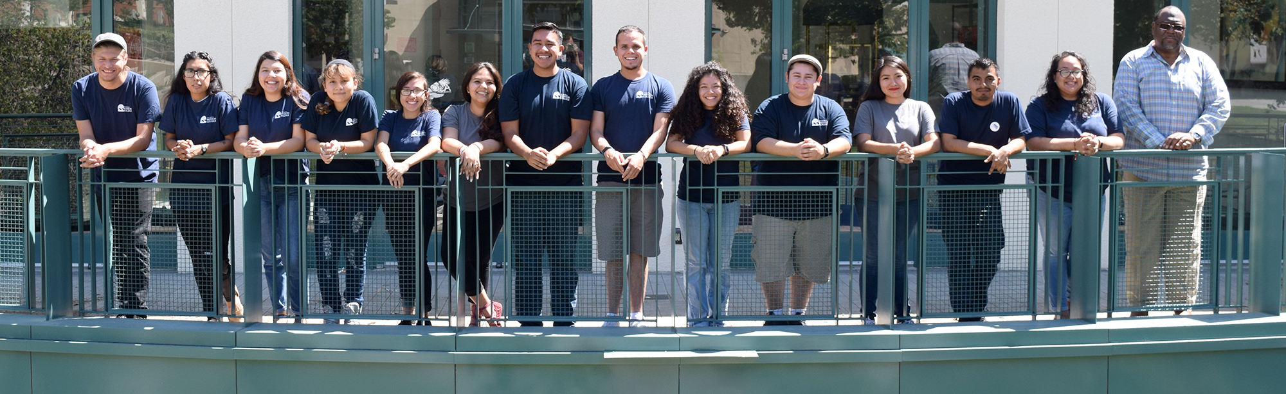

The Associated Student Organization is committed to serve the student body, community and school. To make the leaders step up to make a difference on campus and to create unity, spirit and connections among our student body. The students who participate in A.S.O are responsible, committed people to provide trustful resources and credulous information to our students and community.

ASO MISSION STATEMENT

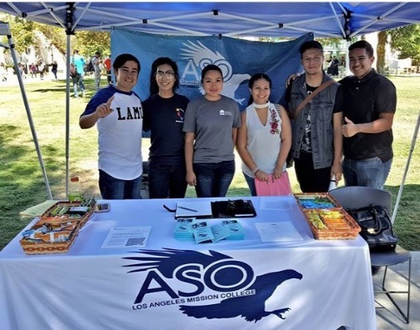



Associated Student Organization

**ASO**

# Clubs at LAMC

* Alpha Gamma Sigma
* Child Development
* Culinary Club
* Dance Club
* Drama Club
* Dreamers Pathway
* Girl Up
* LGBTQ Club
* Math Club
* M.E.Ch.A
* Mental Health Awareness Club
* METAS
* Music Club
* Multicultural Club
* Robotecas
* STEM & Health Club
* Student Veterans Organization

*\*To start/charter a club please visit the ASO office\**

# What is ASO?

## The Associated Student Organization was established to provide students the opportunity to participate in student leadership.

# Objectives of ASO

* Advocate for the rights and needs of ALL L.A.M.C students
* Promote diversity
* Promote safeness on campus

# ASO FEE

Steps to being a “Member”:

1. Pay online or Pay in the Business office $10 ASO fee
2. Bring receipt to the ASO office to receive your member benefits
3. ENJOY YOUR BENFITS

**ONLY for $10.00**

* FREE Printing (10 pages per day)
* FREE Scantrons, Pen and folder
* ASO T-shirt
* Internet access in ASO Lab
* Join a chartered school club
* Eligibility to run for office*

Requirements for ASO Board Member

*MUST COMPLETET AT LEAST 5 UNITS WITHIN LACCD*

*MUST HAVE A CURRENT GPA OF 2.0 OR HIGHER*

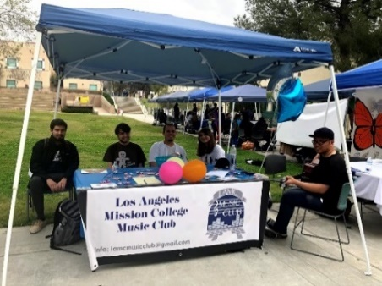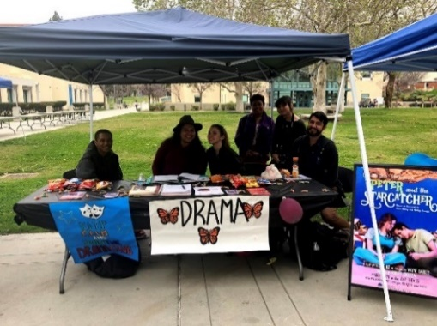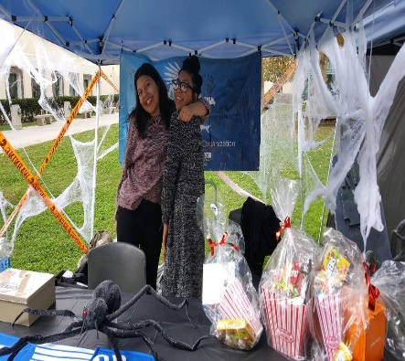

**ONLY $10 !**