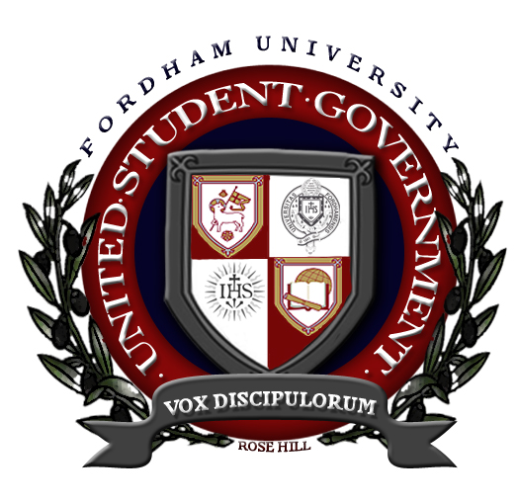
Resolution Requesting the Ratification of an Official USG-Supported Student Bill of Rights
Emphasizing the United Student Government’s constitutional responsibility to “provide a single voice for students in University affairs,”
Recognizing the absence of a document which explicitly and concretely enumerates the basic rights of Fordham University Students which obligates the United Student Government to support such rights,
Affirming the necessity of a definitive statement that explicitly identifies which rights ought to be upheld by the United Student Government;
The Fordham University United Student Government of Rose Hill moves to enact the following measures, which will henceforth be known collectively as the Fordham University Student Bill of Rights:
I: The United Student Government shall pass no legislation that would inhibit the right of any student or student organization from their basic constitutional rights of Freedom of Speech, Freedom of Expression, Freedom of Assembly, Freedom of Religion, and Freedom of the Press. Furthermore, the United Student Government shall strive to work with all administrators to guarantee student rights whenever possible or prudent.
II: Every student and student organization shall have the right to petition the United Student Government.
III: All United Student Government meetings, including all USG Budget, House, Operations, and Senate meetings, shall be open to the public.
IV: All United Student Government official meeting minutes, resolutions, and budget information shall be made available to the public on the United Student Government website and upon request.
V: No student will be denied membership in any United Student Government approved student organization on the basis of their race, creed, gender, ethnicity, sexual orientation or personal beliefs.
VI: Any group of students that wishes to form a student organization to address a unique interest or subject will have the unimpeded right to do so, provided they comply with all USG constitutional standards.
VII: All student organizations shall be given equal opportunities to seek USG funding, provided they comply with all USG constitutional standards.
VIII: The United Student Government shall strive to ensure that all students and student organizations shall have the right to organize programs, exercise rights of free speech, distribute materials, demonstrate, and address issues of concern with University Administration.
Resolved, we, the Fordham University United Student Government, enact this resolution on _________.

_________________ ____________________ ___________________
President Sara Kugel Vice President Caitlin Meyer Senator Donald Borenstein

